**Data Driven Testing(DDT)**

1. What is Data driven testing?

Read the data from external recourse & run the test scripts is called Data driven testing (parameterization)

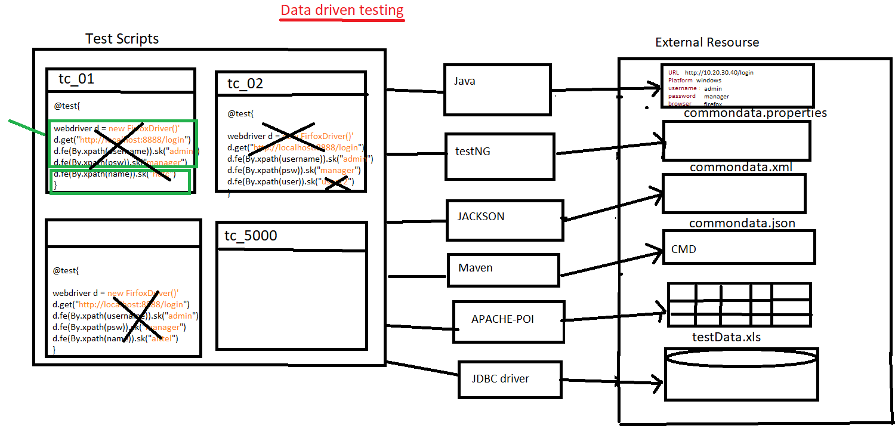

1. Why Data Driven testing?

As per the rule of the automation data shouldn’t not hardcoded because data modification & maintenance is tedious job when you want to run the test with different data, instead we should get the data from external resource like xlsx, properties file, database, XML, JSON, command

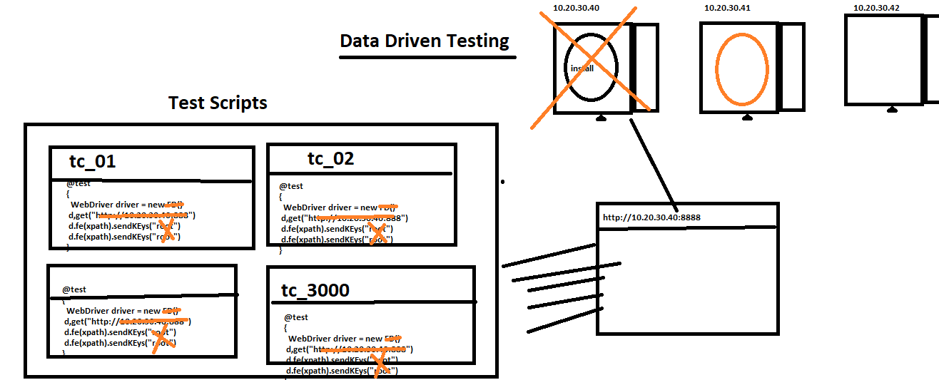

1. What is Advantages of Data driven testing
2. Maintenance of the test data is easy
3. Modification of the test data in external recourse is easy
4. Cross browser testing is easy (means change the browser in property File)
5. Running test scripts in different Environment is easy
6. Running test scripts in different credentials is easy
7. We can create the test data prior the Suite execution (we can also get the data from test Data team)
8. Rerunning test Script with multiple time is easy
9. **How to read data from properties File?**

* Get the java Object of the Physical file using “FileInputSteam”.
* Create an Object of “Properties” class & load all the keys.
* Read the data using getProperty(“Key”).

**Note**: properties file is light weight & faster in execution compare to Excel.

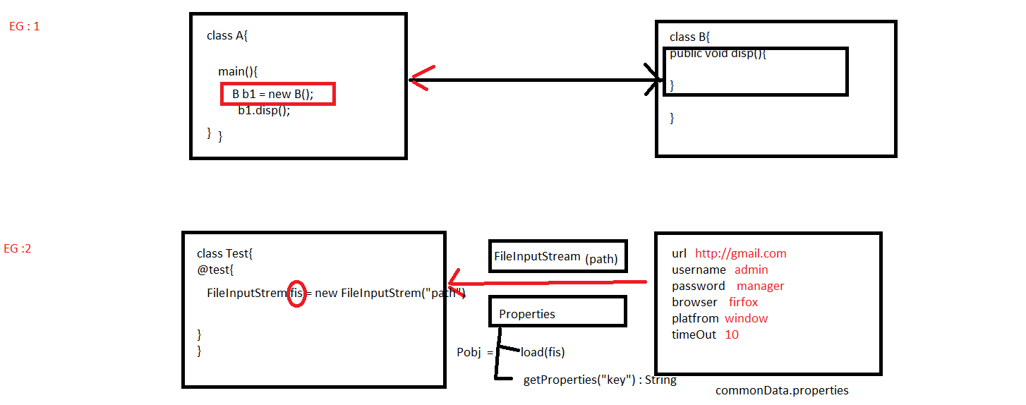

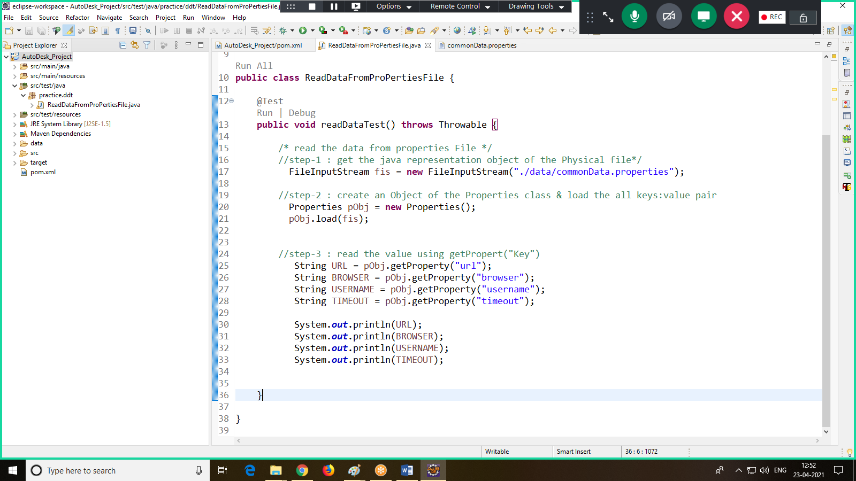

1. **How to read data from testing.xml**

Step1: write common data in XML file using <parameter>, data will be in the form of name: value pair

Step 2: using XMLTest class, we can read the data from testing.xml file

Step 3: make sure we always run the test via testing.xml file only

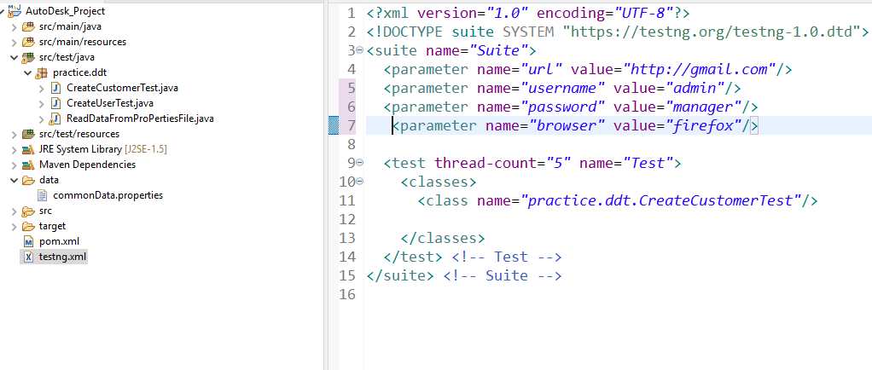

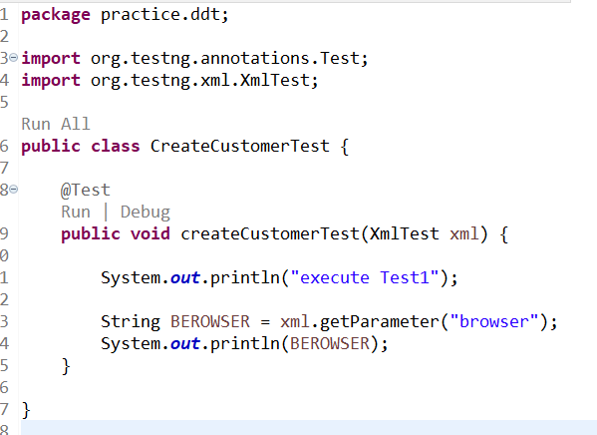

1. **How To Read Data From JSON File**

**package** DDT.practice;

**import** java.io.FileNotFoundException;

**import** java.io.FileReader;

**import** java.util.HashMap;

**import** org.json.simple.parser.JSONParser;

**import** org.testng.annotations.Test;

/**

* This class for reading data from JSON File

* **@author** SOUMYASANTA SAHOO

*

*/

**public** **class** ReadTheDataFromJSONFileTest {

@Test

**public** **void** readTheDataFromJsonFile() **throws** Throwable

{

//Step=1 convert the JSON File into Json Object

FileReader fr=**new** FileReader("./Data/commonData.json");

//Step=2 convert JSON Object into Java Object

JSONParser jp=**new** JSONParser();

Object jObj = jp.parse(fr);

//Step=3 Read the data using HashMap

HashMap obj = (HashMap)jObj;

Object value = obj.get("url");

System.***out***.println(value);

}

}

1. **How to read data from CMD using Maven**

Step 1: install maven Command-Line Software

1. Go to google, search for “download maven”
2. Click on first link
3. Click on “[apache-maven-3.8.1-bin.zip](https://apachemirror.wuchna.com/maven/maven-3/3.8.1/binaries/apache-maven-3.8.1-bin.zip)”
4. Download the .Zip file
5. Unzip the File
6. Get inside the “bin” folder.
7. Copy the location path

Ex: C:\Users\TYSS\Desktop\apache-maven-3.8.1-bin\apache-maven-3.8.1\bin

1. Go to local system “Environment variable” window.
2. We have to create 2 new variables in “user variable section”.

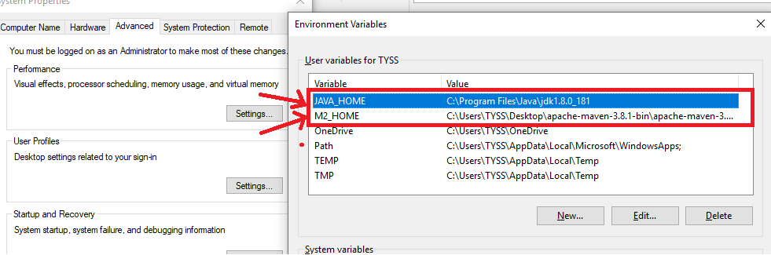

1. **We have to edit “path” variable in “system variable section”**

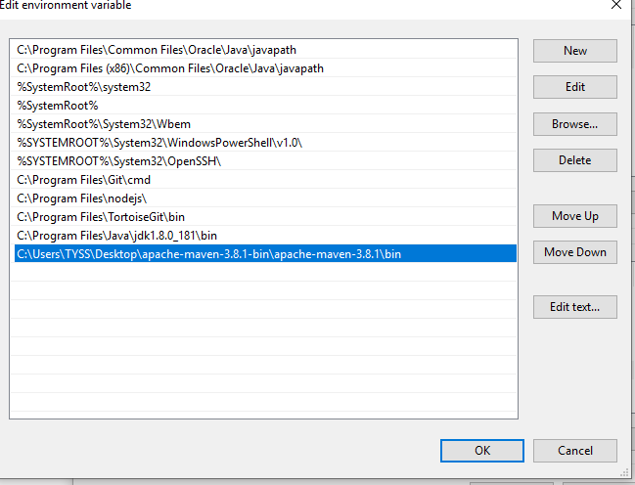

1. Click on “OK” in all the window

Step 2: In order to check weather software in installed or not ?

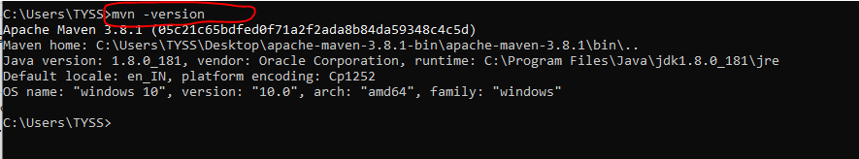

Step 3: pass maven parameter from the command line

1. Open command prompt
2. In Eclipse copy the location of the maven Project

Select project🡺 right click 🡺 properties 🡺 Copy the location

1. Go to command prompt, paste the location of the project

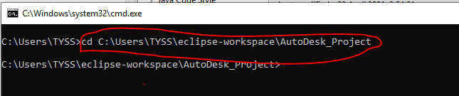

1. Execute maven command at the same pass the maven parameter using –Dkey=value



Step 4: java program to read data from maven parameter from the command line

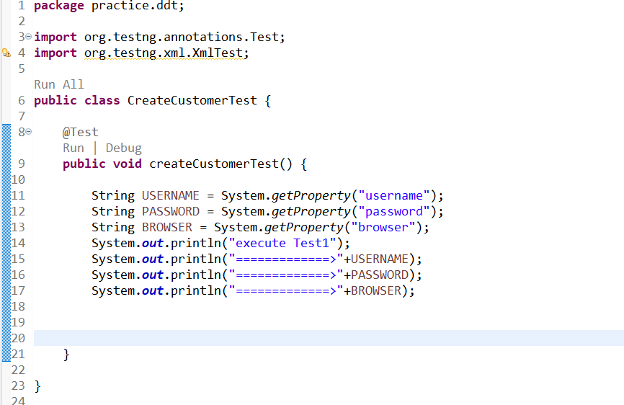

**JDBC**

**What is JDBC?**

It’s an advance API Present inside J2EE, which is used to connect to any data base or talk to any data base from the java code.

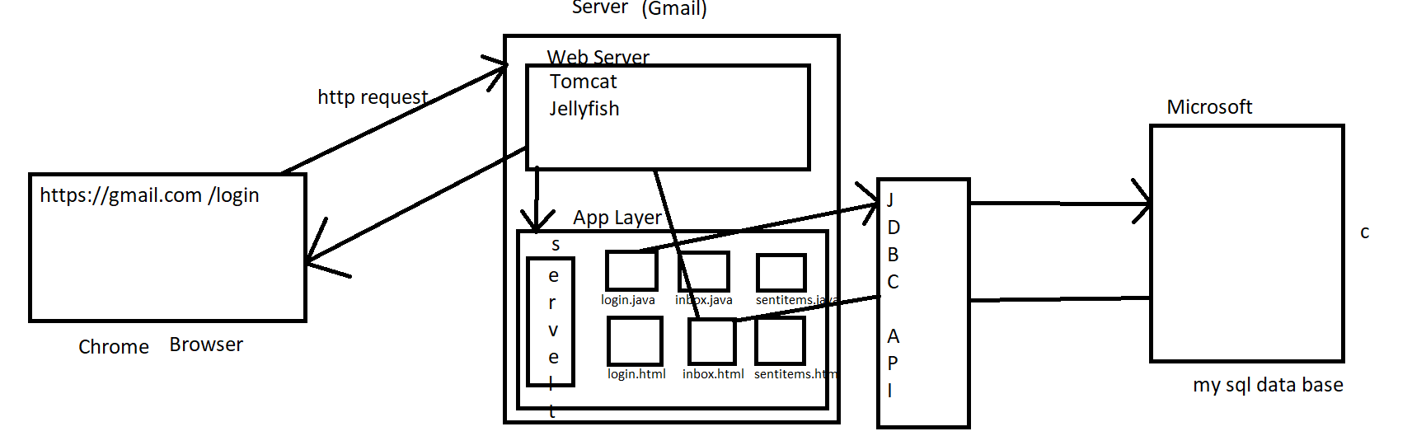



JDBC helps java programmer to store (insert query) / retrieve (Select Query) data from the physical database.

* Every operation we perform in the browser, that request goes to web application with the help of web server in the form of http request, then java program will connect to data base by taking help of JDBC API & JDBC Driver.

**JDBC Workflow?**

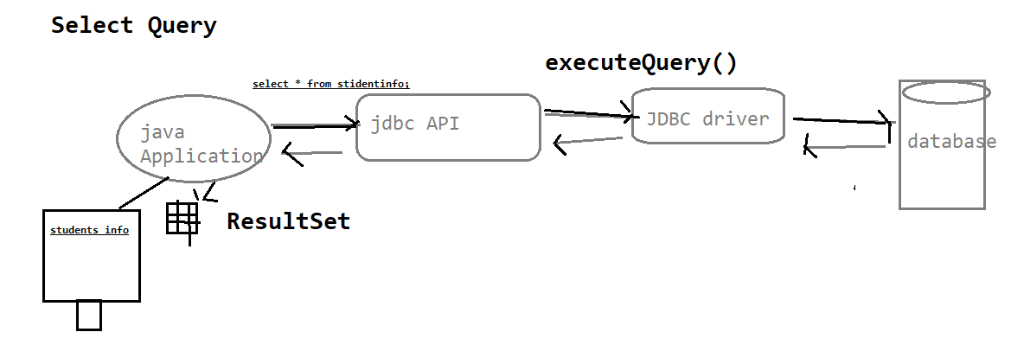

* Select Query – executeQuery()
* When we write the Select query our Java Application will talk to the JDBC API & Our JDBC API talks to the JDBC Driver provided by the Data Base vendor with the help of executeQuery().
* JDBC Driver connect to the DataBase and return the ResultSet (Table) to the user.

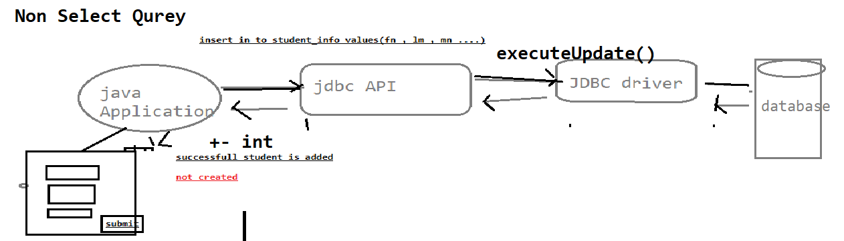

* Non Select Query – executeUpdate()
* When we write the Select query our Java Application will talk to the JDBC API & Our JDBC API talks to the JDBC Driver provided by the Data Base vendor with the help of executeQuery().
* JDBC Driver connects to the DataBase & returns integer value like( 1 row affected).

**What is JDBC Drivers & JDBC API?**

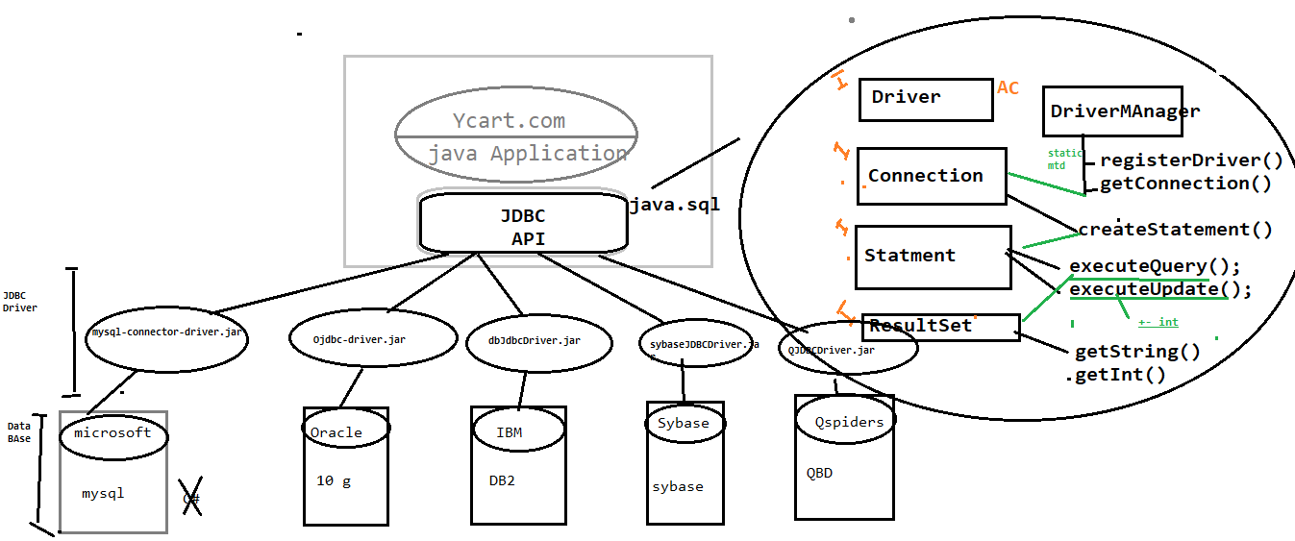

C Language

JDBC API: To connect to the Database Ycart.com people didn’t write any Java program so they released an Interface. It’s an API’s available in java.sql package, which is collection interfaces with abstract method, & it’s database independent.

JDBC Driver: its implementation class of JDBC API provided by data base vender. it’s a database dependent.

1. JDBC API contains Empty Interface & Abstract Classes.
2. JDBC API takes Help of JDBC Driver to connect to Different Data Base.
3. DriverManager is a Singleton Class which helps to establish connection with Data Base only once.
4. Singleton Class allows the user to create only one Object, we can call that object any no. of times. Ex: Antivirus.
5. registerDriver() helps to register the Driver File to the Data Base.
6. By Using getConnection() we can establish connection with the Data Base & it will return the connection.
7. createStatement() helps us to create Statement & returns statement, then only we can execute executeQuery() & executeUpdate().
8. getString() & getInt() of ResultSet Interface talks about the type of Data we will get from the Data Base.

Why JDBC in Automation?

In Automation by using JDBC

1. We can automate any End-to-End Scenario.
2. We can automate Pre-conditions involving Data Base.
3. We can Fetch/Retrieve test data present in Data Base.
4. We can provide validation in GUI w.r.t. to Data Base.

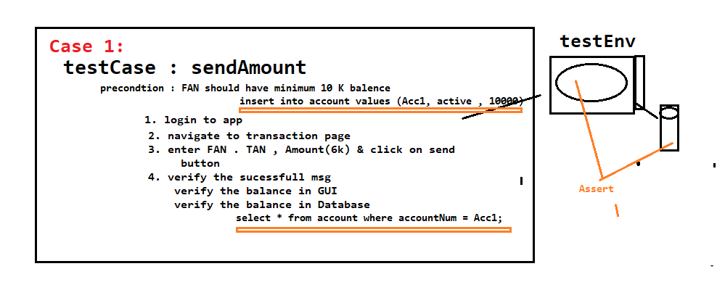

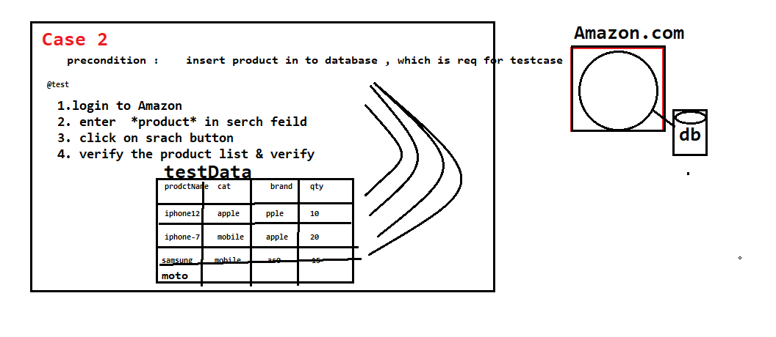

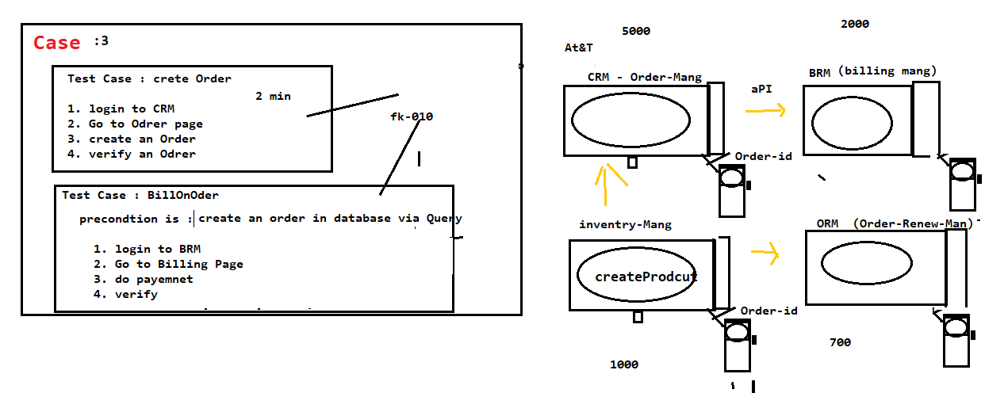

**ExecuteQuery()**

@Test

public void getExecuteQuery() throws SQLException

{

//Step 1: Register the database

Driver driverref=new Driver();

DriverManager.registerDriver(driverref);

//Step 2: establish Connection with database

Connection con=DriverManager.getConnection("jdbc:mysql://localhost:3306/projects", "root", "root");

//Step 3: Issue create statement

Statement stat=con.createStatement();

//Step 4: Execute any query

ResultSet result = stat.executeQuery("select * from project;");

while(result.next())

{ System.out.println(result.getString(1)+"\t"+result.getString(2)+"\t"+result.getString(3)+"\t"+result.getString(4));

}

//Step 5: Close database connection

con.close();

}

**ExecuteUpdate() With finally block**

@Test

public void getExecuteUpdate() throws SQLException

{

Connection con = null;

try {

//Step 1: Register the database

Driver driverref=new Driver();

DriverManager.registerDriver(driverref);

//Step 2: establish Connection with database --- database

con=DriverManager.getConnection("jdbc:mysql://localhost:3306/projects", "root", "root");

//Step 3: Issue create statement

Statement stat=con.createStatement();

//Step 4: Execute any query -- table

int result = stat.executeUpdate("insert project values('TY_PROJ_999','RINCY','26/04/2021','SDET-13','ON-GOING',62);");

if(result==1)

{

System.out.println("Project is sucessfully created");

}

else

{

System.out.println("Query failed");

}

}

catch(Exception e) {

}

finally {

//Step 5: Close database connection

con.close();

System.out.println("Connection closed");

}

}

**POM(Object Repository)**

1. What is Object/Elements/POM Repository

Its collection of elements locators & business libraries in one place & its developed using POM design pattern

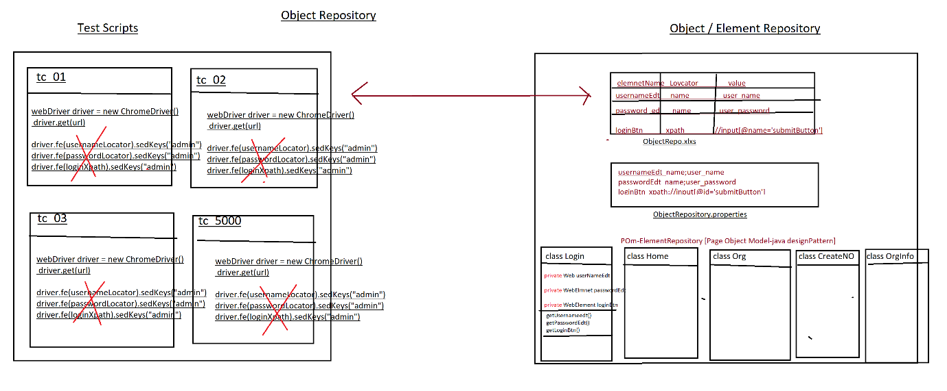

1. Why Object repository ?

As per the rule of the automation, we should not hardcode[fixed]elements with in test Scripts instead, we should get elements from Object Repository , because in Agile process due to frequent requirement changes , modification & maintenance of elements is tedious job

EG : below is the example of Gmail application GUI changes

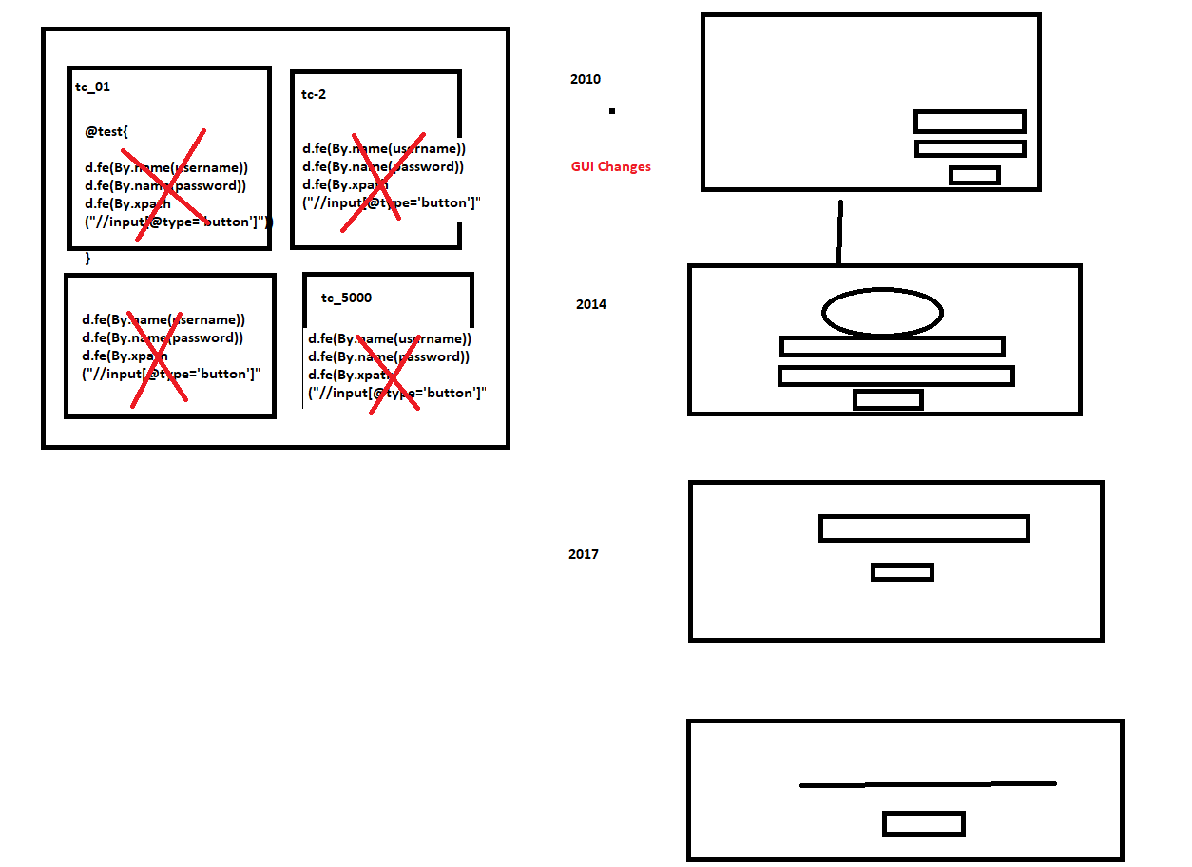

1. What is the advantages repository?
2. Reusability of elements, no need to write xpath & other locators again & again
3. Modification in Repository is easy, when GUI changes frequently
4. Maintenance is easy, because all the elements we kept in one place
5. Test Script Code Optimized via business reusable libraries
6. More Readability
7. Test Script development is faster due to business lib
8. Test Script is more robust
9. Handle Stale Elements Exception.
10. What is POM?

POM is a java design pattern preferred by google to develop object repository.

1. Why POM ?

It’s a well-organized structured design pattern, where we can maintain all the web elements in page wise, due to POM design pattern maintains & modification is easy & faster.

1. Advantages of POM:
2. Well organized structure
3. Handle stale element exception.
4. maintains & modification of element is easy
5. We can directly store Web Elements in java class
6. Better fit for Agile processes
7. Support Auto heal feature
8. Why @FindBy(locator) annotation instead of driver.findElement(“locator”)

Ans : to avoid staleElementReferenceException

1. What is staleElementReferenceException ?

It’s one of selenium Execption , whenever webdriver try to identify an element , element was available in GUI, but at time of performing an action on the elements element was not recognized due to page got refreshed or elements may become old or element not attached to page in such case we get staleElementReferenceException

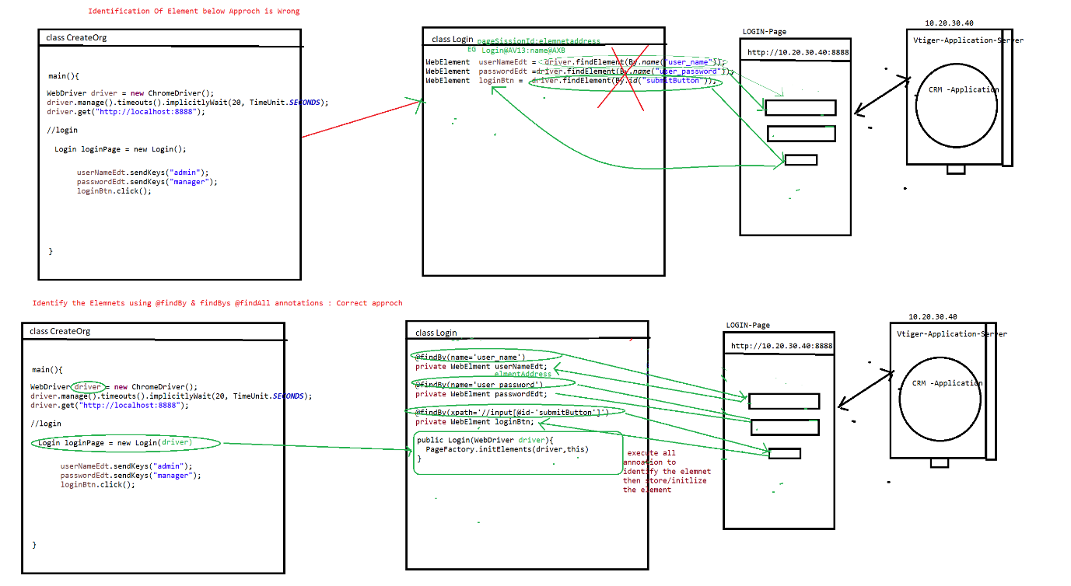

1. Rules of POM

Rule 1 : create separte java class for every page in a application & class name should be same page name

Rule 1 : Identify all the elements using @findBy & @findAll , @findbys annotations & store them in speific pom / java class (Element declartion)

Rule3 : For Every POM class create Constructor to get an Object of the class & initialize the Page Elements , in order to initialize all the page Elements we should use Pagefactory.initElement() (Element initialization)

Rule 4 : declare all the WebElements as private & provide getters methods to accesses elements in testScripts class [this processes is called Encapsulation]

Note : to create getters mtds inside the java class fallow below steps

=>place cursor inside the class🡺 Right click🡺source 🡺generate getters & setters 🡺 select the getters check box 🡺 click on ok button

Rule 5 : Go to every & identify the reusable business libraries & implement them in same POM class

1. Difference between POM & PageFactory design pattern?

POM is java design pattern, where will maintain all the Web element locator in well-organized manner

Pagefactory it’s an extended design pattern of POM , which is used to create an Object to POM classes , & at the time of object creation it will execute all @findBy @findbys annotation then initialize all the elements

Difference between @findBy , @findAll &@findBys annotation

All annotation available in Selenium webdriver, its traditional ways to identify the elements in GUI.

@findBy : used to identify the element using one locator or one condition

@findAll : it contains multiple @findBy annotation , it mean we can identify the same element using multiple locator (multiple conditions) , it will use OR condition during execution of locator

@findALL({ @findBy(@id=’username’) , @findBy(name=’user’)})

Private Webelements userNAmeEdt;

Note : using above concepts we can achieve **Autohealing** technique

**AutoHealing** : during execution , if one locator fails to identify the element , it will retry to identify the same element using another locator

@FindBys : it contains multiple @findBy annotation , it mean we can identify the elements using multiple locator (multiple conditions) , it will use AND condition to during execution of locator

@findBys({ @findBy(@id=’username’) , @findBy(name=’user’)})

Private Webelements userNAmeEdt;

Project Structure

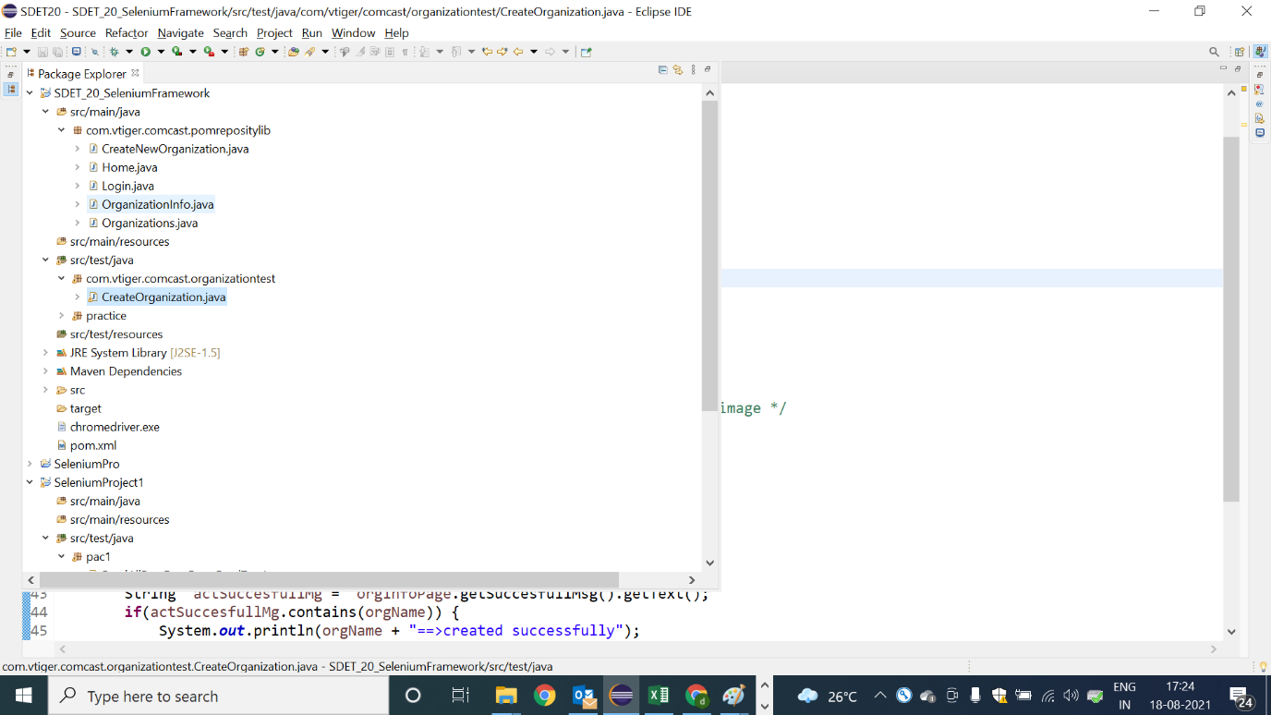

Pom Classes : Login

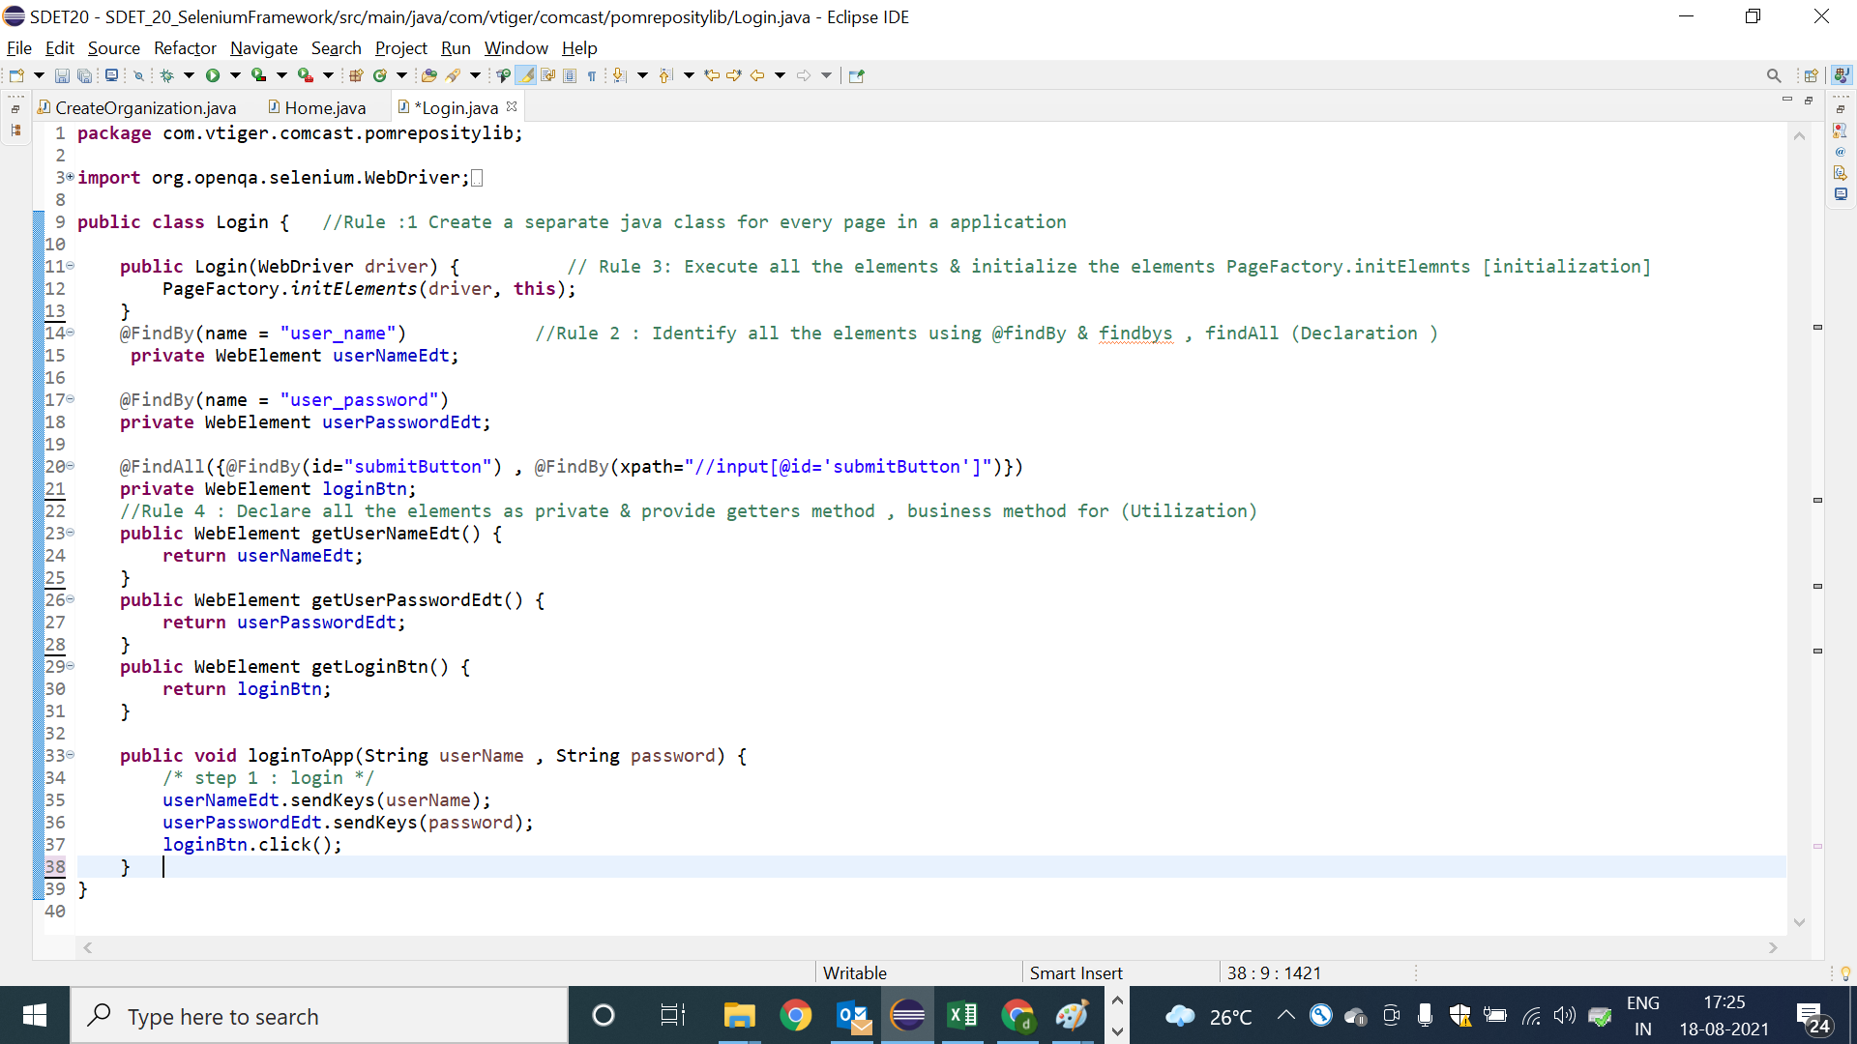

Pom Classes : Home

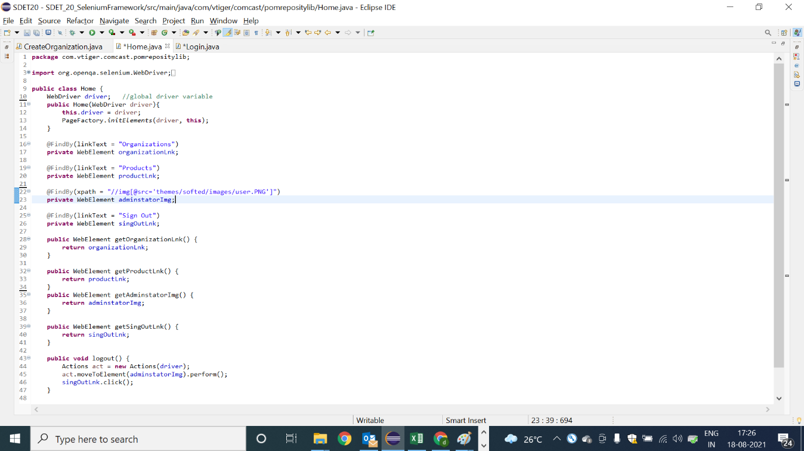

POM class : Organization

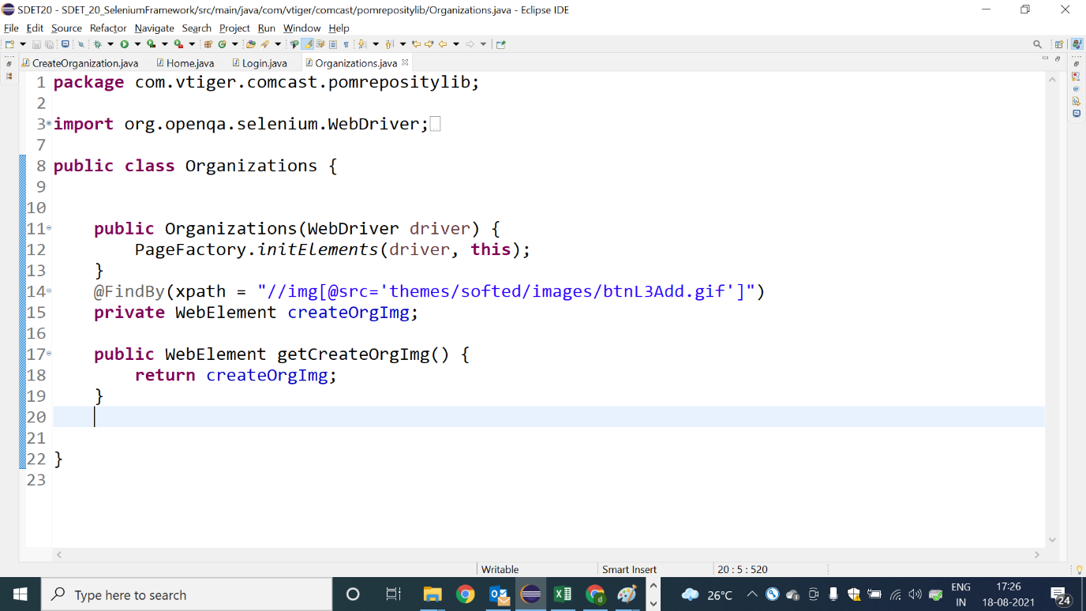

POM class : Create new Organization Page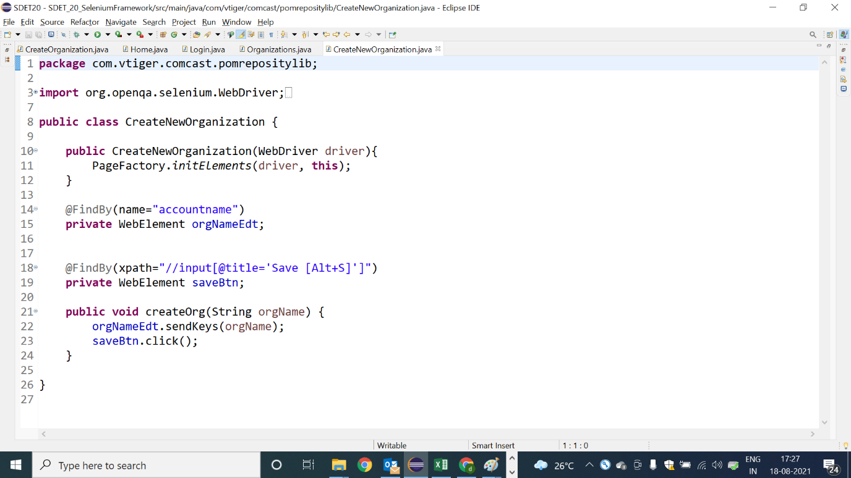

POM class : OrganizationInfo

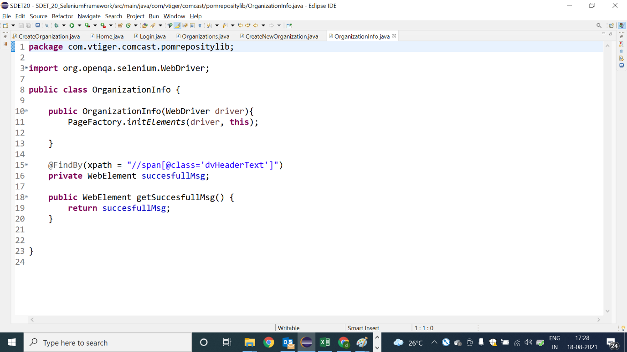

Test Scripts using POM class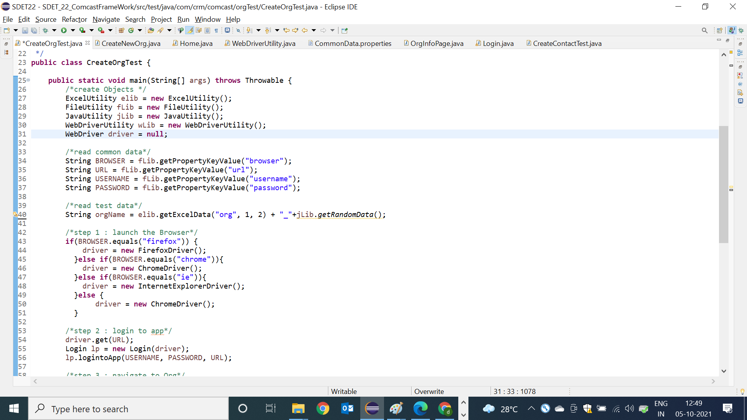

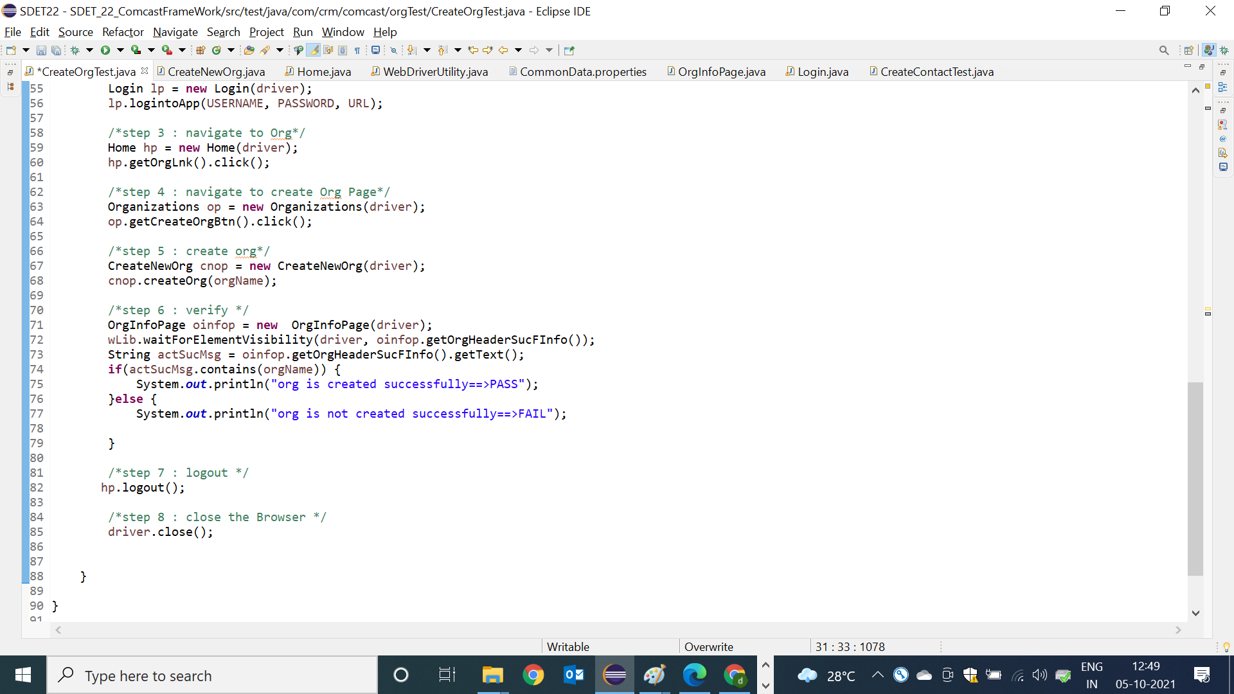

**TESTNG (Unit Testing Framework Tool)**

**Available Unit testing framework tools in Current Market :**

TestNG ------------> Java, .Net [Eclipse / JDevelopers / Intellj ]

Junit -------> Java [Eclipse / JDevelopers / Intellj ]

Nunit ---------> .Net [Visual Studio]

Pydev --------> Python [PyChram]

Rspsc ----------> Rubby [Eclipse]

Jasmin 🡺 javascript [WebStrom ]

All unit testing framework tool is implemented as plugin for eclipse IDE, but Junit is a default plugin for eclipse IDE.

**What is testNG ?**

🡺TestNG is a unit test **TDD**[test Driven Development ] framework , which support java & .Net

**🡺**TestNG is an open source unit test framework, where NG stands for **Next Generation**.

🡺TestNg developed as addition plugin for Eclipse

🡺TestNG is inspired from JUNIT & NUNIT, it means it as all the feature of Nunit & Junit & also contains addition features that makes TestNg become more powerFull

**Installation steps of TestNG:**

Go to Eclipse window

Click on help option-> Eclipse Marketplace

* Write TestNG in find edit box and click on go button.
* Find TestNG for eclipse division and click on **install** button
* Click on confirm button and I accept the terms and conditions and click on finish
* **In order to verify the** TestNG installation- 🡪 Go to windows

🡪 Show view 🡪 others 🡪expand java folder, TestNG symbol will be present

**TestNG usage in development:**

TestNG is used in development to write white box/ unit test cases and each unit test case will be used to test the source code of the application

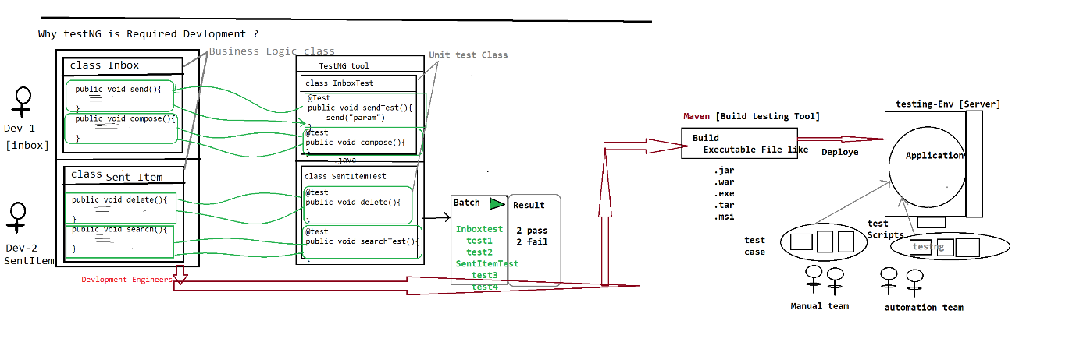

🡺In case of development, testNG will used to develop unit test cases and each unit test case check the business logic of the source code.

🡺Used to achieve WBT

**TestNG usage in selenium automation**

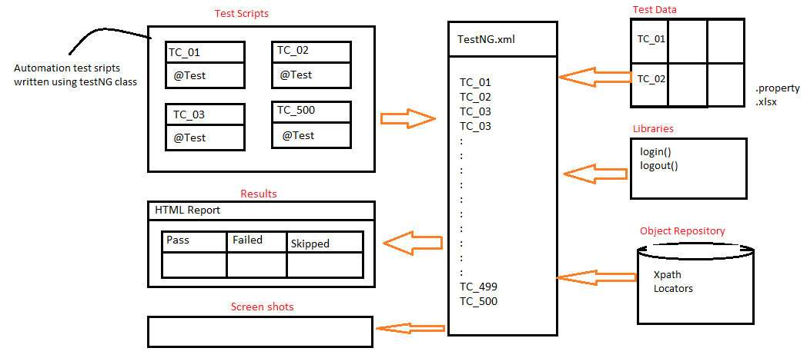

🡺In case of automation, testNG will be used to develop all the scripts using testNG annotations and achieve batch execution without any manual interaction.

🡺TestNG will be used to handle all framework component & help us to run all the test scripts in batch / parallel / group without any manual intervention

🡺TestNG.xml is main controller of the selenium framework , where we start the execution

**Why TestNG ? Why not Junit ?**

* **Annotation**
* **Batch Execution**
* **Assesrtions**

**New functionalities are:**

->Html report

->Parallel execution

->Grouping execution

->Additional annotations

->batch execution is easier

-> iTest Listeners [used to take ScrrenShot]

->Retry Analyser [used to rerun the failed test script]

**Annotations:**

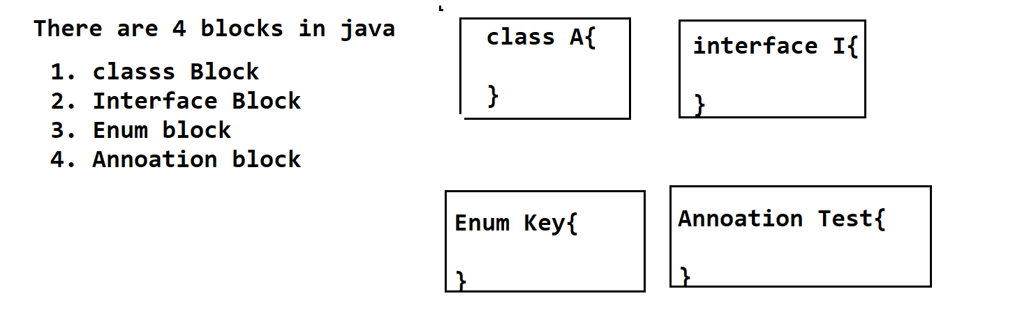

Its Java block , which is used to provide metadata(information/instruction ) to the JVM , at the time of execution in RUN-Time.

* Annotation always start with @symbol
* @Test
* @BeforeMethod
* @AfterMethod
* @BeforeClass
* @AfterClass
* @BeforeTest
* @AfterTest
* @paramaters
* @dataProvider
* @Listner

===================

**@Test**

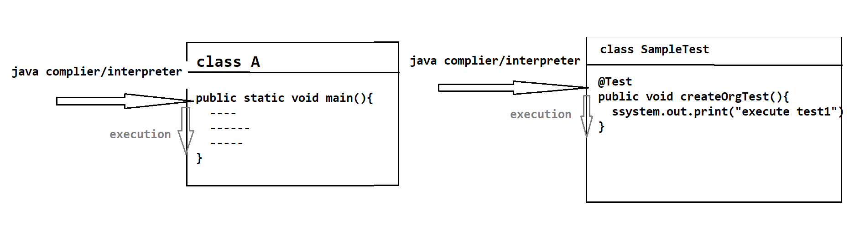

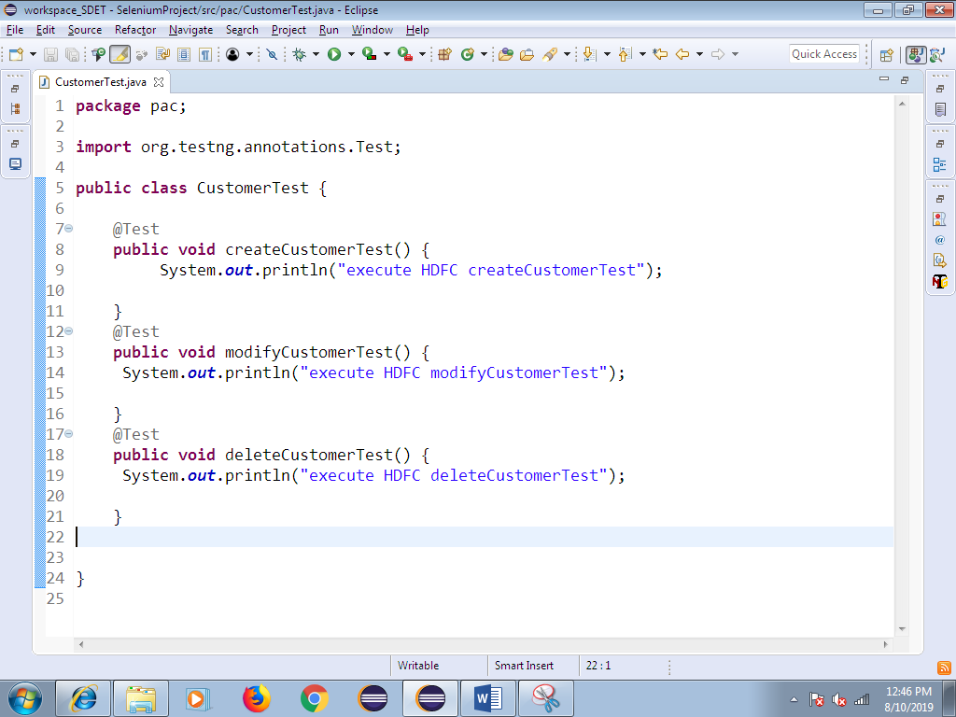

1. Whenever we execute testng class, javaCompiler/Interpeter always looks for @Test Annotation method to start the execution.
2. **Without @Test , testNG class will not be executed, @test annotation method act like main method in testNG**
3. In one testng class we can have multiple @test methods, but each test method should have @Test annotation before method signature.
4. Annotation method return type should be “void” and access specifier should be public., but method name can be anything.
5. As per the Rule of the Automation , TESTNG class Name should be ModuleNAme , @test method name should be manual testCase Name
6. As per the Rule TestNG class Name & testNG method Name should end With “Test”
7. One Manual test case contains multiple steps all those steps should be automated using one @test annotation & test name should be manual test-case Name & end with Test

**How to Verify html report**

Refresh the project after execution—select project right click and click on refresh

Automatically we get **test-Output** folder within the same project.

Expand test-output folder 🡪 select emailable.html and right click 🡪 open with🡪 Open with browser

**Priority**

Whenever we execute testNG class , bydefault all the test method will be executed based on Alphabetical Order , in order the change the Order of Execution , we go for priority

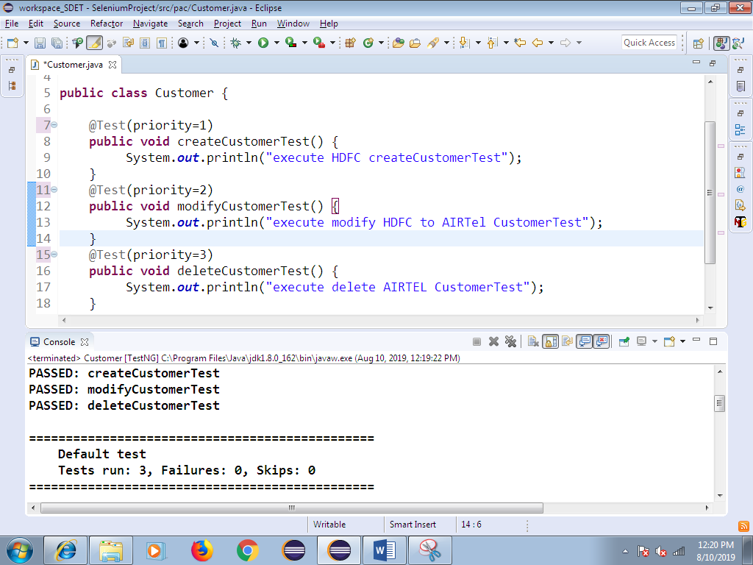

**DependsOnMethod :**

Its help us to check the dependent test case is pass or fail,

If dependent test-script get pass, execution will continue

If dependent test-script get fail, skip the test execution

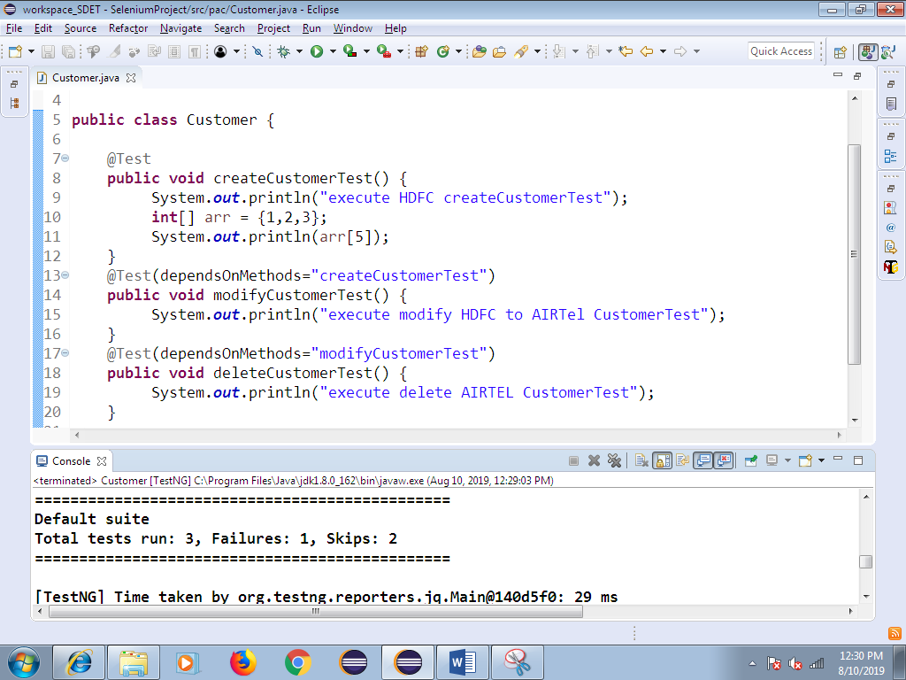

**10. Invocation Count:**

Same test-script executed with multiple Times with same test data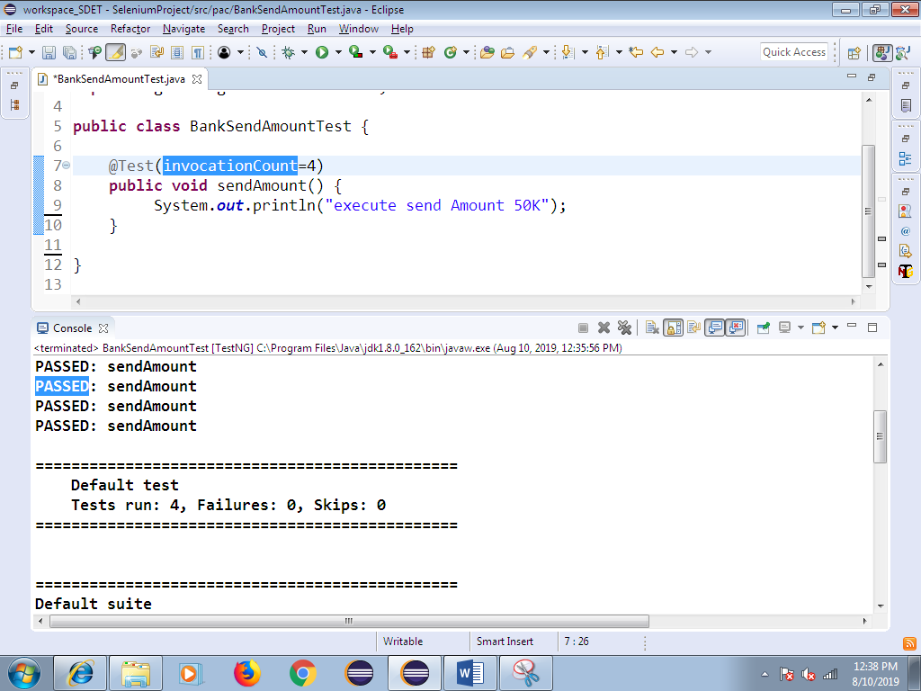

1. **. Data Provider**
2. In Order to execute same test case multiple Times with different test Data , we go for @DataProvider annotataion
3. Data Provider annotation always return TWO –DIMENSTINAL Object array
4. Data Provider annotation help us to execute same test multiple times with the different set of data , each test-script should have dedicated @dataprovider annotation
5. DataProvider annotation play major role in Data driven framework , where we need to test tha application with huge amount of data like Ecommerce , banking application
6. In Below example , row count is 5 🡺 it indicates test needs to be executed 5 times

Column count is 2🡺 it indicates every iteration 2 arguments will be passed

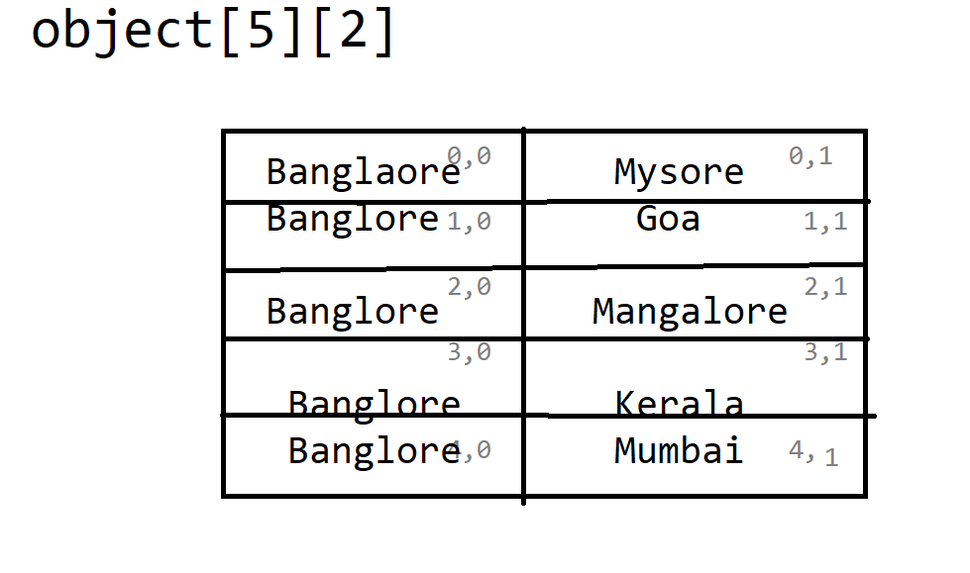

**🡺Sample program for data provider**

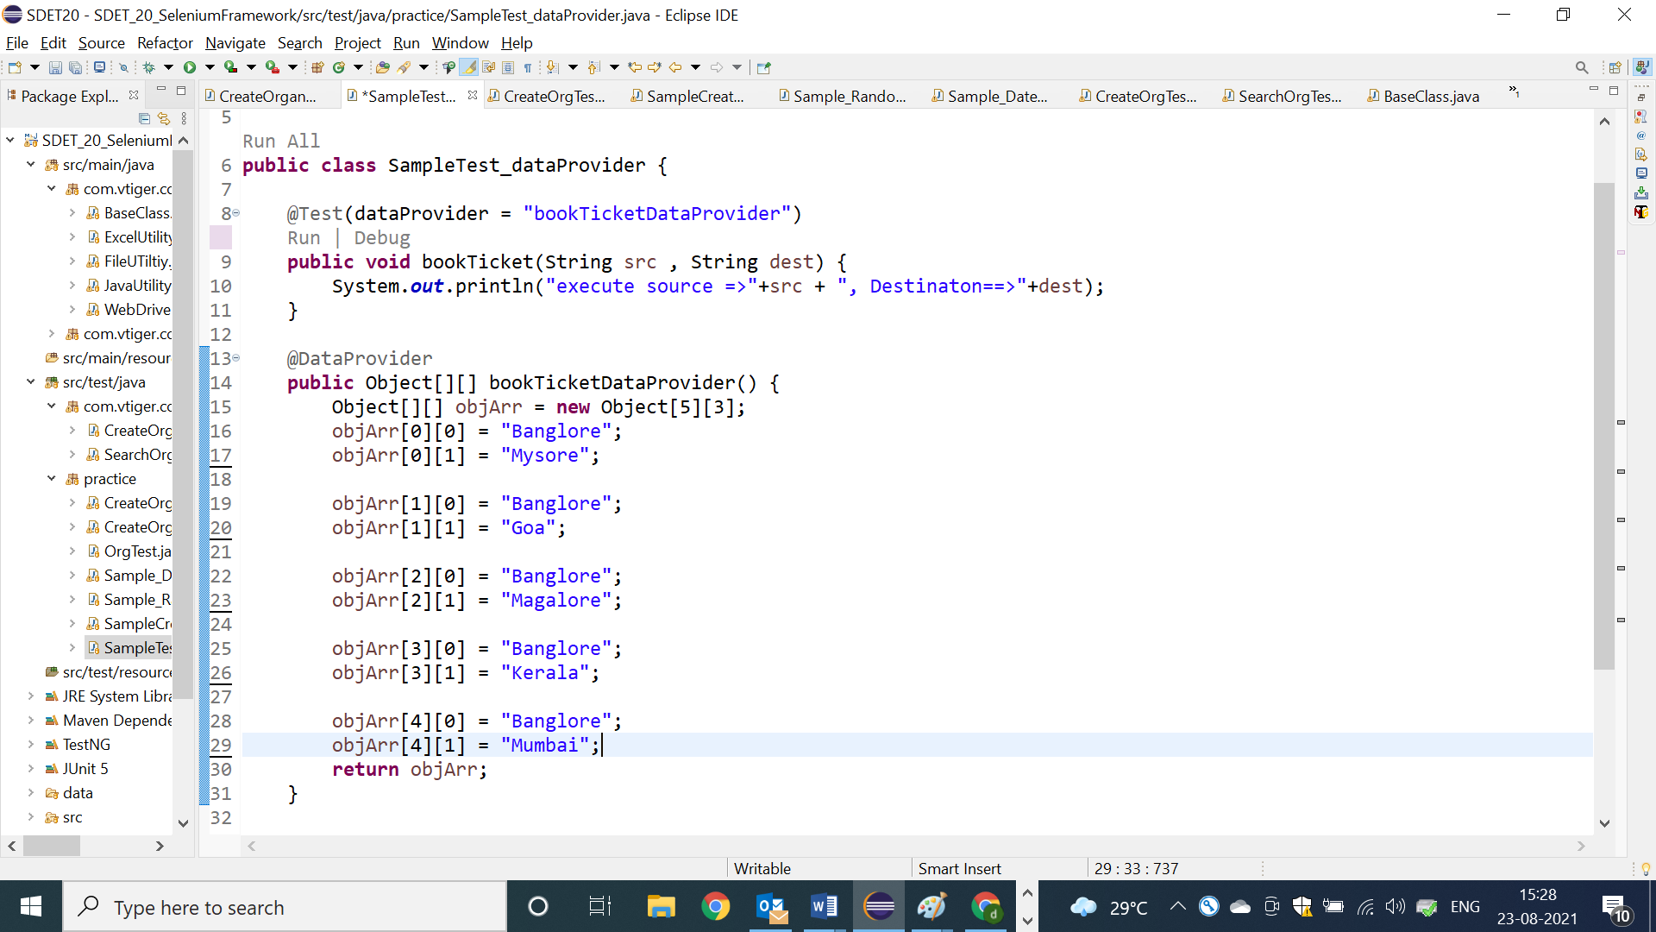

**🡺Data provider example with 3 arguments**

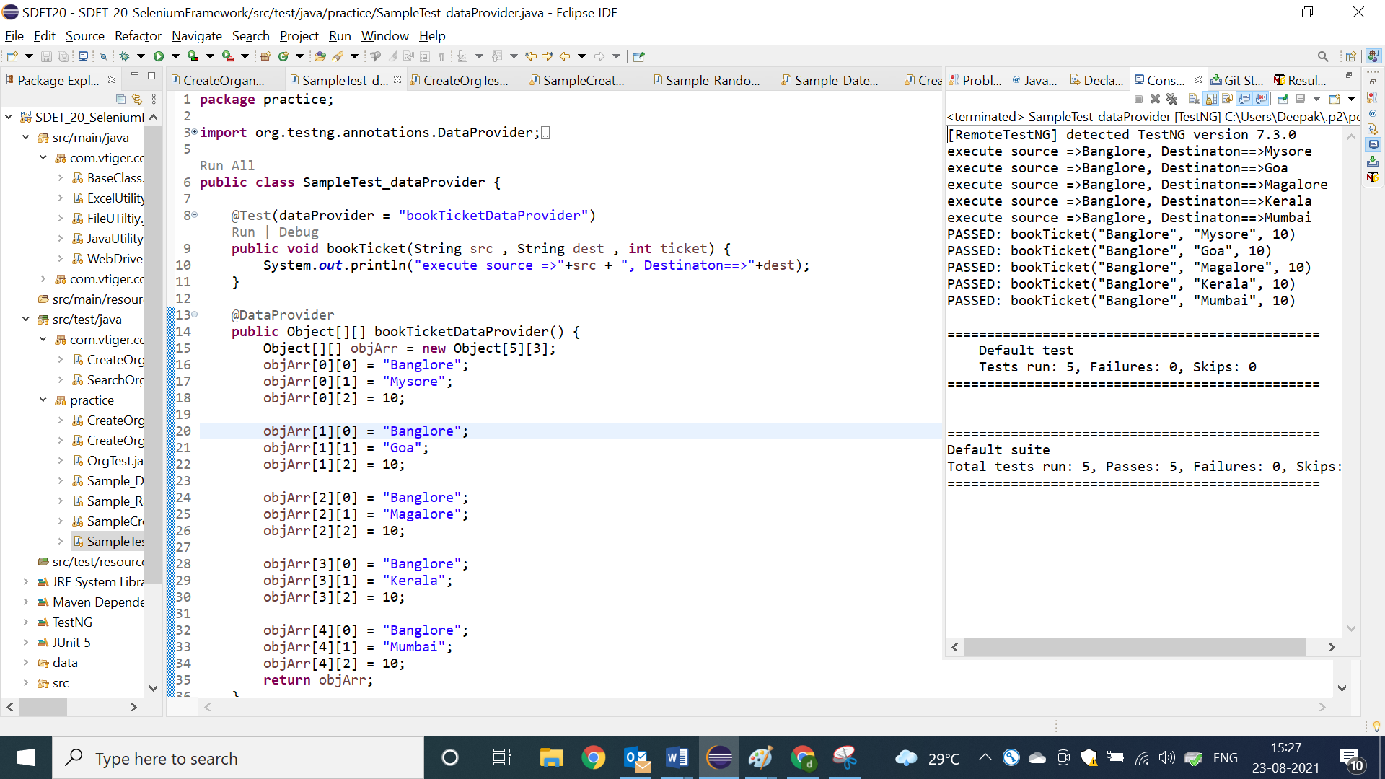

**@BeforeMethod @AfterMethod**

1. Before method annotations will be executed, before executing each @test method in a class
2. After method annotation will be executed, after executing each @test in a class
3. Beforemethod & aftermethod will not be executed, without @test annotation method, because they are configaration method
4. In order to implement similar pre- condition for all the testcase like “LOGIN code ” we go for @BM
5. In order to implement similar post-condition for all the testcase like “LOGOUT code ” we go for @AM

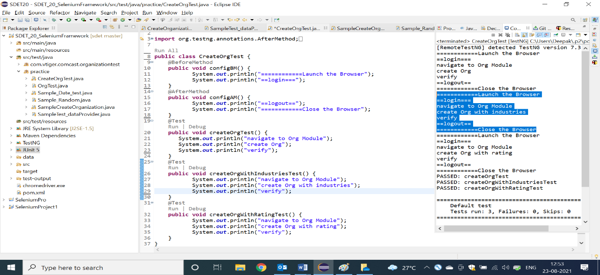

**@BeforeClass & @Afterclass**

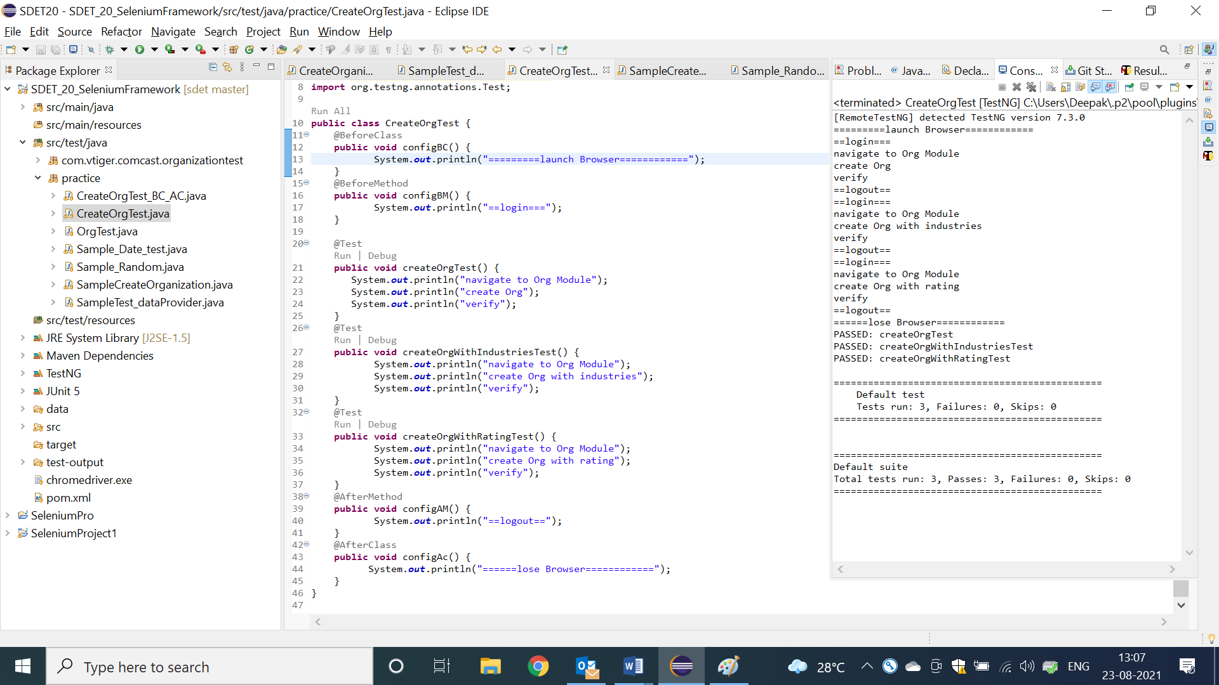

1. BeforeClass Annotation method will be executed, before Executing first @test in a class
2. AfterClass Annotation method will be executed, after executing all/last test-case with in a class
3. BeforeClass & AfterClass annotations will be executed only once in a entire class execution.
4. It will be used to develop global configuration like launch browser, object initialization

NOTE: As per the Rule of the Automation , test case should not be have dependency between one to another test , every testcase should be unique (it means every test should have fresh login & logout code )

**ConFig Annotation methods Usage in REAL Selenium Framework**

1. In Real selenium FrameWork , all the configure annotation will be implemented

Inside the BaseClass, that is being shared all the Automation engineers via GITGUB

1. BaseClass should be available in generic libraries package.
2. As per the Rule , Every testScripts class should extend BaseClass, so that all the configure annotation will be inherited to the test scripts automatically

**Advantages :**

1. Code Reusability
2. Code Optimization
3. Modification is easy
4. Maintenance is easy
5. Test Development is faster

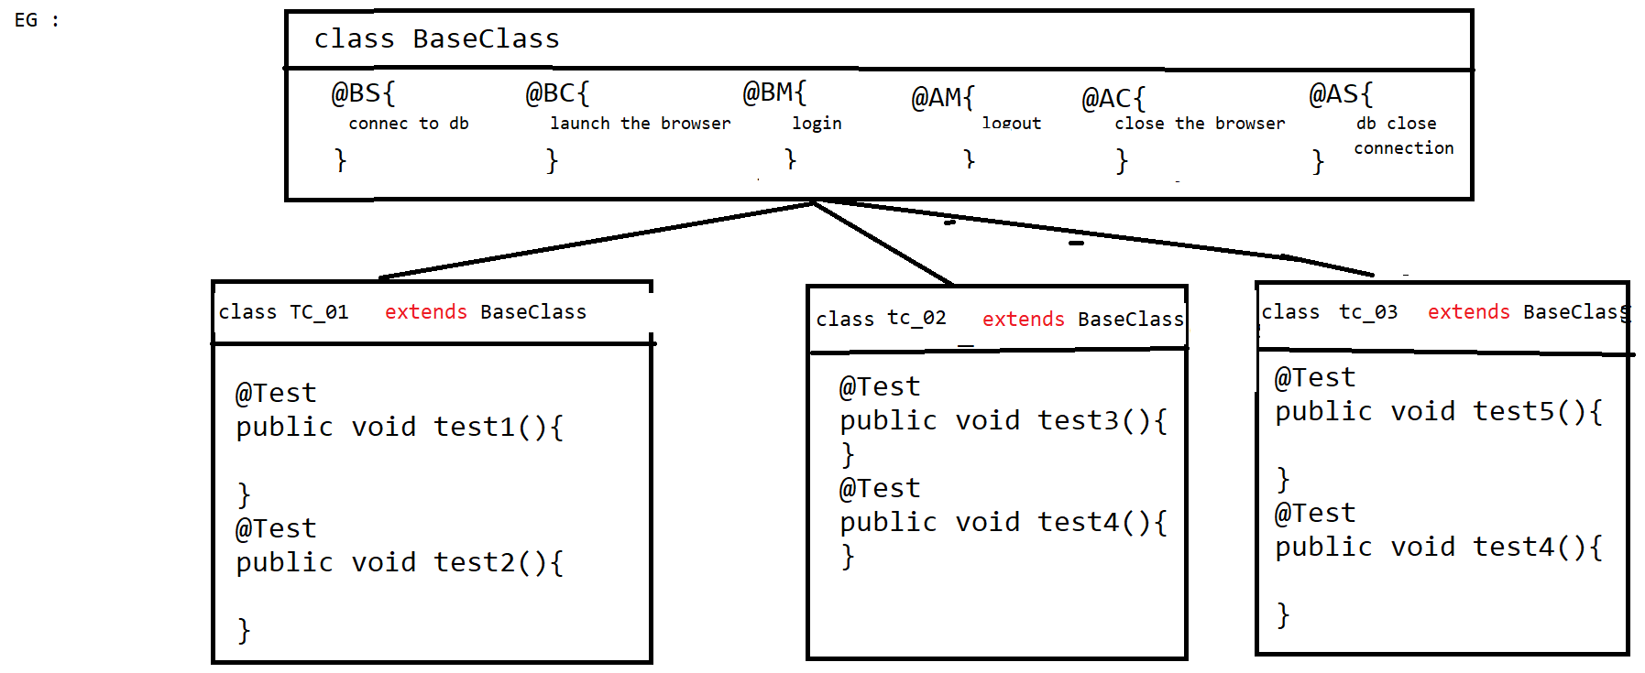

**Project Structure in Eclipse**

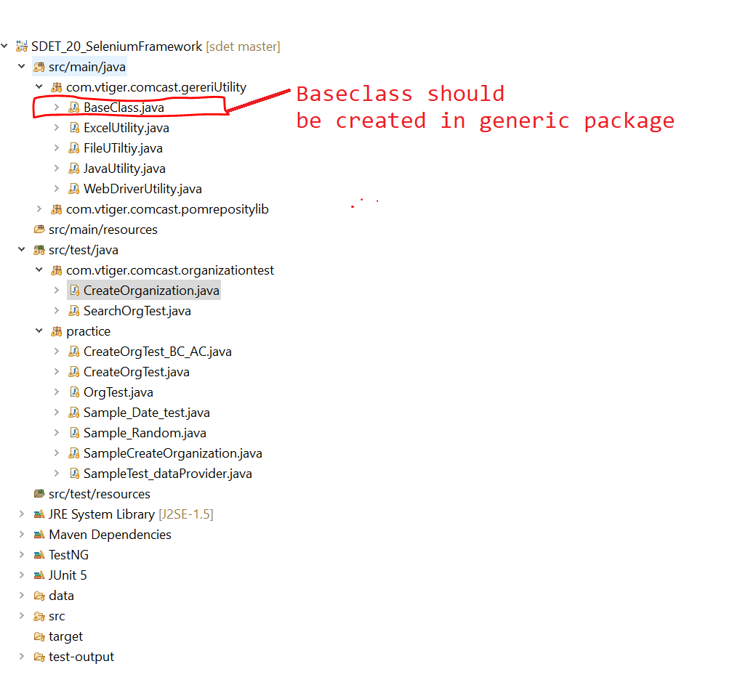

**=========Base class Program=============**

**package** com.vtiger.comcast.gereriUtility;

**import** org.openqa.selenium.WebDriver;

**import** org.openqa.selenium.chrome.ChromeDriver;

**import** org.testng.annotations.AfterClass;

**import** org.testng.annotations.AfterMethod;

**import** org.testng.annotations.AfterSuite;

**import** org.testng.annotations.BeforeClass;

**import** org.testng.annotations.BeforeMethod;

**import** org.testng.annotations.BeforeSuite;

**import** com.vtiger.comcast.pomrepositylib.Home;

**import** com.vtiger.comcast.pomrepositylib.Login;

**public** **class** BaseClass {

**public** WebDriver driver;

/*Object Creation for Lib*/

**public** JavaUtility jLib = **new** JavaUtility();

**public** WebDriverUtility wLib = **new** WebDriverUtility();

**public** FileUTiltiy fLib = **new** FileUTiltiy();

**public** ExcelUtility eLib = **new** ExcelUtility();

@BeforeSuite

**public** **void** configBS() {

System.***out***.println("========================connect to DB========================");

}

@BeforeClass

**public** **void** configBC() {

System.***out***.println("=============Launch the Browser=======");

driver = **new** ChromeDriver();

wLib.waitUntilPageLoad(driver);

driver.manage().window().maximize();

}

@BeforeMethod

**public** **void** configBM() **throws** Throwable {

/*common Data*/

String USERNAME = fLib.getPropertyKeyValue("username");

String PASSWORD = fLib.getPropertyKeyValue("password");

String URL = fLib.getPropertyKeyValue("url");

String BROWSER = fLib.getPropertyKeyValue("browser");

/* Navigate to app*/

driver.get(URL);

/* step 1 : login */

Login loginPage = **new** Login(driver);

loginPage.loginToApp(USERNAME, PASSWORD);

}

@AfterMethod

**public** **void** configAM() {

/*step 6 : logout*/

Home homePage = **new** Home(driver);

homePage.logout();

}

@AfterClass

**public** **void** configAC() {

System.***out***.println("=============Close the Browser=======");

driver.quit();

}

@AfterSuite

**public** **void** configAS() {

System.***out***.println("========================close DB========================");

}

}

=============Sample Test Script code using base class==============

**package** com.vtiger.comcast.organizationtest;

**import** org.testng.annotations.Test;

**import** com.vtiger.comcast.gereriUtility.BaseClass;

**import** com.vtiger.comcast.pomrepositylib.CreateNewOrganization;

**import** com.vtiger.comcast.pomrepositylib.Home;

**import** com.vtiger.comcast.pomrepositylib.OrganizationInfo;

**import** com.vtiger.comcast.pomrepositylib.Organizations;

**public** **class** CreateOrganization **extends** BaseClass{

@Test

**public** **void** createOrgTest() **throws** Throwable {

**int** randomInt = jLib.getRanDomNumber();

/*test script Data*/

String orgName = eLib.getDataFromExcel("Sheet1", 1, 2) + randomInt;

/*step 2 : navigate to organization*/

Home homePage = **new** Home(driver);

homePage.getOrganizationLnk().click();

/*step 3 : navigate to "create new organization"page by click on "+" image */

Organizations orgPage = **new** Organizations(driver);

orgPage.getCreateOrgImg().click();

/*step 4 : create organization*/

CreateNewOrganization cno = **new** CreateNewOrganization(driver);

cno.createOrg(orgName);

/*step 5 : verify the successful msg with org name*/

OrganizationInfo orginfoPage = **new** OrganizationInfo(driver);

String actSuccesfullMg = orginfoPage.getSuccesfullMsg().getText();

**if**(actSuccesfullMg.contains(orgName)) {

System.***out***.println(orgName + "==>created successfully");

}**else** {

System.***out***.println(orgName + "==> not created successfully");

}

}

@Test

**public** **void** createOrgWithIndutriesTest() **throws** Throwable {

/*test script Data*/

**int** randomInt = jLib.getRanDomNumber();

String orgName = eLib.getDataFromExcel("Sheet1", 4, 2) + randomInt;

String industriesType = eLib.getDataFromExcel("Sheet1", 4, 3);

/*step 2 : navigate to organization*/

Home homePage = **new** Home(driver);

homePage.getOrganizationLnk().click();

/*step 3 : navigate to "create new organization"page by click on "+" image */

Organizations orgPage = **new** Organizations(driver);

orgPage.getCreateOrgImg().click();

/*step 4 : create organization*/

CreateNewOrganization cno = **new** CreateNewOrganization(driver);

cno.createOrg(orgName, industriesType);

/*verify orgname & industry */

OrganizationInfo orginfoPage = **new** OrganizationInfo(driver);

String actSuccesfullMg = orginfoPage.getSuccesfullMsg().getText();

**if**(actSuccesfullMg.contains(orgName)) {

System.***out***.println(orgName + "==>created successfully");

}**else** {

System.***out***.println(orgName + "==> not created successfully");

}

String actIndustryType = orginfoPage.getIndutryTypeInfo().getText();

**if**(actIndustryType.equals(industriesType)) {

System.***out***.println(industriesType + "==>industry is verified successfully");

}**else** {

System.***out***.println(industriesType + "==>industry is not verified successfully");

}

}

@Test

**public** **void** createOrgWithRatingTest() **throws** Throwable {

/*test script Data*/

**int** randomInt = jLib.getRanDomNumber();

String orgName = eLib.getDataFromExcel("Sheet1", 7, 2) + randomInt;

String rating = eLib.getDataFromExcel("Sheet1", 7, 3);

/*step 2 : navigate to organization*/

Home homePage = **new** Home(driver);

homePage.getOrganizationLnk().click();

/*step 3 : navigate to "create new organization"page by click on "+" image */

Organizations orgPage = **new** Organizations(driver);

orgPage.getCreateOrgImg().click();

/*step 4 : create organization*/

CreateNewOrganization cno = **new** CreateNewOrganization(driver);

cno.createOrg(orgName, rating, **true**);

/*verify orgname & industry */

OrganizationInfo orginfoPage = **new** OrganizationInfo(driver);

String actSuccesfullMg = orginfoPage.getSuccesfullMsg().getText();

**if**(actSuccesfullMg.contains(orgName)) {

System.***out***.println(orgName + "==>created successfully");

}**else** {

System.***out***.println(orgName + "==> not created successfully");

}

String actRatingType = orginfoPage.getRatingTypeInfo().getText();

**if**(actRatingType.equals(rating)) {

System.***out***.println(rating + "==>industry is verified successfully");

}**else** {

System.***out***.println(rating + "==>industry is not verified successfully");

}

}

}

**Batch Execution**

* Collection of multiple test script is called batch, execute multiple test script through xml in a single click is called batch execution.
* In order to achieve batch execution, we go for Testng.xml configuration file
* TestNG xml file always start with suite xml tag fallowed by <test> and <classes.>
* In one xml file we can invoke N-number of testng classes, but all the classes should be present within a project.
* All the class should fallowed by packageNAme

EG :

<class name=”com.comcast.orgtest.CreateOrg”></class>

**How to create testNG xml file automatically through eclipse?**

Select all the testNG classes or packages -> right click-> select🡺 testNG 🡺and click on “Convert to testing” and🡺 click on finish.

* Automatically you will get the testng.xml file with in the project
* In order to edit xml File🡺 double click on testing.xml🡺 click on “Source”

**Batch Execution : [Full regression testing]**

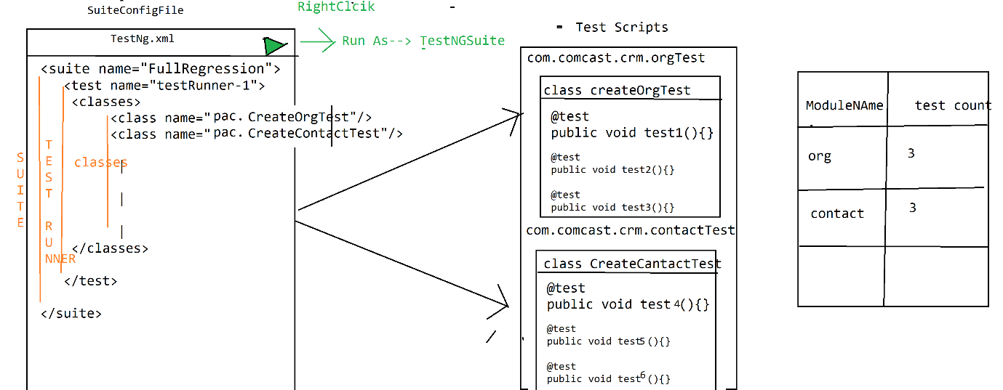

**Grouping Execution:**

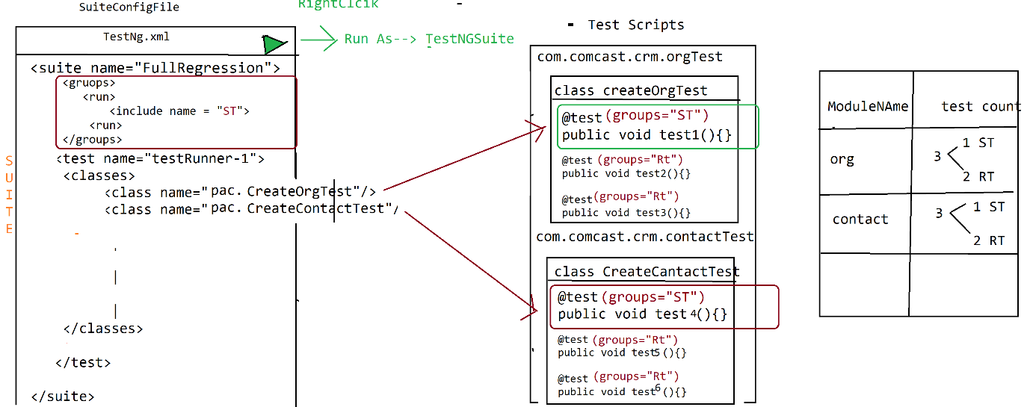

* Collection of similar test scripts across the testing classes is called grouping Execution
* In order achieve grouping execution , each & every test script should have group name, group name will be written along with annotation
* In grouping execution, all configure annotation should have group name , other wise those annotation will not participate in grouping execution like

@BeforeSuite @BeforeClass , @BeforeMethode etc

EG :

@BeforeSuite(groups = {"smokeTest","regressionTest"})

**public** **void** configBS() {

System.***out***.println("======Execute BeforeSuite=============");

}

**Smoke Test:**

@Test(groups={"smokeTest"})

**public** **void** createCustomerTest()

{

System.***out***.println("execute createCustomerTest");

}

@Test(groups={"regressionTest")

**public** **void** modifyCustomerTest()

{

System.***out***.println("execute modifyCustomerTest");

}

* In order to invoke grouping execution should declare Group Key in testing.xml file

& group keep should be declared before <test>, after <suite> tag

**Smoke Test:**

<suite name=*"Suite"*>

<groups>

<run>

<include name=*"smokeTest"*/>

</run>

</groups>

<test name=*"Test"*>

<classes>

<class name=*"pac1.ProjectAndCustomerTest"*/>

<class name=*"pac2.ReportTest"*/>

</classes>

</test>

</suite>

🡺We can invoke multiple groupkey in one XML File

<suite name=*"Suite"*>

<groups>

<run>

<include name=*"smokeTest"*/>

<include name=*"regressionTest"*/>

</run>

</groups>

<test name=*"Test"*>

<classes>

<class name=*"pac1.ProjectAndCustomerTest"*/>

<class name=*"pac2.ReportTest"*/>

</classes>

</test>

🡺One test can have multiple Group name

@Test(groups={"regressionTest","smokeTest"})

**public** **void** modifyCustomerTest()

{

System.***out***.println("execute modifyCustomerTest");

}

**Regional Regression Test:**

🡺To execute particular test cases across the Suite is called regional regression testing

🡺in Real time , impact area is given bu developer / test lead , based on that idea XML will be created

🡺 Whenever we want execute particular @test method inside class , we go for <method> & <include>

<?xml version=*"1.0"* encoding=*"UTF-8"*?>

<!DOCTYPE suite SYSTEM "https://testng.org/testng-1.0.dtd">

<suite name=*"Suite"*>

<test thread-count=*"5"* name=*"Test"*>

<classes>

<class name=*"com.comcast.crm.contacttest.CreateContactTest"*>

<methods>

<include name=*"createdContactTest"*/>

</methods>

</class>

<class name=*"com.comcast.crm.orgtest.CreateOrgTest"*>

<methods>

<include name=*"createdOrgWithRatingTest"*/>

</methods>

</class>

</classes>

</test> <!-- Test -->

</suite> <!-- Suite -->

**Parallel Execution:**

**There are 3 types of Parallel Execution**

1. **Distributed Parallel execution:**
2. **Cross browser parallel execution**
3. **Cross platform parallel execution**
4. **Distributed Parallel execution:**

🡺Distribute the test case across the multiple test runner & execute each <test>/Test runner in parallel is called Distributed Parallel execution

* we reduce the suite execution time, so that we can get the result early
* in order the archive parallel execution we should enable parallel=”tests” & thread-count=5 in <suite> , then create multiple test runner & distribute the testcase
* maximum thread count is 5
* Thread count should be same as number of <test> testRunner

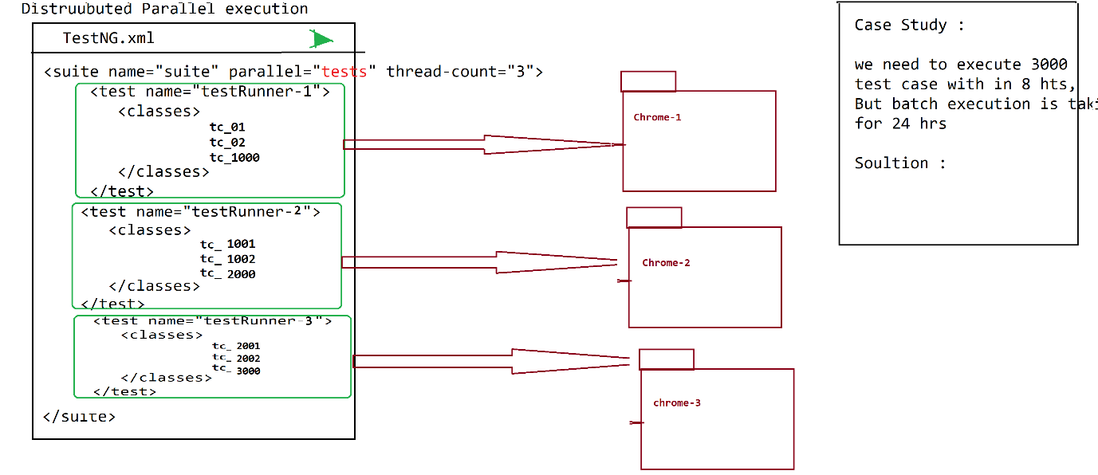

1. **Cross browser parallel execution / Browser Compatibility testing**

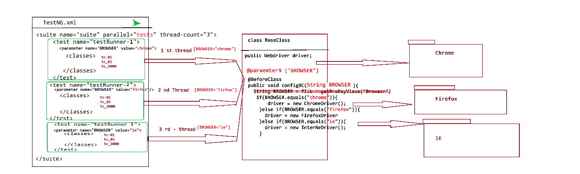

1. Execute same set of testcase in different Browser parallel is called cross browser testing
2. To achieve cross browser testing we should we <parameter> in XML file & @parameters annotation inside the testScript

1. **<parameter > is used to specify the browser data for each <test>**

**EG :**

<?xml version=*"1.0"* encoding=*"UTF-8"*?>

<!DOCTYPE suite SYSTEM "https://testng.org/testng-1.0.dtd">

<suite name=*"Suite"* parallel= *"tests"* thread-count=*"2"*>

<test name=*"Test-Runner-Chrome"*>

<parameter name=*"BROWSER"* value=*"chrome"*/>

<classes>

<class name=*"com.vtiger.comcast.organizationtest.CreateOrganization"*/>

<class name=*"com.vtiger.comcast.organizationtest.SearchOrgTest"*/>

</classes>

</test> <!-- Test -->

<test name=*"Test-Runner-Firefox"*>

<parameter name=*"BROWSER"* value=*"firefox"*/>

<classes>

<class name=*"com.vtiger.comcast.organizationtest.CreateOrganization"*/>

<class name=*"com.vtiger.comcast.organizationtest.SearchOrgTest"*/>

</classes>

</test> <!-- Test -->

</suite> <!-- Suite -->

1. @parameters annotation will be used to receive the data (Eg : browser , platform etc) from the XML file to test Scripts [Like BaseClass]

Note : Replace below annotation inside the balseclass

@Parameters("BROWSER")

@BeforeClass

**public** **void** configBC(String BROWSER) {

System.***out***.println("=============Launch the Browser=======");

**if**(BROWSER.equals("chrome")) {

driver = **new** ChromeDriver();

}**else** **if**(BROWSER.equals("firefox")) {

driver = **new** FirefoxDriver();

}**else** **if**(BROWSER.equals("ie")) {

driver = **new** InternetExplorerDriver();

}**else** {

driver = **new** ChromeDriver();

}

wLib.waitUntilPageLoad(driver);

driver.manage().window().maximize();

}

**Assertion / CheckPoint**

* **Assertion is a feature available in TestNG used to validate test scripts expected results**
* **As per the Rule of the automation every expected result should be verified with Assert statements, because java “if else “statement will not have capability to fail the testNG test**

**Scripts**

* **There are 2 types of Assertions in TESTNG**

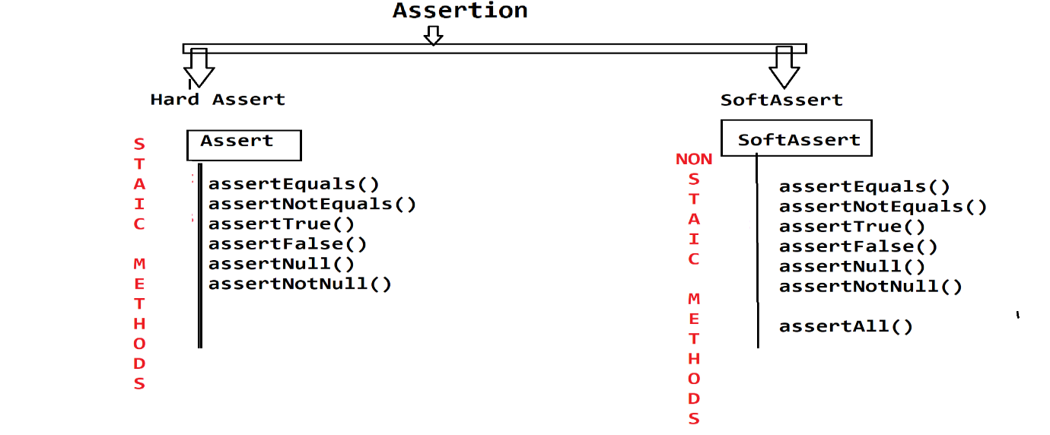

|  |  |
| --- | --- |
| **Hard Assertion** | **Soft Assertion** |
| All methods are static in nature | All methods are non-static in nature |
| It does not allow further execution of test if the line containing hard assert gets failed. | Next steps would be executed even if the line containing soft assertion gets failed. |
| Whole test case gets failed if at least 1 hard assert fails. | AssertAll() extra lines of code are required to track the fail status. |
| To verify mandatory fields we go for hard assert | To verify non mandatory fields we go for soft assert |

**HardAssert**

Whenever hardAssert method fails, testNG generate AssertError exception & stop the current test execution & continue execution with remaining test

@Test

**public** **void** createCustomerTest(){

System.***out***.println("step_1");

System.***out***.println("step_2");

Assert.*assertEquals*("A", "B");

System.***out***.println("step_3");

System.***out***.println("step_4");

}

@Test

**public** **void** modifyCustomerTest() {

System.***out***.println("=============================");

System.***out***.println("step_1");

System.***out***.println("step_2");

System.***out***.println("step_3"); }

OutPut

step_1

step_2

=============================

step_1

step_2

step_3

PASSED: modifyCustomerTest

FAILED: createCustomerTest

java.lang.AssertionError: expected [B] but found [A]

**Soft Assert**

Whenever softAssert mtd fails , testNG Generate AssertError exception & continue execution with remaining steps of same testScript

**public** **void** createCustomerTest(){

System.***out***.println("step_1");

System.***out***.println("step_2");

SoftAssert s = **new** SoftAssert();

s.assertEquals("A", "B");

System.***out***.println("step_3");

s.assertEquals("X", "Y");

System.***out***.println("step_4");

s.assertAll();

}

@Test

**public** **void** modifyCustomerTest(){

System.***out***.println("=============================");

System.***out***.println("step_1");

System.***out***.println("step_2");

System.***out***.println("step_3");

System.***out***.println("step_4");

}

Output

step_1

step_2

step_3

step_4

=============================

step_1

step_2

step_3

step_4

PASSED: modifyCustomerTest

FAILED: createCustomerTest

java.lang.AssertionError: The following asserts failed:

expected [B] but found [A],

expected [Y] but found [X]

**Assertion usage in Real Time**

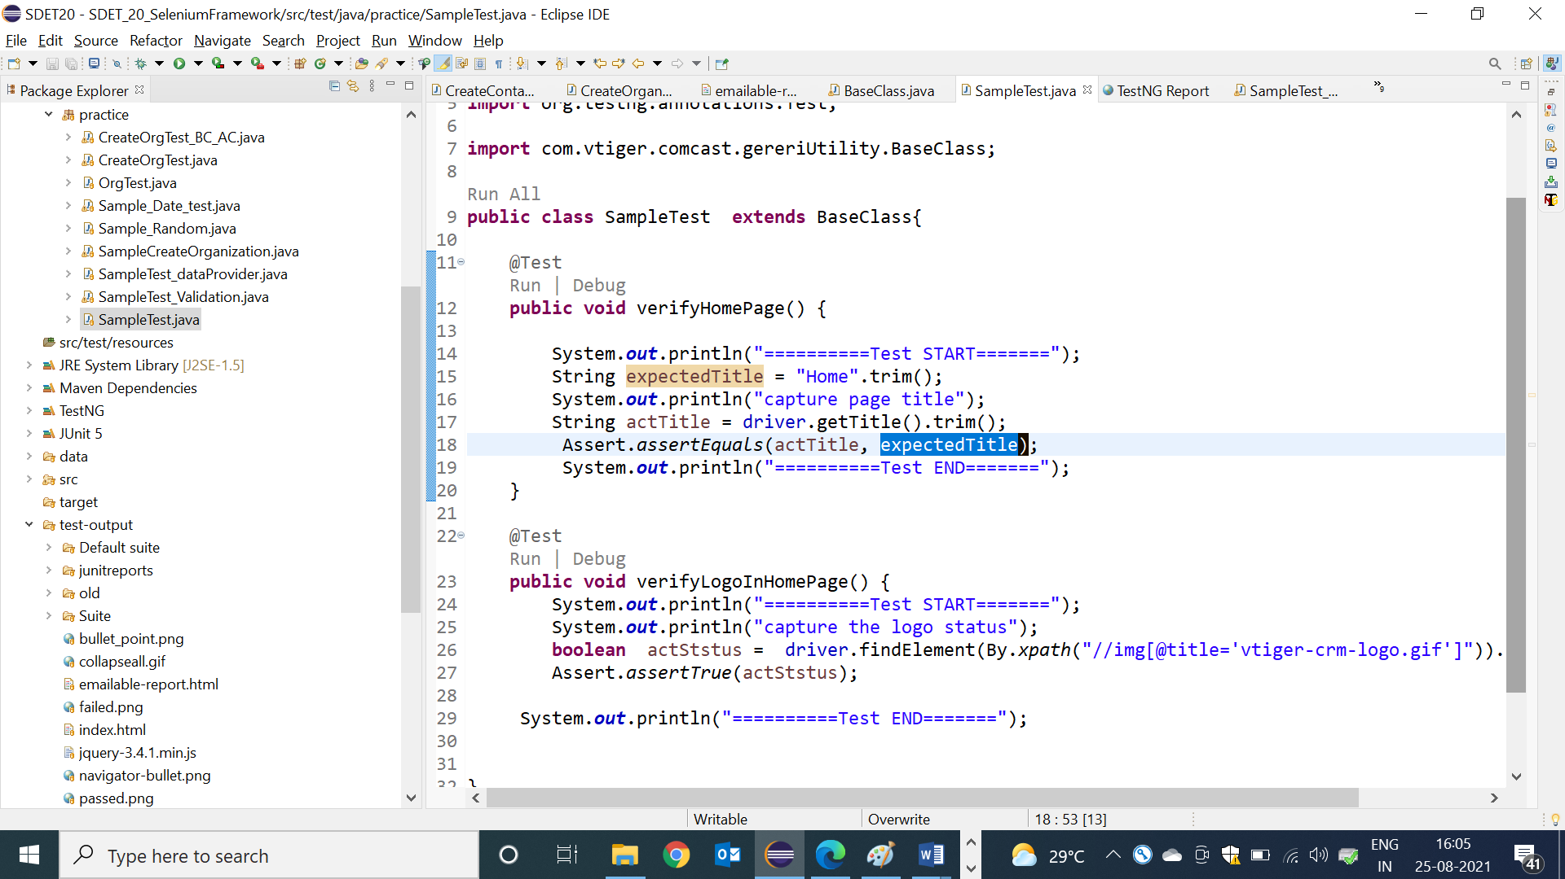

**Advantages of Assertion:**

* It’s used to fail the TESTNG test scripts
* It’s used for test scripts validation
* It’s generate “AssertErrorException” & reason of the failure + failed line number whenever test is failed
* We can compare any 2 primitive variable or array or Collection or MAP in single line

**Screen Shot:** 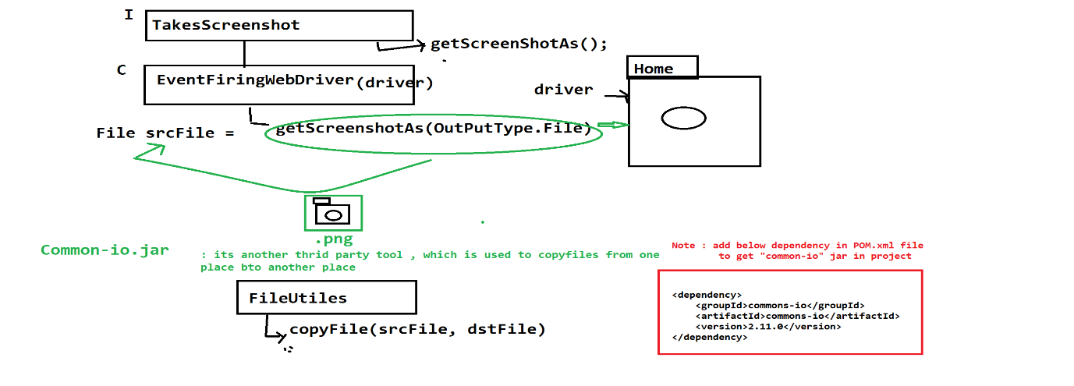

**WebDriver Code to take a Screenshot**

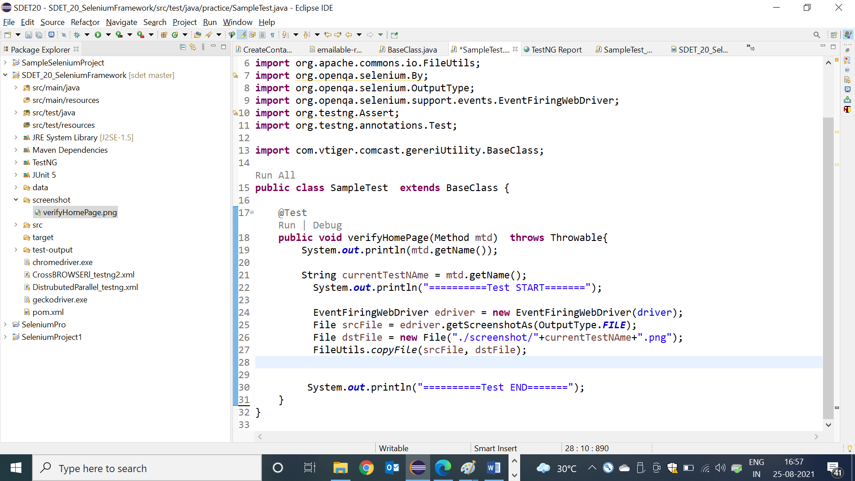

**Listener:**

* Listen is feature available in TESTNG , which is used to capture runtime events during execution & perform appropriate action based on eventtype

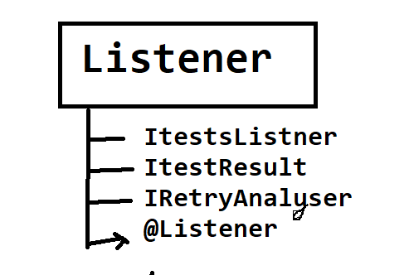

**ITestListener:**

* This is a special feature in testNG which enables the user to take run time events whenever the test scripts fail/pass. Implementation class for ITestListener is mandatory to use Listener feature
* @Listener is testing annotation , which is used to monitor the test execution in the runtime & generate a runtime event to Listener Implementation class , if test is pass / fail
* @Listener annotation will be declared in every testScripts class before class definition block
* ListImplemenation class helps us to receive the failure events from the @Listener & perform appropriate actions

**Advantages of Listener :**

* We can use Listener to take a screenshot for the failed test case, when we execute in bulk
* We can also use Listener for connect to DB , Launch browser & login precondition program
* We can also use Listener for Extend Report Configuration

**Listener Implementation class :**

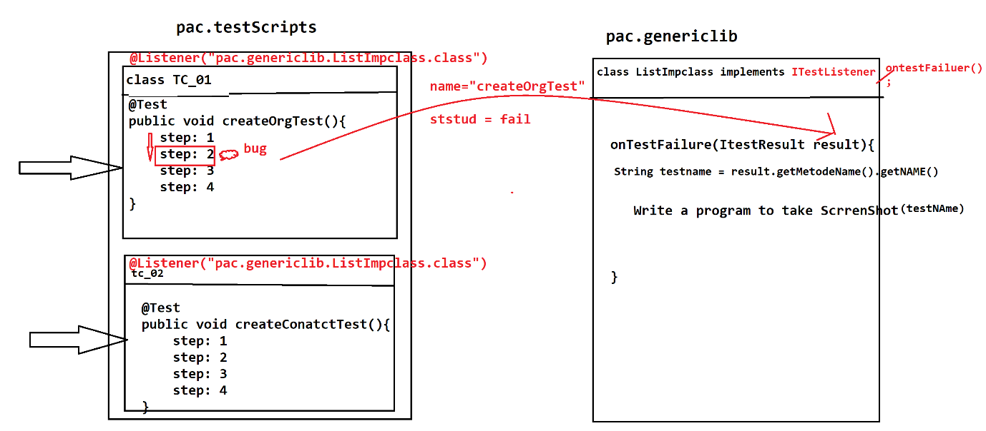

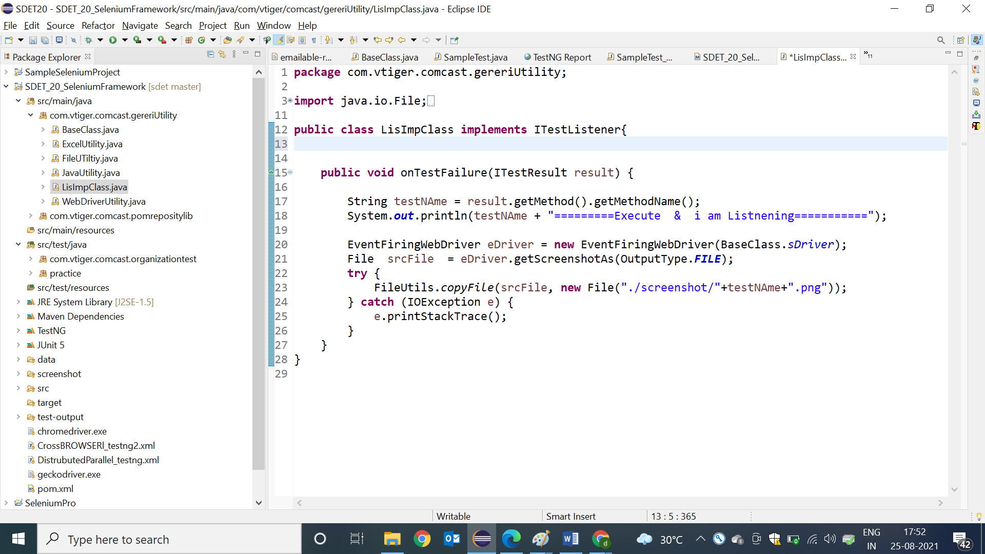

Sample test for Listener :

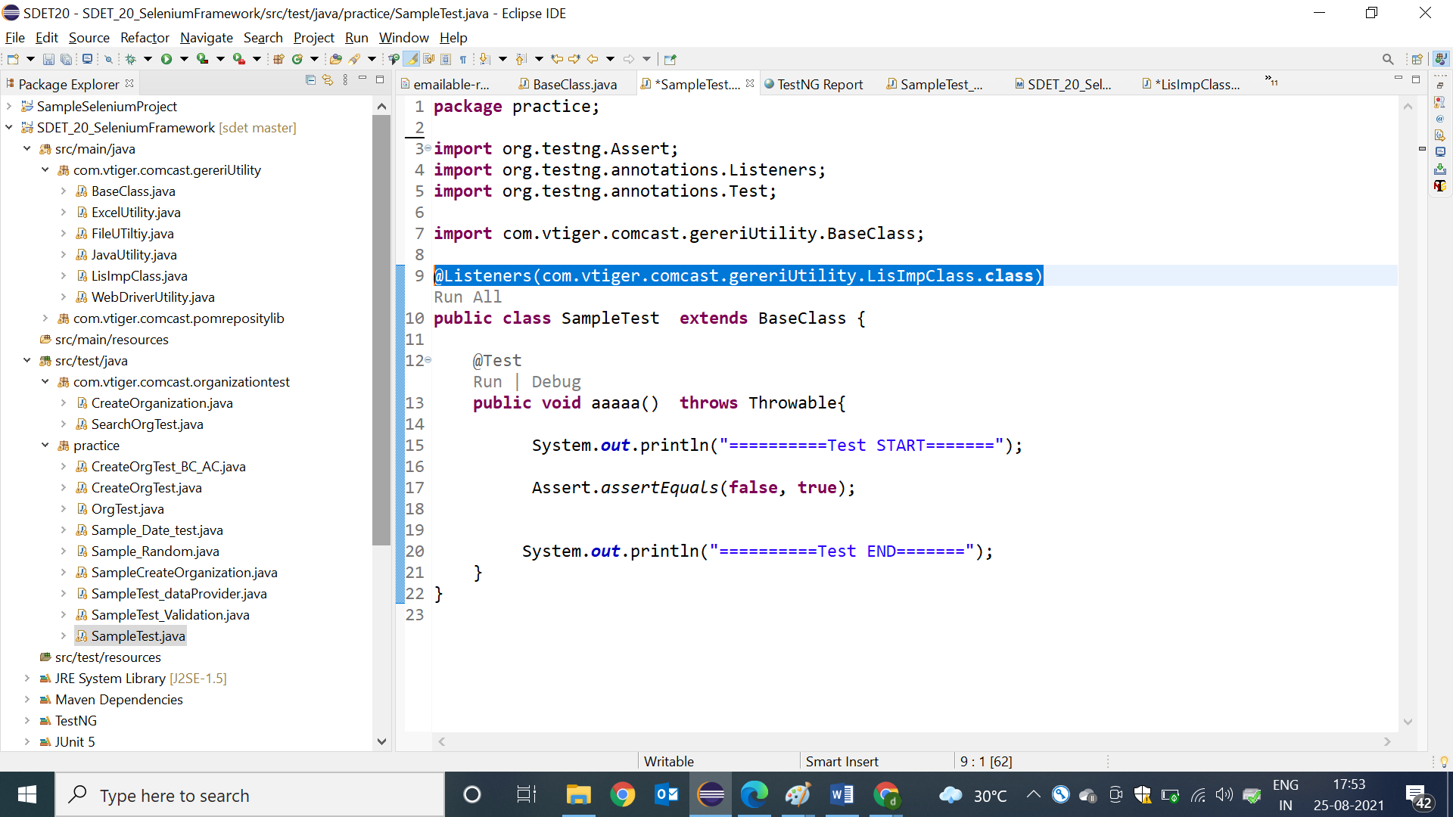

How to use Listener in TestNG.xml

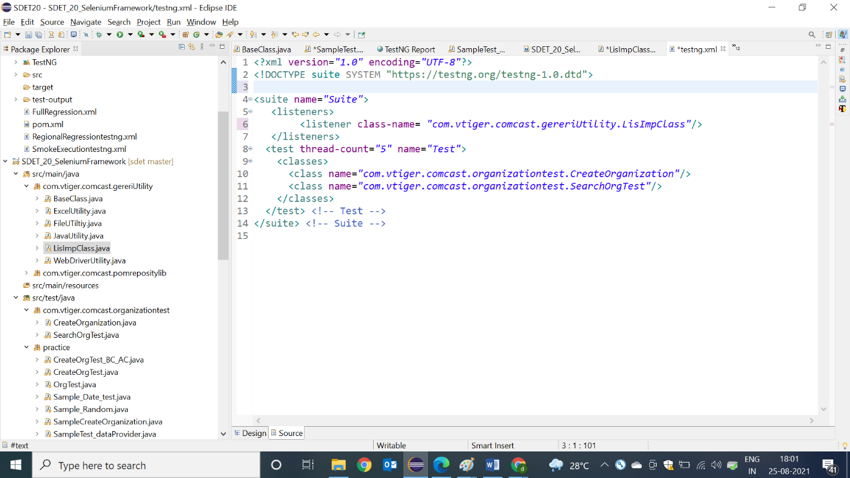

**RetryAnalyzer:**

This feature of TestNG helps the user to rerun the test script. TestNG will this method every time a test script fails. Implementation class for IRetryAnalyser interface is as soon. The retry limit specifies how many times the failed script should rerun

**public** **class** RetryAnalyzer **implements** IRetryAnalyzer{

**int** counter=0;

**int** retrylimit=4;

**public** **boolean** retry(ITestResult result) {

**if**(counter<retrylimit) {

counter++;

**return** **true**;

}

**return** **false**;

}

**GIT**

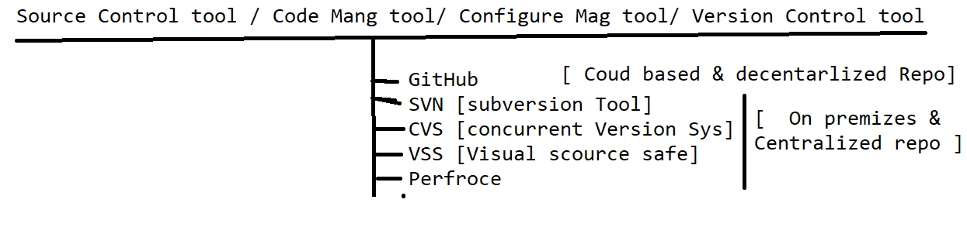

**What is Github**

It’s a distributed cloud decentralized repository where we can maintain our sourceCode / Automation Framwork / CRS doc /build of the application in one place

There are 2 Software in GitRepository

1. Git HUB : Cloud based repository(software) , which is used to maintain the source code ,create an account[https://github.com] in order to use it [no need to install]
2. Git [Git client] : it’s a software should installed in client machine , which is used to communicate to GITHUB
3. EG : Git client Software EGit , GitDeskTop , GitBash

**Advantages of GitHub Cloud**

1. Since its cloud based repository, no need have maintenance team to maintain the Software / HardWare
2. Cloud means pay rent for what you use
3. Cloud software always access via internet
4. Cloud System / server physically not present within the Organization, but present virtually
5. Initial investment is not required for Software/ Physical location
6. Scale UP / Scale Down is easy
7. File Share between the team members is easier
8. It provides remote access, it means anywhere contributors can access via internet
9. Provide History for changes made by users & backup facility
10. GitHub also provide platform to review [pull request] the Code of Automaton test scripts
11. GitHub Also handle the conflict’s
12. Jenkins Always get the latest framework from the Git for batch Execution

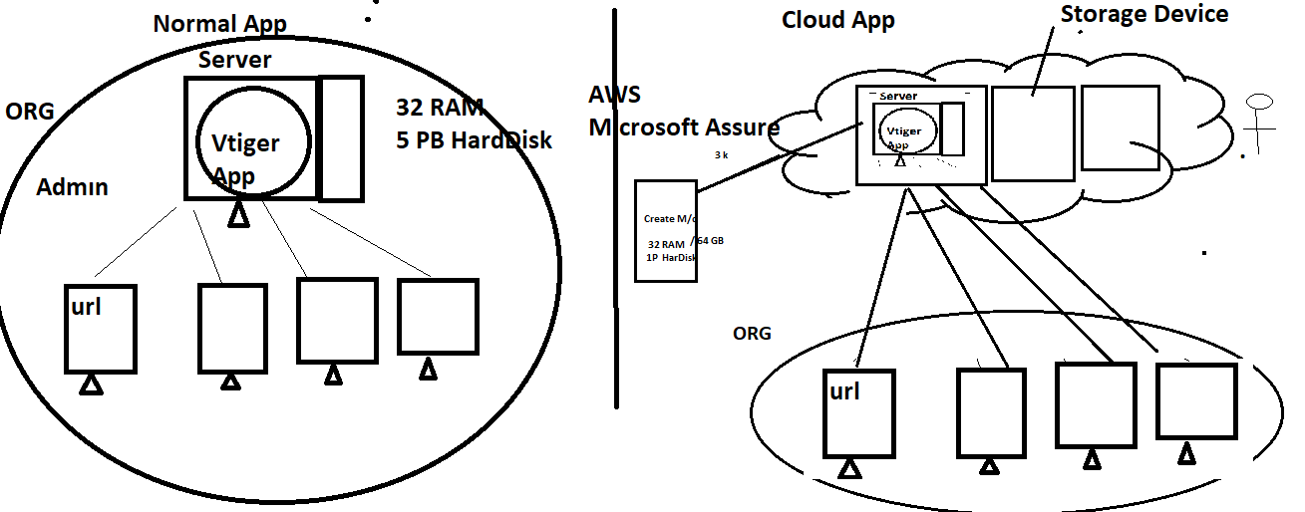

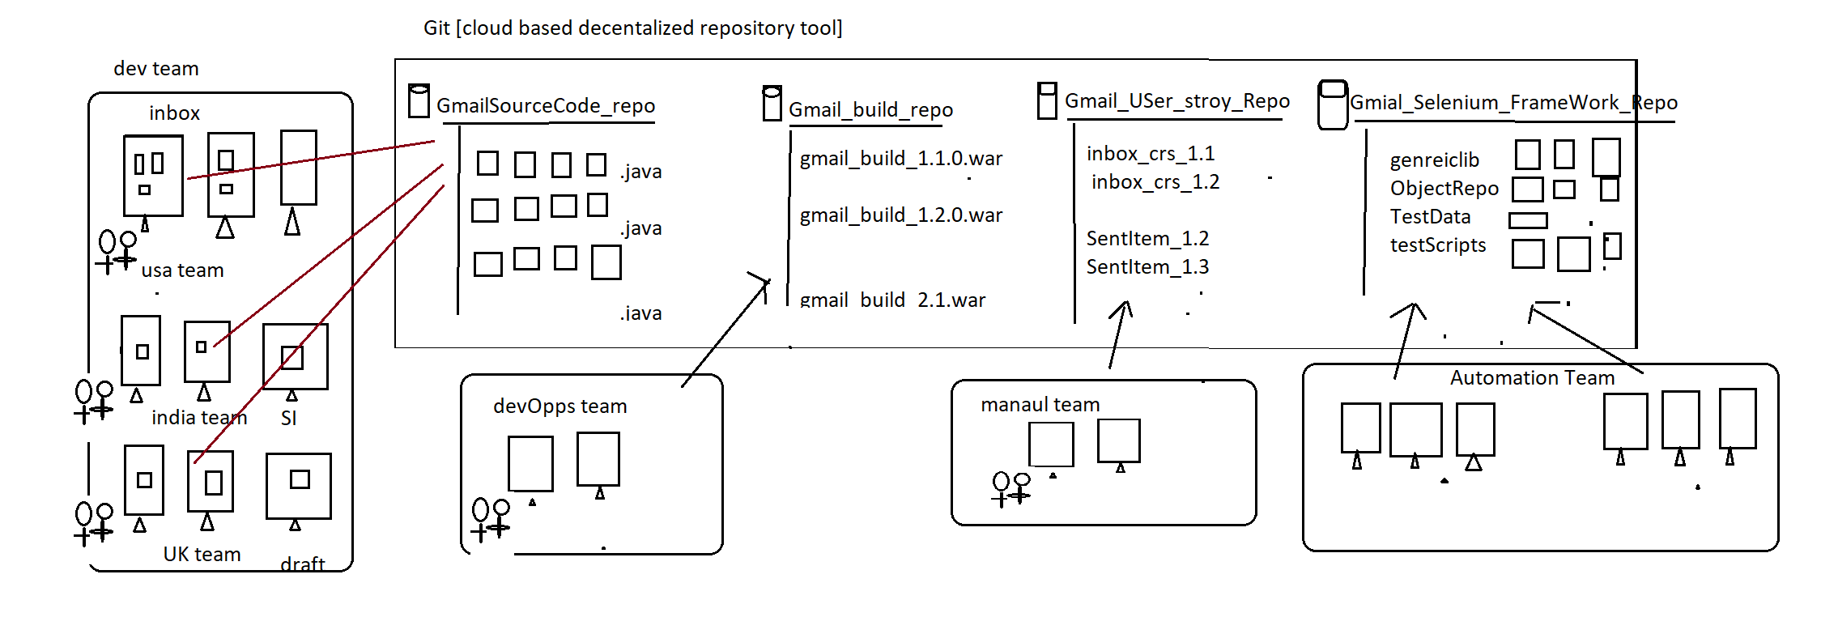

Developer Usage of Git : used to maintain the Source of the Application in one place

Automation Usage of Git : used to maintain the entire Automation framework in one place

DevOps Usage of Git : used to maintain the multiple application build version(like .exe, .war , .tar , .jar etc) in one place

Manual team Usage of Git : used to maintain the entire CRS / use case of the application

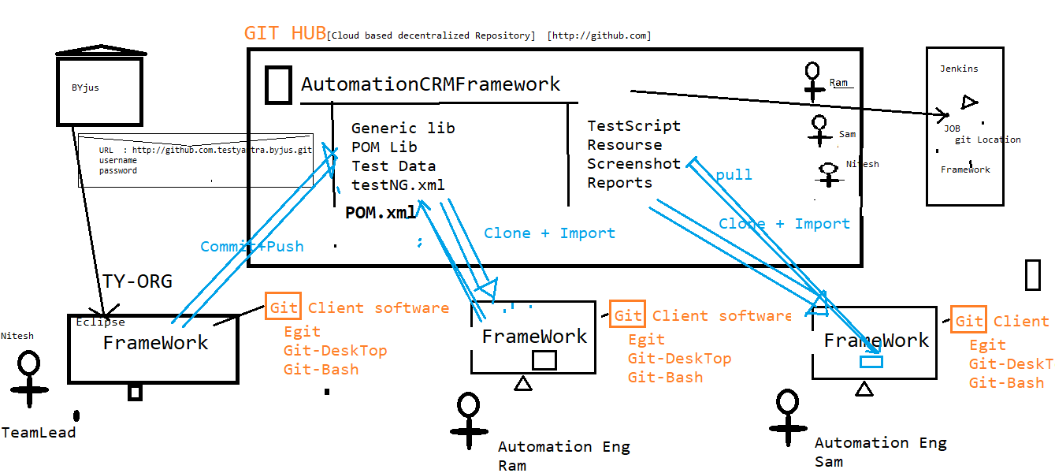

**Git Architecture**

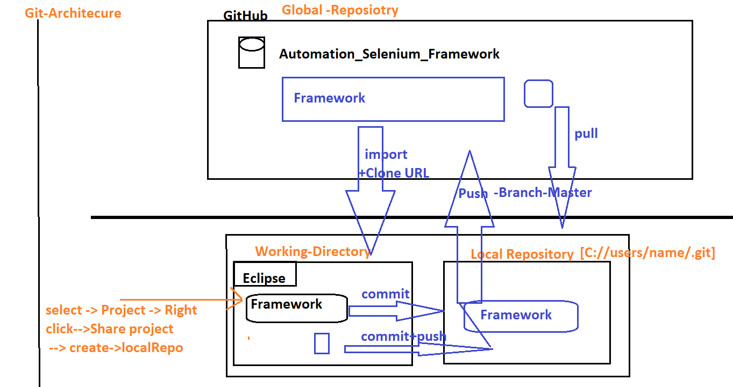

**Why Git is Decentralized Repository?**

Git is Decentralized Repository because, in Git before pushing any Code to git Hub, we have to commit the code to local repository first, make sure code is working in Local Repository then push Code to GITHUB(Global Repo)

* There are Three stages in Git, start with “Working Diretory”🡺Local Repo🡺Global Repo

**What is Git Conflicts**

When two or more engineers modified the same file , when Eng-1 one push the file to GitHub will not get any conflicts , but Eng-2 try to push the same file to GitHub , will get git

Conflicts (because that file already modified by Eng-1)

Solution: Before push any file to GitHub, we should mandatorily Pull the Project & select merge option , then[eclipse automatically merge the Code with comments]& remove comments manually & analyse the code then push it

**What is Pull Request ?**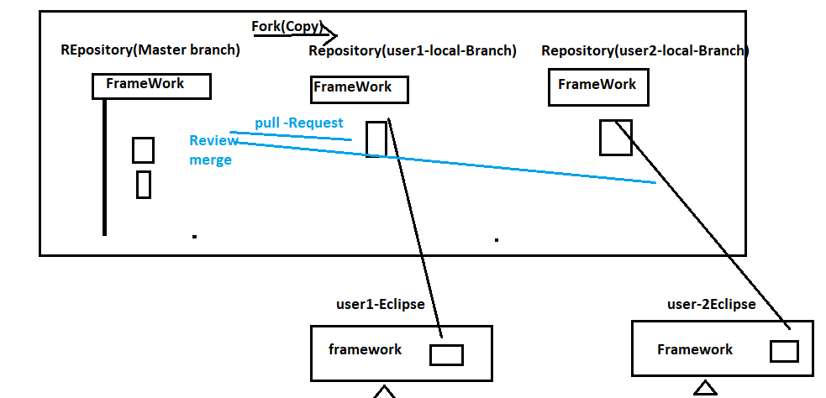

Whenever user made changes in the Programs , some Organization will not have access to push your changes to Master-Branch , in such case we supposed to create a local branch using “fork” option , than push the changes to local branch & than create “Pull Request” to Team lead asking for “REVIEW & MERGE” my program to master branch.

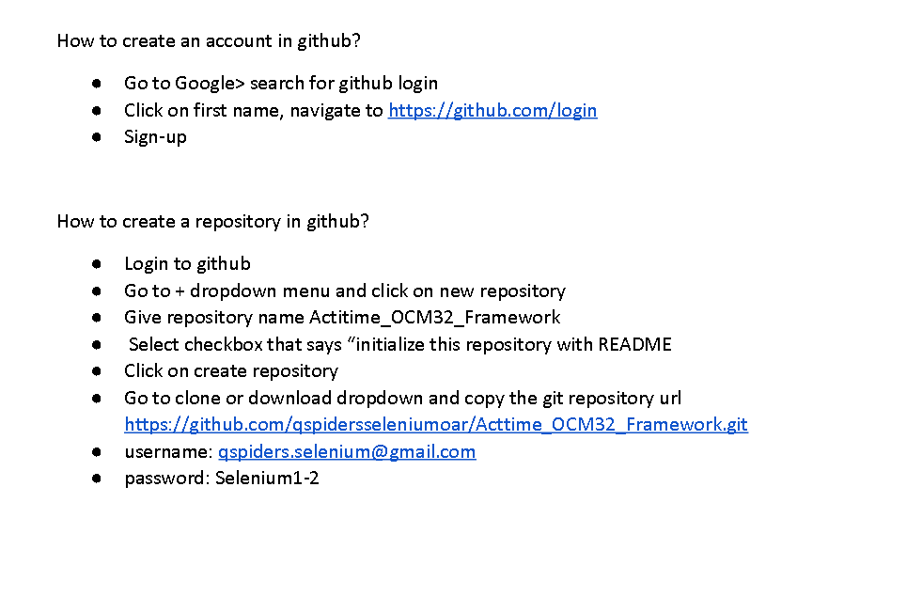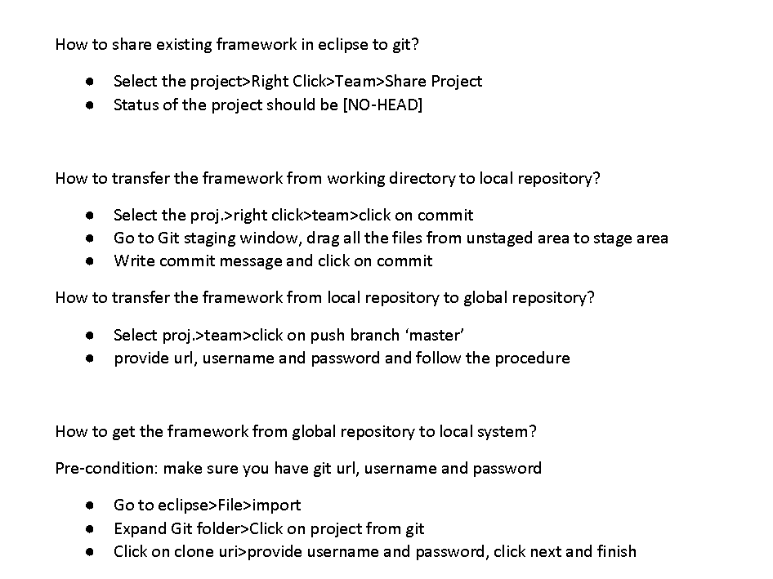

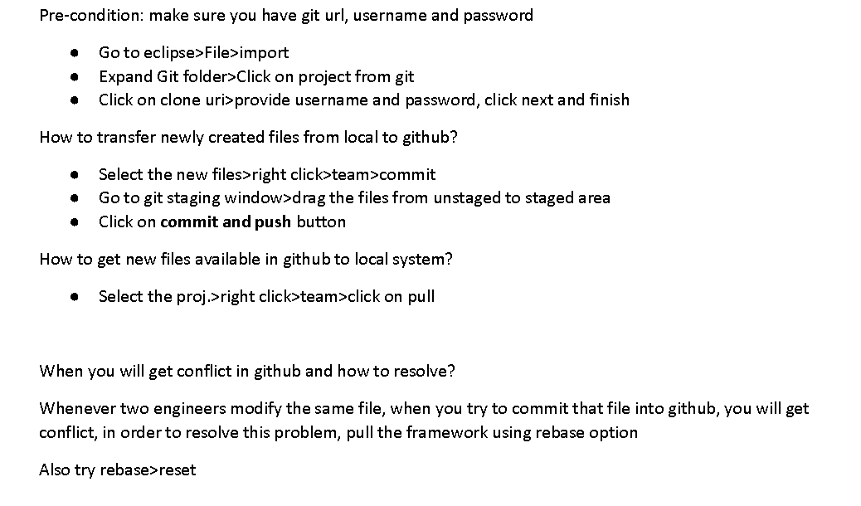

**Git Commands:-**

After installing check whether it has installed correctly or not

git- -version

**First step is to setup some global configuration**

git config --global user.name pvpatil5

git config --global user.email [pvpatil123@yahoo.com](mailto:pvpatil123@yahoo.com)

**To know all the configuration**

git config - -list

**For help:-**

git - -help

Add file

**How to initialize a repository from existing code:**

git init

**Adding files to staging area:**

git add –A :- It will add all the files in working directory

git add filename.extension :- add only the specific file

**How to know status if files are added to stating area or not**

git status

**How to do commit:**

git commit –m “Type message here..”

**To know each commit:**

git log

**How to connect local repository to remote repositority:**

git remote add origin gitURL.git

**Pushing Changes:-**

git diff :- It will print the changes done in last commit and new commit

git status

git add –A

git commit –m “Message”

git push origin master

git pull origin master

**Creating branchs:-**

git branch branch_name

**Switching from one branch to another branch**

git checkout branch name

**Merge a Branch:-**

git checkout master

git branch - -merged

git merge branch_name

git push origin master

**Deleting a branch:-**

git branch –d branch_name

**Clone remote repository:-**

git clone remote_githubURL<workLocation>

**How to pull from remote repository:-**

Git pull origin master

Git –ammend for editing the commit message

Line added by Mukesh

MAVEN

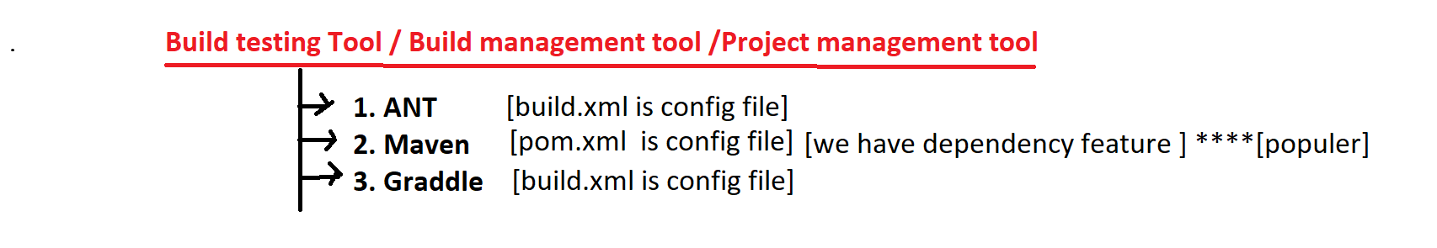

1. **Why maven is required in Development?**

its build testing/

management tool used for build creation & testing & deployment

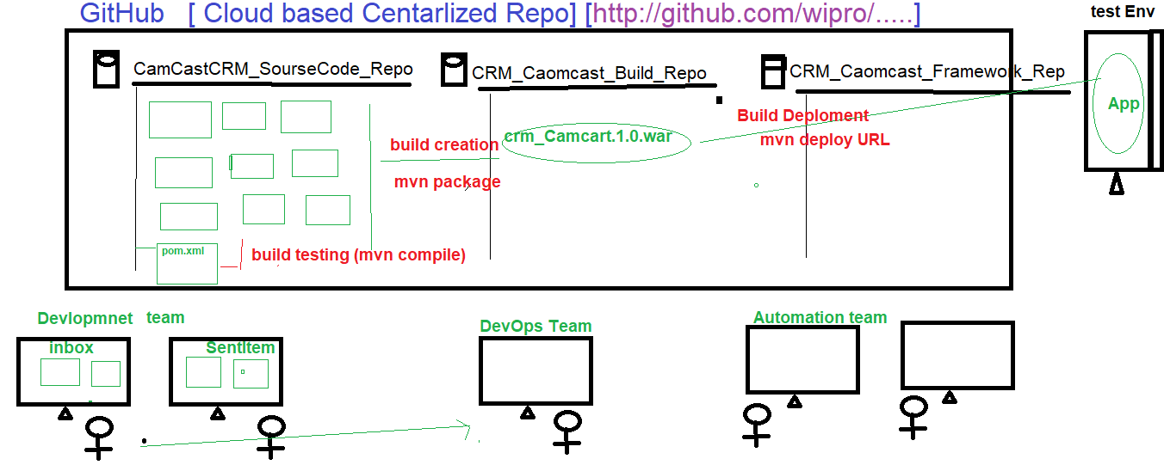

Build testing: maven used to check the compilation & integration issue between the source Code, when multiple developers working with same application.

Build creation/Process: process of converting source code format in to executable format is called build creation (mvn package)

Build Deployment: deploy the executable file in to server is called build deployment process(mvn deploy & mvn install).

1. **Why Maven in Automation.**

It’s build testing tool, which is used to check the integration & Compilations issues between the framework component, whenever one users done the modification, addition deletion happened in the framework

-> When multiple engineers working with the same framework, there might be chances one engineer modification might affect entire framework, in order to resolve/check this kind issue we go for Maven

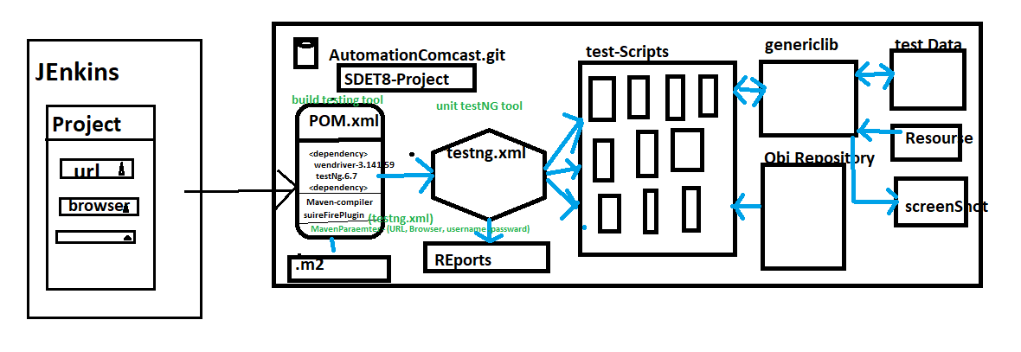

1. **Advantages of Maven**
2. Check the integration & compilation issue between the framework component whenever modification, addition deletion happened in the framework
3. handle dependencies jars
4. create framework configuration quick setup for new engineers (because all the required dependencies jar. Versions declared in POM.xml, you just to get the framework from github & run the POM(Update Maven Project) /CMD>mvn test)
5. create framework folder structure
6. we can run the test script in command Line without Eclipse
7. Which is used to check framework build broken or not ?
8. Maven majorly support in Jenkins for CD/CI [Jenkins]
9. Maven also support Profiling (whenever we have multiple testing.xml file in one POM.xml, in-order to execute specific xml testing.xml file in CMD prompt , we go for profiling
10. Maven Also support run time maven parameter

EG : CMD > -Dusername=admin –Dpassword=password

1. **What all the Maven Software required to handle maven Project in real time?**

* Two software available in Maven

🡺Maven Ellipse Plugin

🡺Maven Command Line Plugin

1. 🡺Maven Eclipse Plugin : it’s a default plugin available in Eclipse Ide , used to create project in Eclipse

Eclipse🡺new 🡺Project🡺Maven🡺MavenProject🡺 Enter GroupId &artifactID🡺Finish

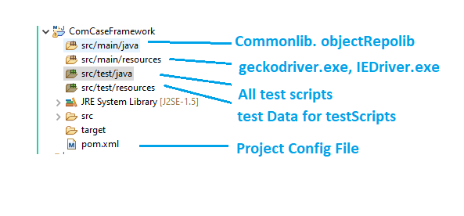

🡺Maven Command Line Plugin : it’s should be installed explicitly in all local computers , used to handle the Maven project in CMD line

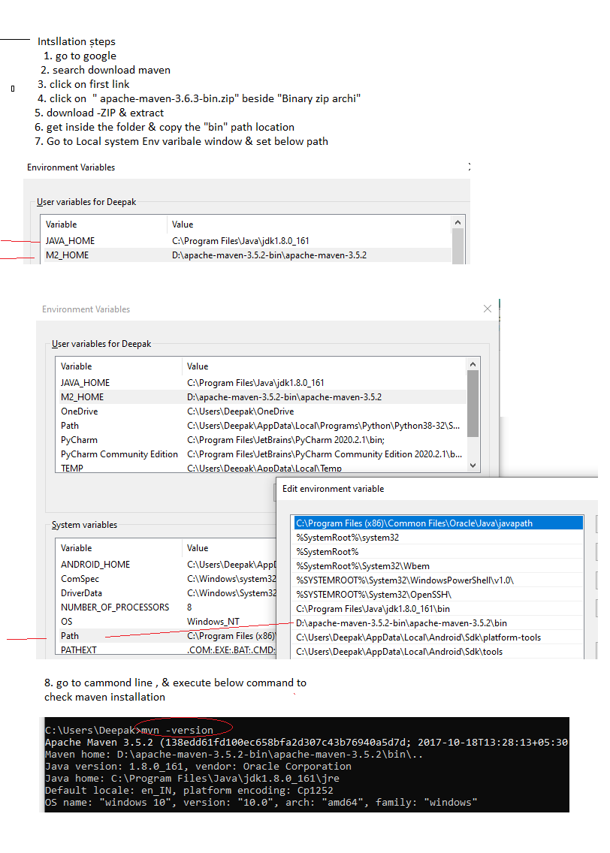

1. What is Maven Dependency & how to handle?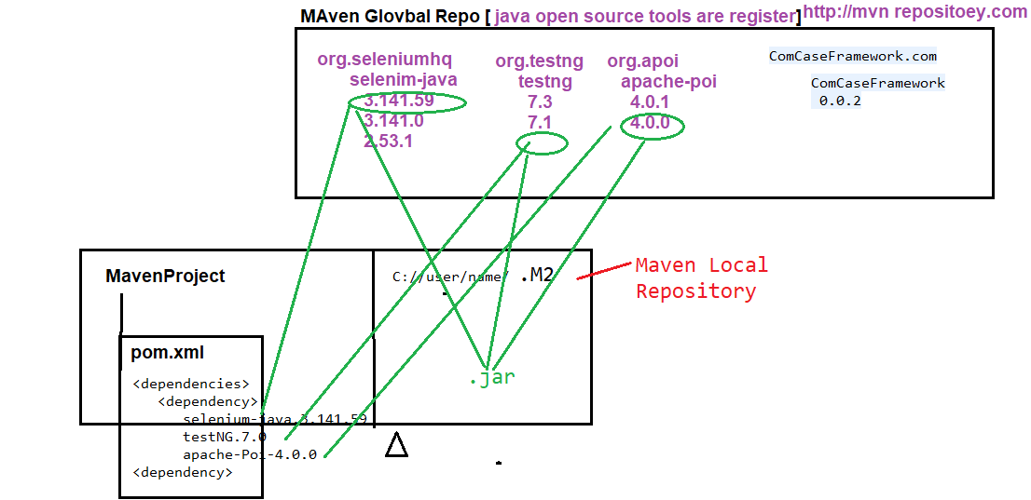

Dependency is a feature available in maven tool, which used to get/download required Jar’s files from Global-Repository(http://mvnrepository.com) to Local-Repository (.M2 folder C://user/name/.m2)

To handle Maven Dependency fallow below steps

1. Create maven Project
2. Go to POM.xml [Project Object Model] file inside the Maven Project
3. Edit POM.xml
4. Add below Tag

<dependencies>

</ dependencies >

1. Go to GlobalRepository [http://mvnrepository.com], search for the required tool like selenium-java , testing etc
2. Copy the dependency code

EG:

<dependency>

<groupId>org.testng</groupId>

<artifactId>testng</artifactId>

<version>7.1.0</version>

<scope>test</scope>

</dependency>

1. Paste the dependency code inside the POm.xml
2. Save the file

What is gropuId & artifactID

gropuId 🡺 name of the community/ Organization

artifctID 🡺 name of the Project

1. **How to execute test in CMD**
2. Project🡺 RightClick🡺 Properies 🡺 copy the Project location

EG : C:\Users\Deepak\eclipse-workspace\ComCaseFramework

1. Open CMD

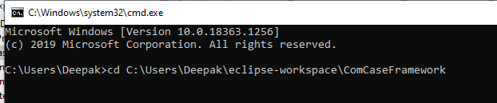

1. Execute Maven commands
2. **Explain maven Build Life Cylcle / maven Commands**

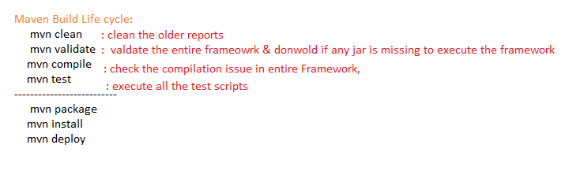

**How to execute only one test using maven Cmd**

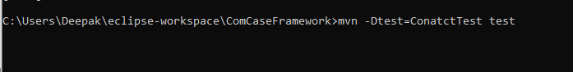

What is Maven Profiling ?

When Framework contains multiple testing.xml files, inOrder to execute particular testing.xml via POM.xml file , we go for profiling



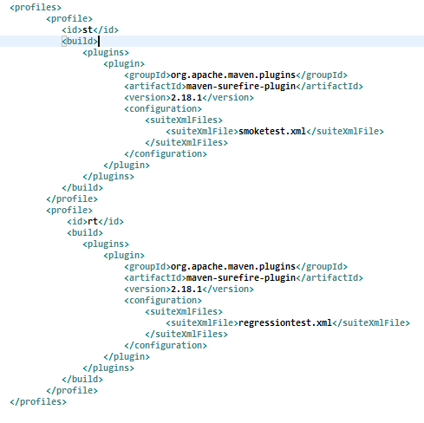

How to execute TestNG.xml via POM.xml

To execute testing.xml via POM.xml , we should include “maven-sureFire-plugin” In side the POM.xml

<build>

<plugins>

<plugin>

<groupId>org.apache.maven.plugins</groupId>

<artifactId>maven-surefire-plugin</artifactId>

<version>2.18.1</version>

<configuration>

<suiteXmlFiles>

<suiteXmlFile>testng.xml</suiteXmlFile>

</suiteXmlFiles>

</configuration>

</plugin>

</plugins>

</build>

What is Maven Parameter???

Using Maven Parameter we can pass the data from the command line in run Time



Pass maven Parameter from the Eclipse

Select-TestNGFile🡺 Right Click🡺 Run As🡺 Run Configuration 🡺 Arguments

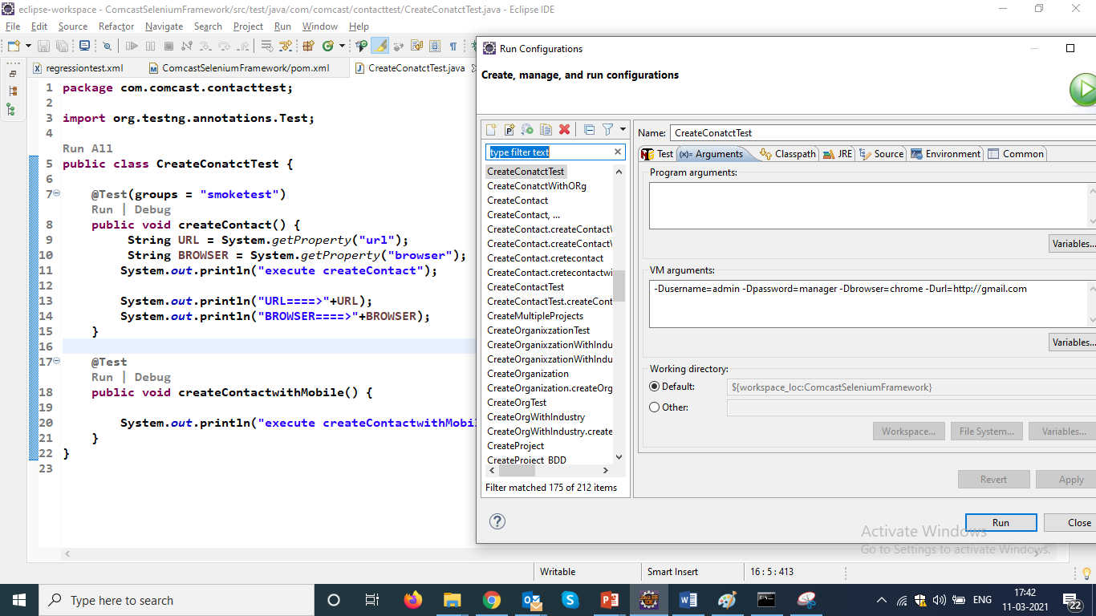

**When We execute MavenFramework in command line , where html report will be generated ?**

Yes, report will be generated inside the **target** folder in below location

🡺Go eclipse =>refresh the Project🡺 target 🡺 sureFire-reports🡺 emialable-Report.html

**How to create Maven Project in Eclipse ?**

* **Click on File 🡪 New 🡪 Project**

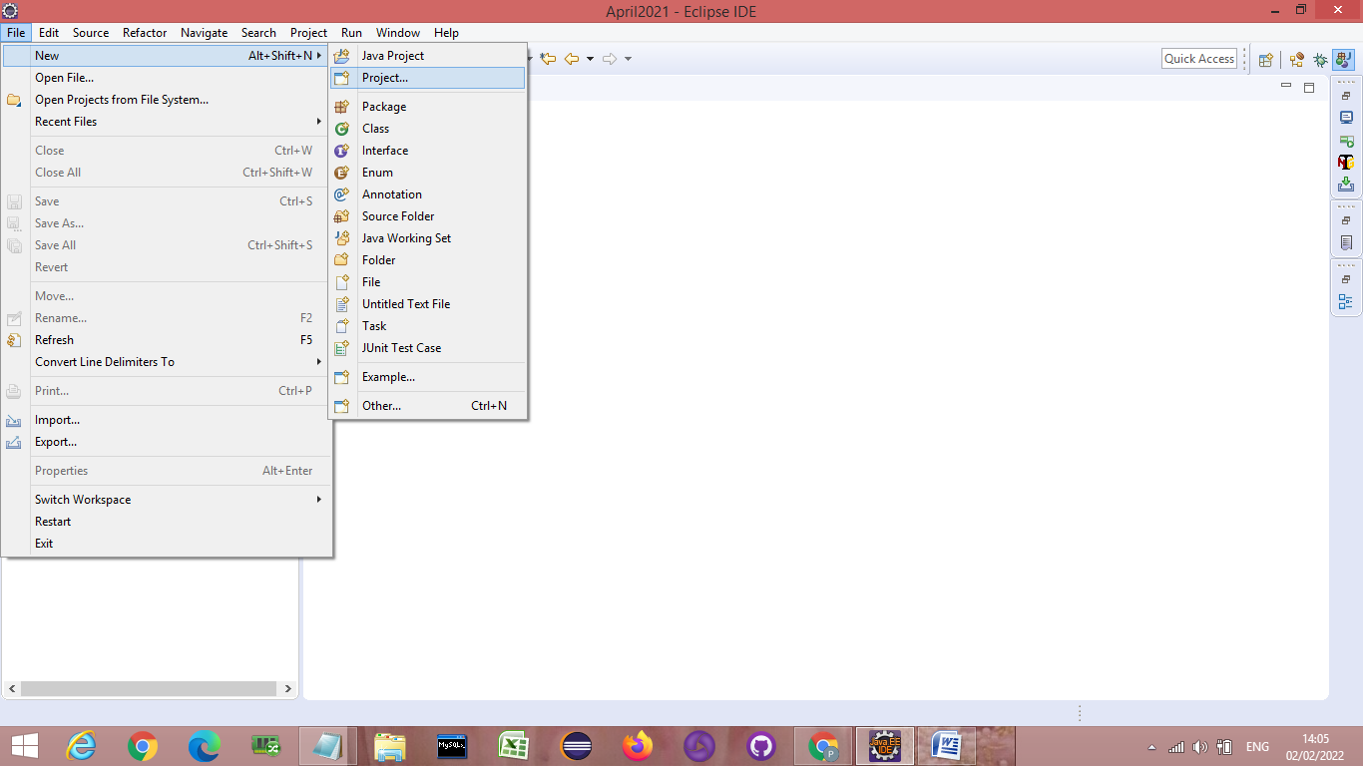

* Click on Maven Folder 🡪 Maven Project 🡪 Click Next

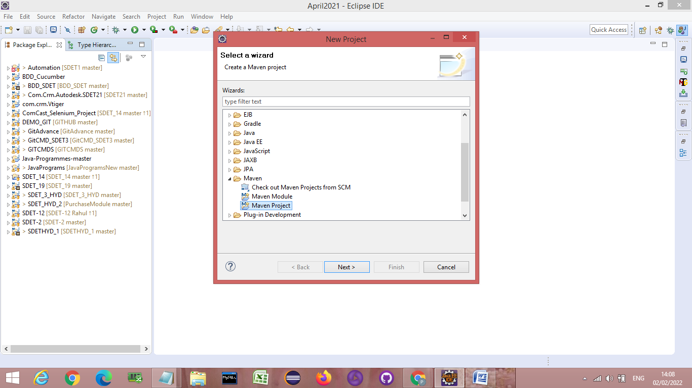

🡪 Select the Workspace 🡪 Don’t click on the first checkbox 🡪 Click on Next

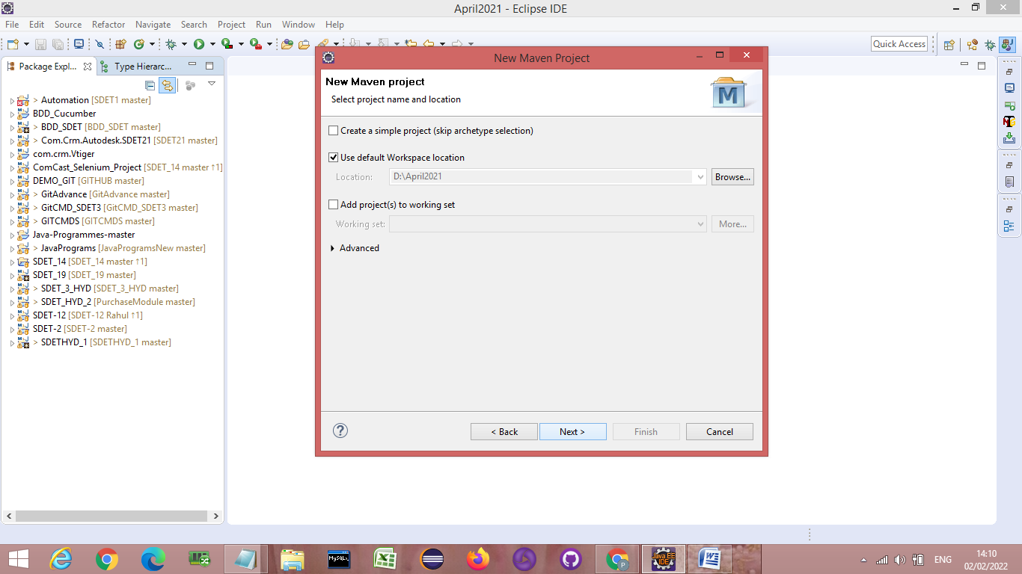

🡪Click on Configure 🡪

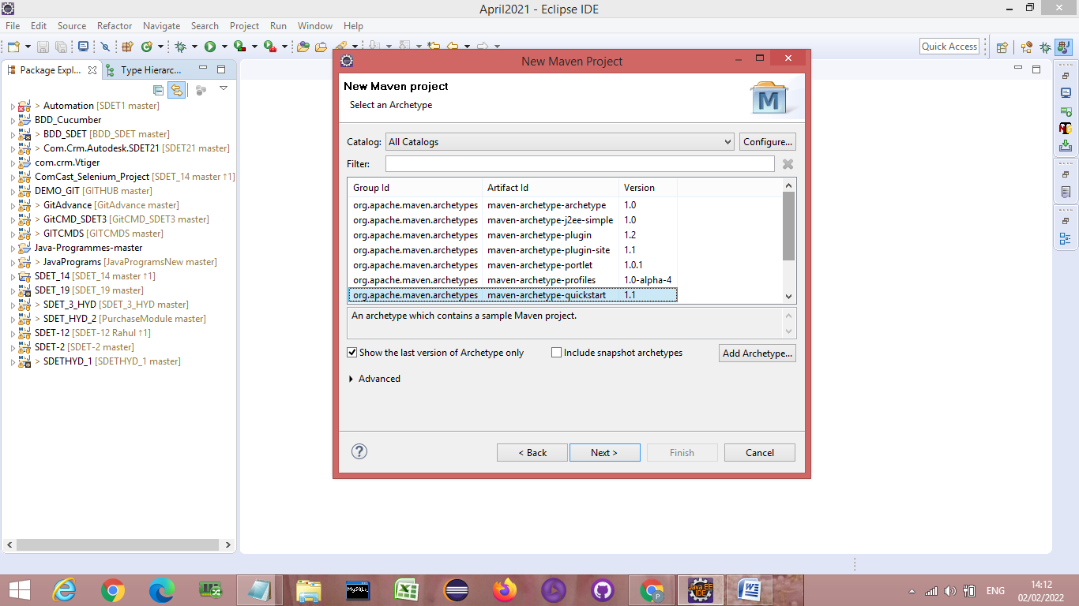

🡪 Click on Add remote catalog

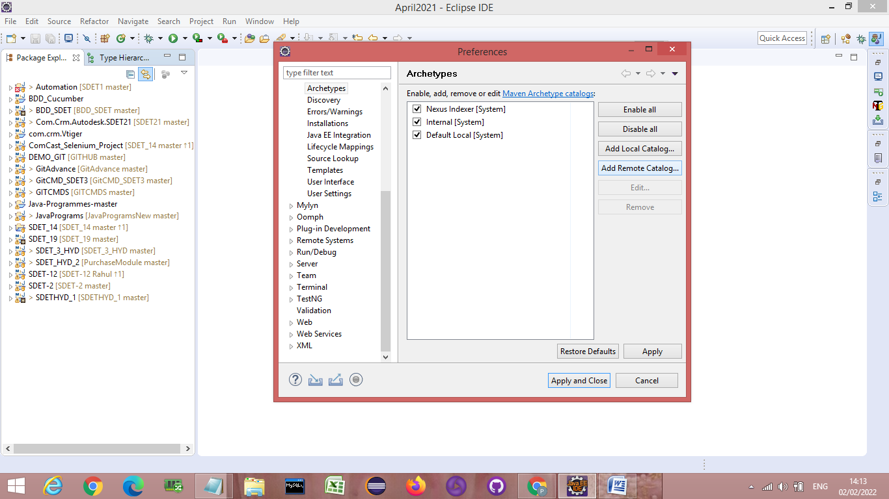

🡪Add the below link in catalog file textbox 🡪 then Click on OK

[**https://repo.maven.apache.org/maven2/archetype-catalog.xml**](https://repo.maven.apache.org/maven2/archetype-catalog.xml)

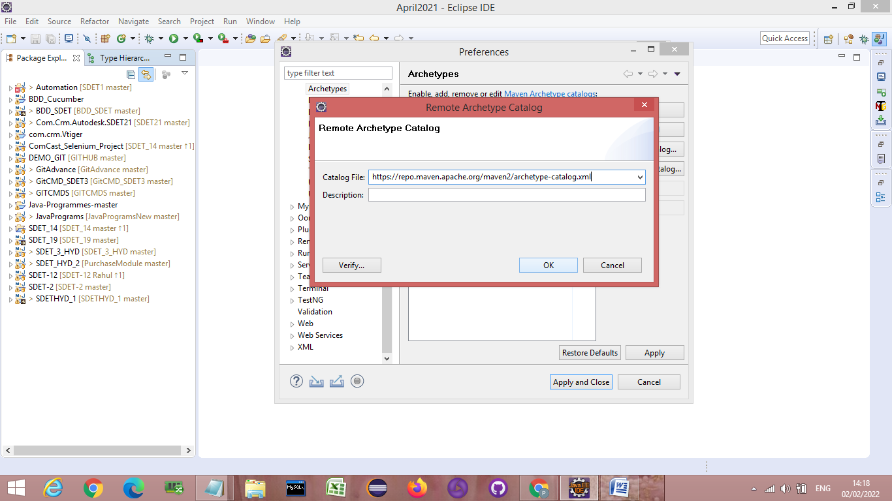

**🡪**Click on Apply and Close 🡪 This will start downloading Archetype make sure you are connected to good network connection.

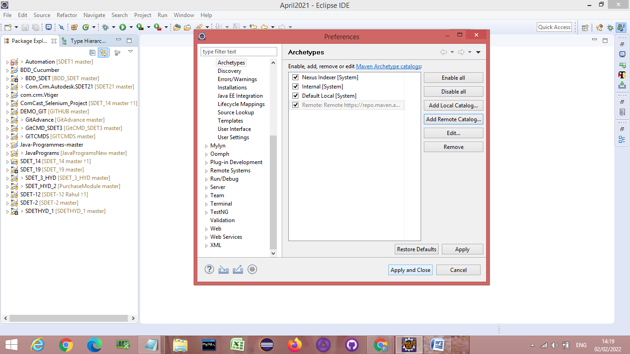

**🡪In the filter textbox type 🡪maven-archetype-quickstart 🡪 You will get 3 suggestion 🡪Select**

**maven-archetype-quickstart 1.4🡪then click on Next**

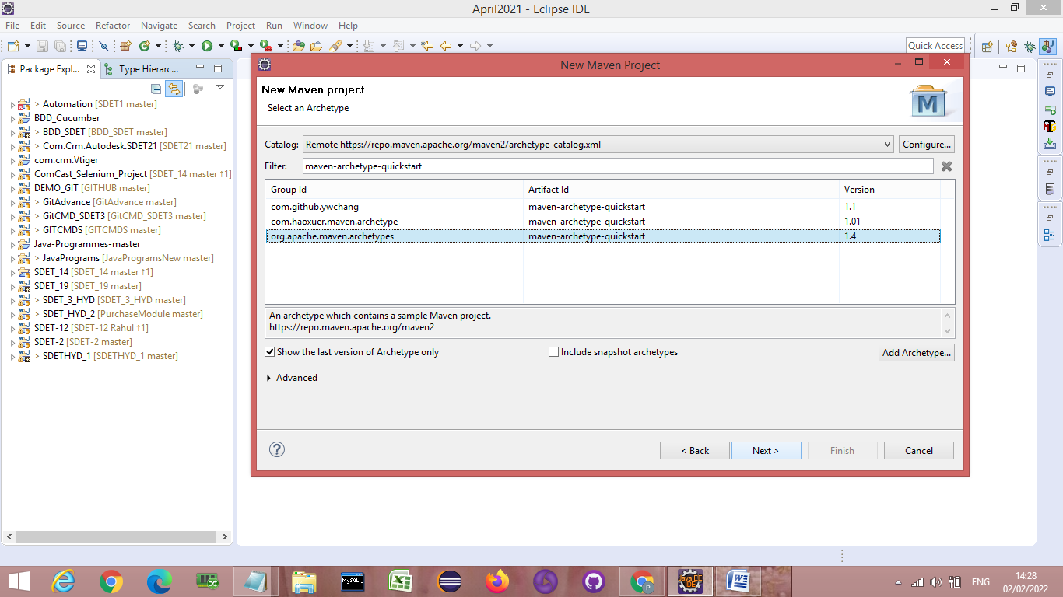

**🡪Fill the below details in textboxes**

* **Group Id : DEMO_MAVEN_Project**
* **Artifact Id : DEMO_MAVEN_Project**

**Then click on Finish 🡪 Maven Project will be created**

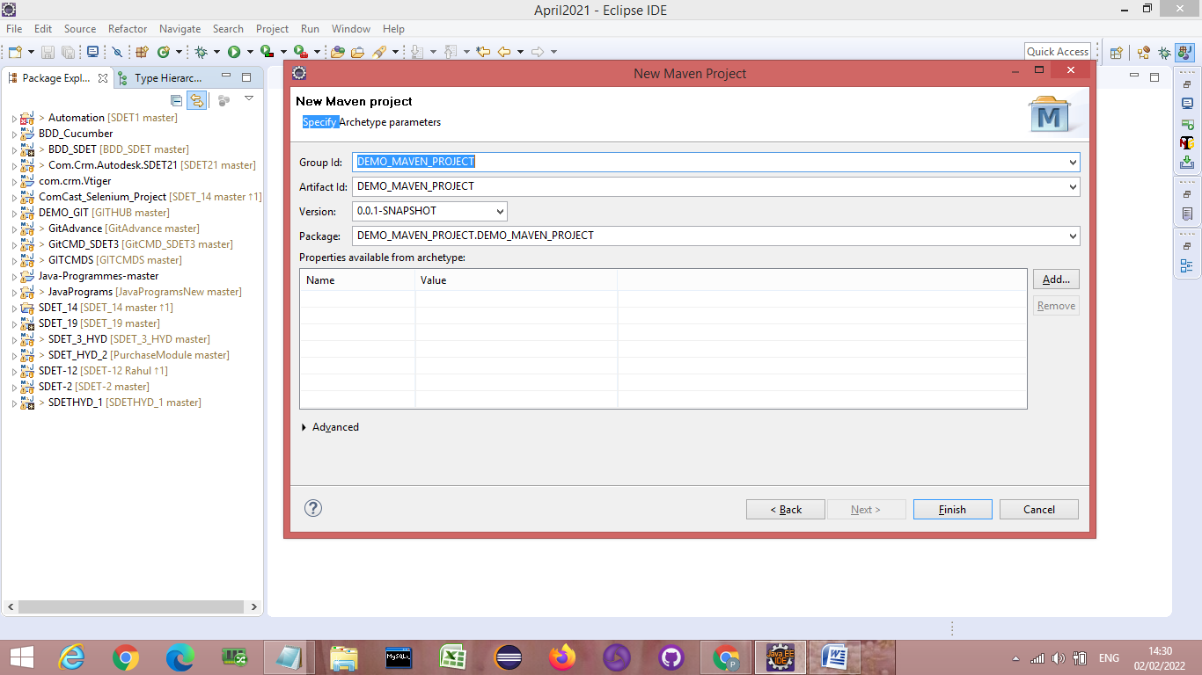

**Jenkins**

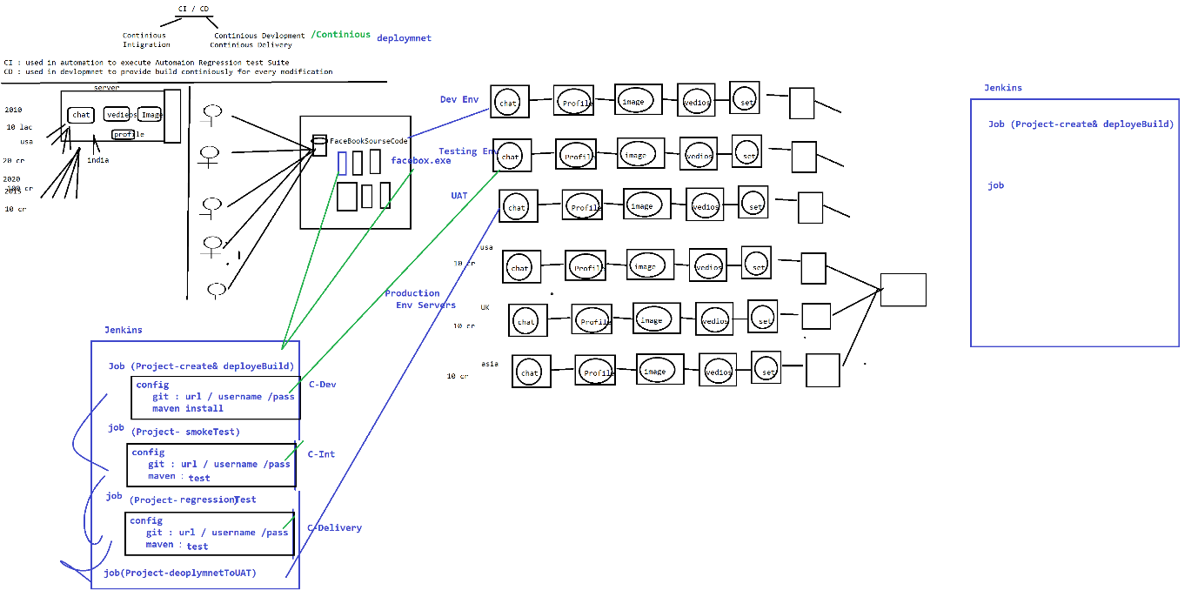

1. **Installation Steps :**
2. Download Jenkins & install
3. Login to Jenkins & install below Plugin

Jenkins 🡺 Manager Jenkins 🡺 Manage Plugin🡺 Select “Available”

Search & install below Plugins

. Maven Integration Plugin

GitHub Integration Plugin

1. Configure Env variables in Jenkins for below PlatForm/Software

. JDK : C:\Program Files\Java\jdk1.8.0_161

. Maven : D:\apache-maven-3.5.2-bin\apache-maven-3.5.2

.Git : C:\Program Files\Git\bin\git.exe

Jenkins 🡺 Manager Jenkins🡺 Global tool Configuration

1. What is Jenkins:

Its CI/CD/CD tools

Continuous Development: which includes build creation & deployment processes is automated using Jenkins

Continuous Integration: execution of smoke & regression testing process is automated using Jenkins

Continuous Delivery : delivery final stable build to UAT environment , this process is automated using Jenkins

1. What is use of Jenkins in Testing

Jenkins is a Continuous integration tool where continuously monitor the framework Build in git location, then perform appropriate action based on request

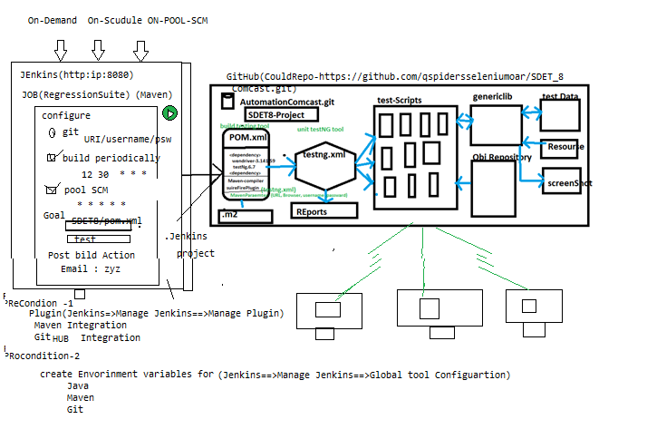

Advantages of Jenkins

1. Jenkins Provide 3 level of execution

. On demand : based on Customer demand we can start the execution

. On Scheduling: based on scheduled time , start the execution automatically

. POOL SCM : where continuously monitor the SCM(GitHub) & automatically start the execution whenever we get new Build / one new test script is getting added to Git

1. Email Notification :

. Jenkins sends out an execution Report via email, once execution is completed

. Jenkins also Send Build broken Email, when Compilation issue between the framework component

1. Jenkins also support run time **parameter**
2. **Jenkins also support PipleLines Job**

**What is Jenkins Pipeline?**

Execute multiple job sequentially one after the other I called Jenkins Pipeline

Note : make sure “pipeline” plugin should be installed in jenkins

EG : below example is the list job’s re pipelined , & it mean just execute 1 st job then automatically all the jobs executed which is available in pipeline.

Job 1 -Build creation 🡺Job2- Build-Deploye🡺Job3-SmokeTest🡺Job4-Regressiontest🡺job4-Delivery;

**How to Set Jenkins parameter?**

Jenkins parameter help us to pass data in to test suite in run Time

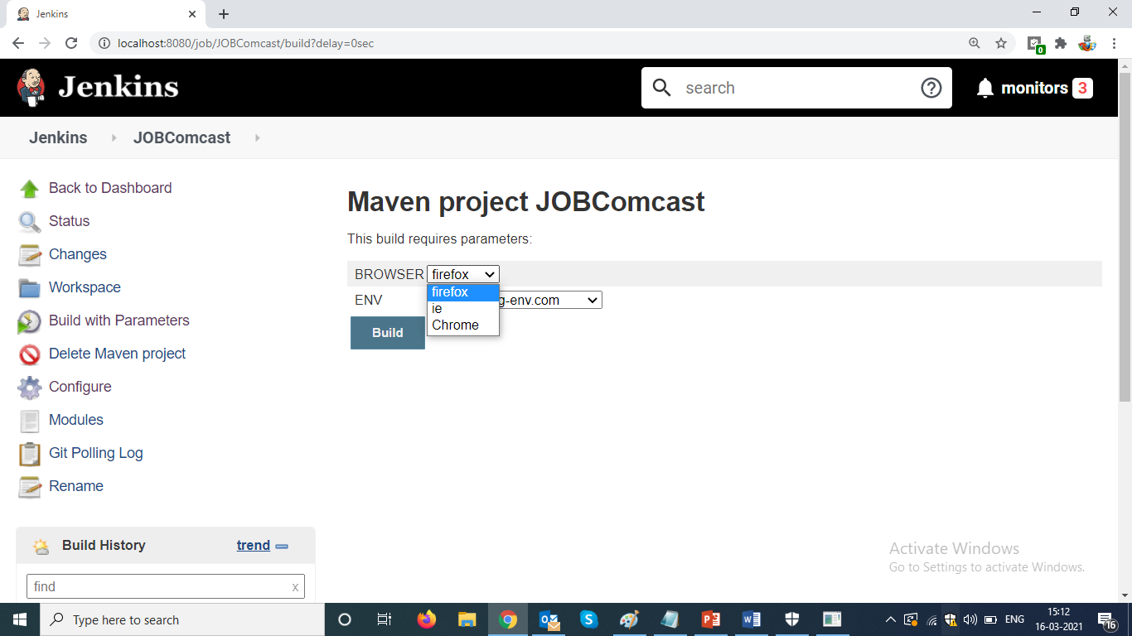

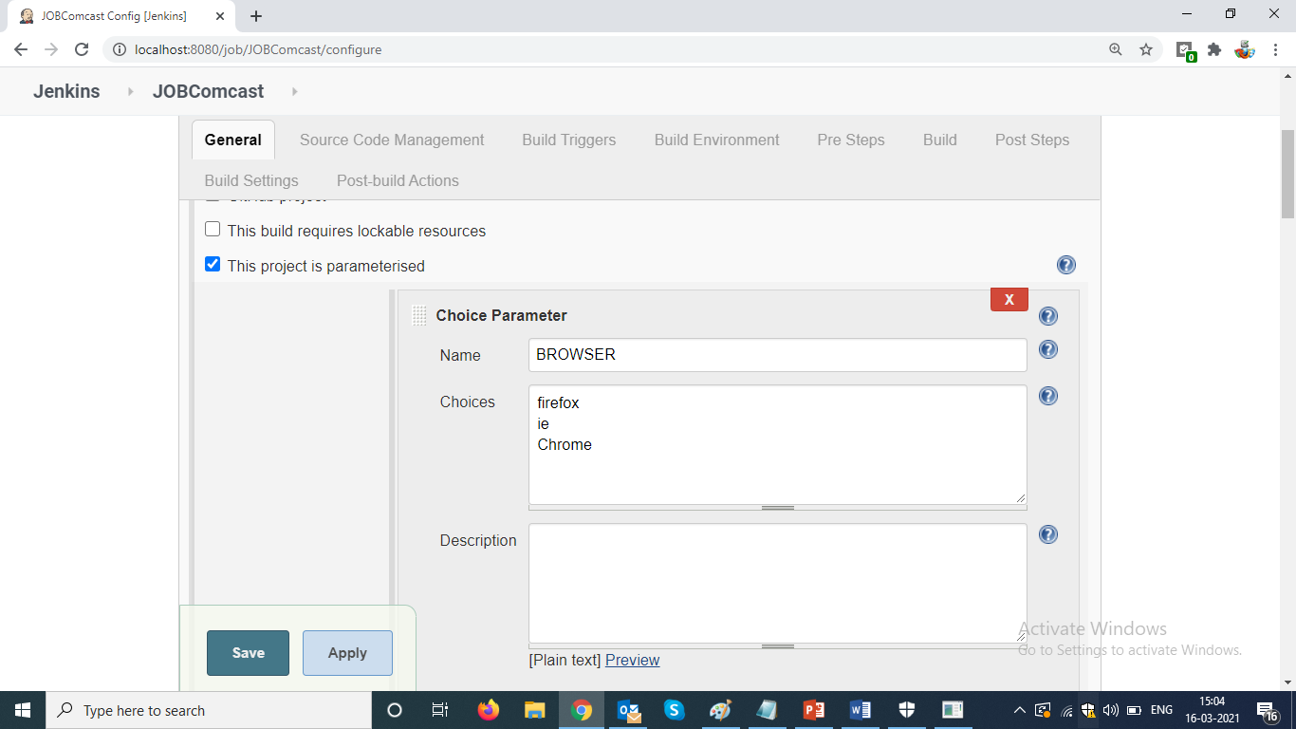

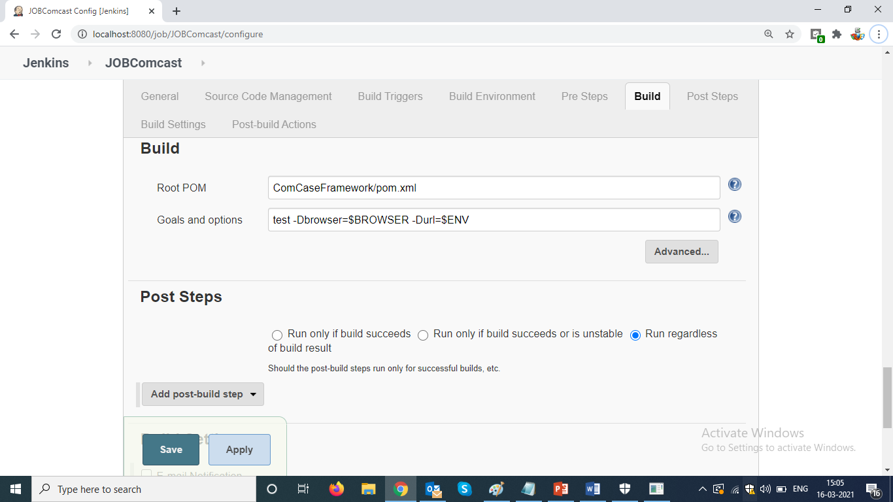

**Types OF Framework**

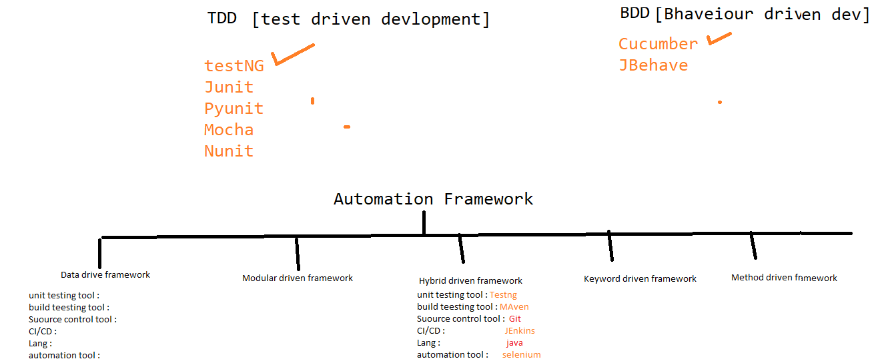

1. Data driven framework
2. Modular driven framework
3. Hybrid driven framework
4. Keyword driven framework
5. BDD framework

**What is Data driven Framework???**

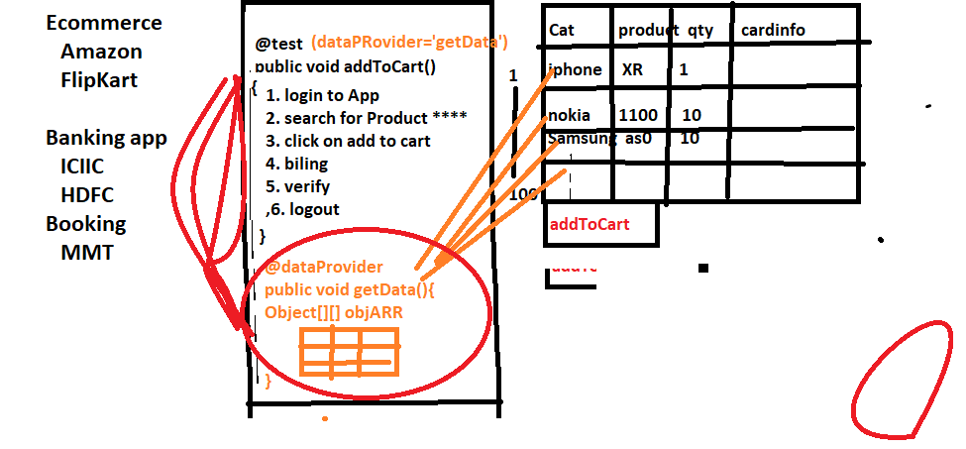

Whenever we need to test the application with huge set of data , we go for data driven framework

In data driven framework every test will have dedicated @dataProvider annotation & will have separate excel sheet for every test

@dataProvider

When ever need to execute same test with different set of data we go for @dataprovider annotation

**What is modular driven framework???**

Whenever application is huge / contains lots of modules we prefer modular driven framework

In modular driven framework, all framework components will maintain in module wise

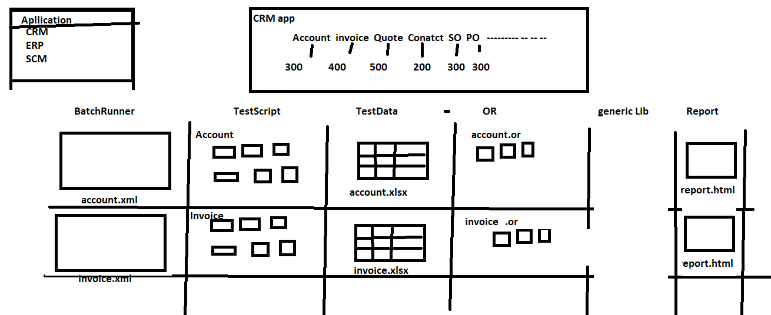

**What is Keyword driven Framework**

When manual test Engineer want to write Automation test script with less knowledge on automation tool & without knowledge coding, we go for keyword Driven framework

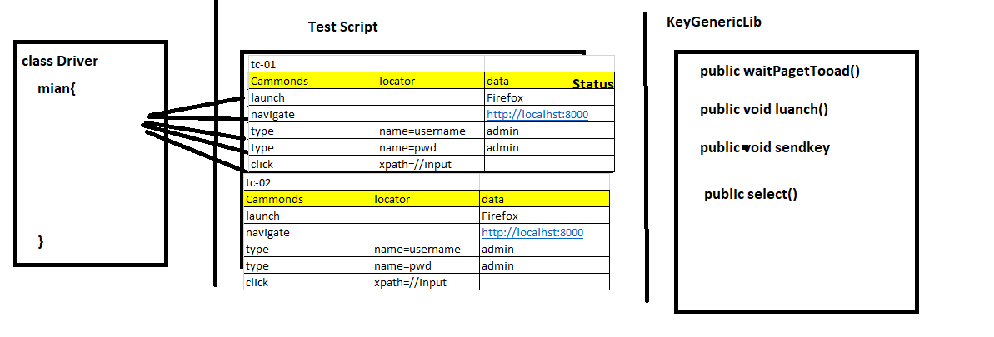

**Hybrid driven framework:**

Combination of more than one framework is called hybrid driven framework

EG: the framework which we designed is hybrid because its combination of data driven + Modular driven + keyword driven framework + Method driven

**BDD Framework:**

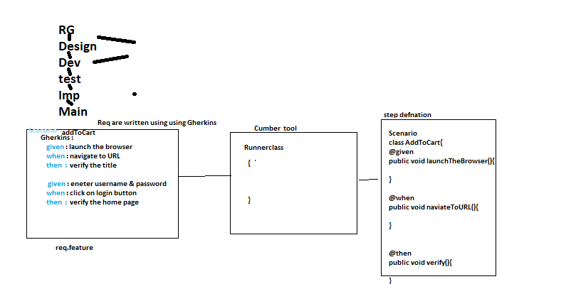

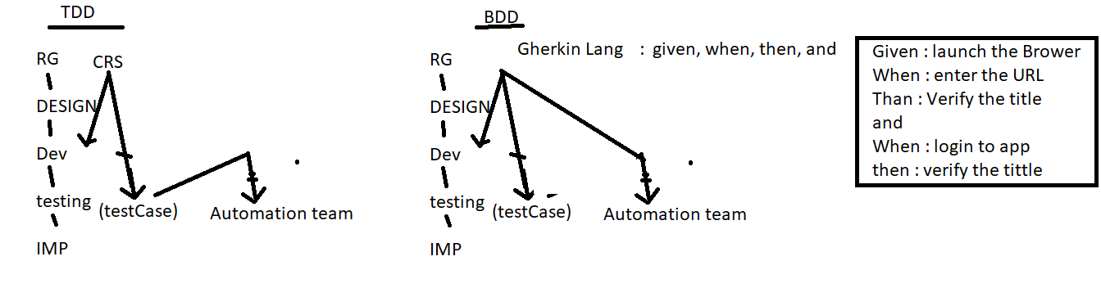

**Framework document**

**Definition:** Framework is a well-organized structure of reusable components where one driver (.xml) file will take care of the execution without any manual intervention.

**Definition:** Framework is collection of reusable components that makes automation development execution and modification is easier and faster.

**Definition:** Framework is a set of instruction followed by every organization that makes automation test engineer life easy.

Framework has the following basic components:

1. Common Utils
2. POM/Object Repository
3. Test Data
4. Resource
5. Test Scripts
6. Run Me/driver/XML file
7. HTML Report
8. Screen Shots
9. Maven
10. Jenkins

Framework Architecture is depicted in the figure below.

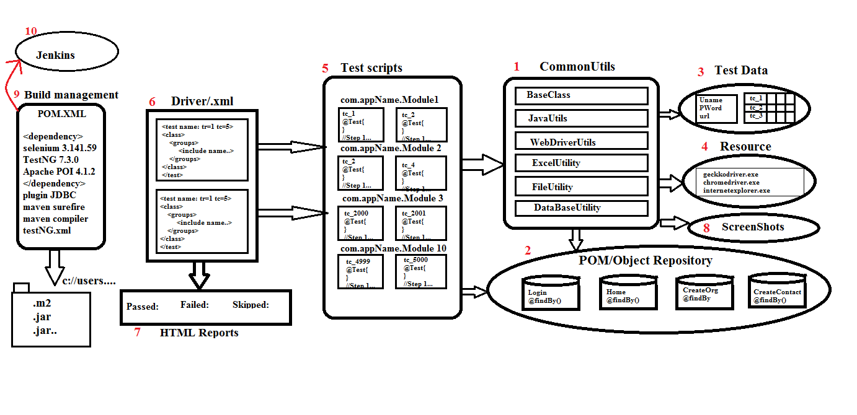

1. **Common Utils:** It is one of the common components in my framework which can be used to any project. It contains several reusable classes like
   1. Base class: It contains common TestNG configuration annotations which is required for all the test script. As per the automation rule every test script should extend base class to use those annotations.

Real usage of testNG annotations:

* ***@Before suite*:** it is used to configure database connectivity and extend report, it will execute before <test> tag in xml file.
* ***@Before test:*** it is used to launch the browser in case of parallel execution before executing each <test> tag in xml file.
* ***@Before Class:*** it is used to launch the browser in sequential execution, it will get executed before executing each class
* ***@Before Method:*** it is used to login into application which is executed before executing every @test method
* ***@After method:*** it is used to logout into application which is executed after executing every @test method
* ***@After Class:*** it is used to close the browser in sequential execution; it will get executed after executing each class
* ***@After suite:*** it is used close the database connectivity.
  1. Java Utils: It contains java specific methods which can be used for all the test scripts like get-Random-number, get-Date etc.
  2. Web Driver Utils: It contains web-drivers action which is common for all the test scripts like select, switch-To-Window, switch-To-Frame etc., in real framework we use web driver utility to perform action on the browser so that the test script level is easy and no read to remember the syntax.
  3. Excel Utility: It is developed using Apache POI which is used to read and write data from Excel sheet. As per the rule of the automation, the data should not be hard coded in the test script so that we will take the help of Excel utility to interact with Excel file.
  4. File Utility: It is used to capture common data from Property file which is developed using java.
  5. Database Utility: This is developed using JDBC which is used to connect to any database from the automation test script. In real time few scenarios require to connect to database for validation to execute precondition.
  6. Listener Implementation: It is a implementation class of TestNG ITest Listener which is used to capture failure event in run time and capture the Screenshot in screenshot folder.
  7. Retry Listener: It is an implementation class of testNG IRetry Analyser which is used to execute same script multiple times when ever test script is failed.
  8. IConstant: It contains common global variable which is used across the framework in Implicit-Wait, Excel-Path, Property-Path, Explicit-wait.

1. **POM/ Object Repository:** It is a collection of re-usable webelements and business library which can be used to specific business or project. In order to develop we have used POM design pattern as per the rule automation element locator should not be hard coded in test script because maintenance and modification is tedious job whenever requirement is changed. In real time most of the organization follow Agile process , where frequent requirement changes should be handled, in such cases POM repository helps us to maintain and modification becomes easier.
2. **Test data:** It is one of the components in the framework it contains the data which is requited to run the framework. There are two types of data:
   1. Common data:
      1. URL: used to run test scripts in different environment
      2. User Name / Password: which is used run all the data in different Credentials
      3. Browser: used to run all the test script in different browsers
   2. Test Script Data: data which is required for all the test script. Every test script is dedicated with one row with in Excel file. As per the rule of automation data should be externalized because modification maintenance is easier
3. **Resource:** It is one of the components in the frame work which contains resources to run the Framework like IE-Driver-Server, Chrome-Driver-Server, Gecko-Driver-Server, User-Guide Document.
4. **Test scripts:** Itcontains collection of TestNG test scripts which is automated using @Test. During test script development make sure generic libraries, object repository is being used. In real time when ever manual test cases is allocated to us we should create a separate package for a module and develop a test script by taking utility
5. **Driver/XML File:** It is a TestNG component used to execute all the test scripts in batch, parallel, group. In real time whenever we get a new build we should crate testNG.xml and trigger the execution.
6. **HTML Report:** Whenever TestNG execution is completed it automatically generate HTML report which helps us to know the status of application. In Real time reporting component is very much important because it provides the quality of application and same report is being submitted to customer. In real time report helps the engineer to know the root cause of the issue whenever test Script is getting failed.
7. **Screen Shots:** Whenever any test script is failed during execution we will have screenshot in screen shot folder, same screenshot can be used for debugging and rise defect in JIRA.

**Advantages of Framework:**

1. Test script development is faster and easier because of reusability
2. Modification and maintenance of data is easy because data is stored in external resource
3. Modification and maintenance of element is easy because we have used POM design pattern to maintain then elements in well-organized way
4. POM design pattern is the perfect fit for agile Process
5. Framework provide automatic screenshot for failed script
6. Framework provides flexibility to achieve cross browser testing, distributed environment testing, smoke testing, regression testing, regional regression testing
7. Framework provide accurate execution report for every execution
8. Framework provides generic reusable utility for all actions like Excel Utility, base class, database utility.
9. Test script can be re used for every new build
10. Test script is optimized

**Disadvantages of Framework:**

1. Should be good in programming

**Phases of Framework:** There are 3 phases in Frame work

1. Framework design Phase: In this phase framework developer will design the framework which contain common utility like generic libraries, test data template, POM classes with partial elements. This phase is executed in Sprint-1 or Release-1
2. Framework Implementation Phase: This phase start from Sprint-2, all automation engineer participate in test script development implementation
3. Framework Execution phase: Execution phase is always handled by Jenkins tool, that is whenever we get a new build to testing environment JENKINS will automatically execute and send email to the concerned engineer

**MANAGERIAL INTERVIEW QUESTIONS**

1. Brief yourself , tell about your Self..

-----------Name

---------Education

-----------Experience: I am totally having 3 years of experience in QA , Out of which 2 years automation & 1 year in maul testing . &currently working in TY as Software test Eng & previous company details.

----------roles & responsibility

1. Why are switching the company ?

I am not changing the company, testYnatra is trying deploying me Here.

1. What is your roles & responsibility?

* Whenever we get manual test case from the manual team, our team lead is going to allocate test case to us
* When test case is allocated, we do execute test manually to understand the business flow of the application, if test case is not clear talk to author/team lead & get the clarity, or else consider for automation
* Involved in segregation of test cases is automatble or not?
* Involved in test scripts automation
* Before test scripts development, get the latest framework form the Git Repo
* Involved in test data creation
* Involved in test POM class creation & adding elements in to repository
* Involved in business/ workFlow library creation
* Involved in generic library creation if required
* Involved in review test scripts
* Involved in verifying execution reports, when Jenkins send out execution report
* Involved in debugging the test scripts & raise regression defect if test failed because of Product issue or else fix the test scripts
* Involved in daily stand Up meeting
* Involved in framework development
* Involved in creation of webdriver action for every element in GUI like select , mouseMove() , swucthToWindow() etc..
* Involved on giving KT to team members
* Involved configuration of suite execution in Jenkins
* Involved in maintenance of test scripts in Git Location
* Involved in Sprint Review * retrospect meetings
* Involved in tracking automation defect in Jira

1. Explain Automation Life cycle

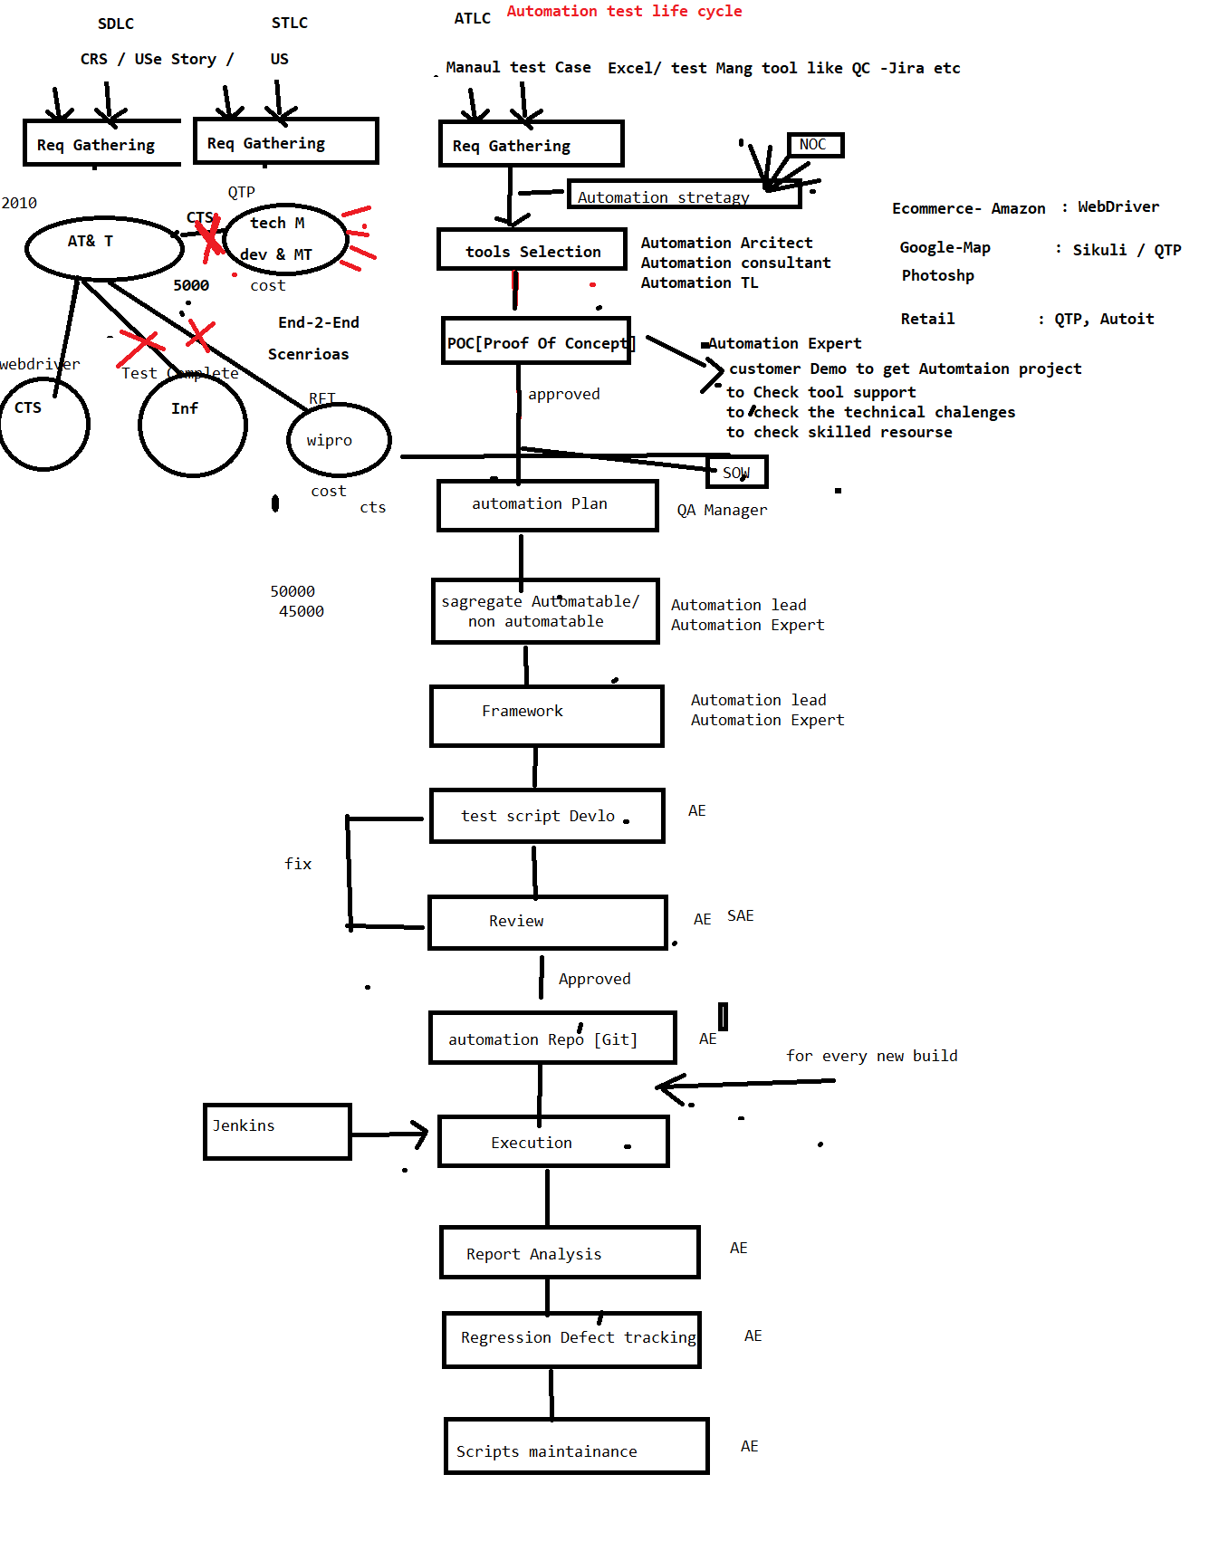

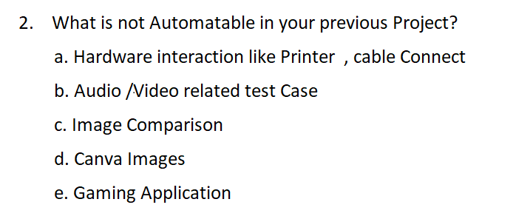

EG-1 : In my previous project , there was a scenario , where create Customer along with image of the Customer , in that scenario , i have automated Upload image but could not verify the Image Pixel

EG-2 : In my previous project , their was a scenario , where create a Quotation & print the Quto Document , in that scenario , i have automated click on print button , but

could not verify print response

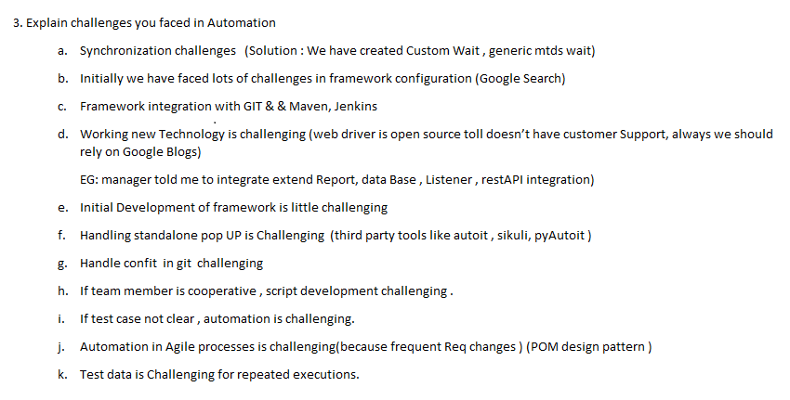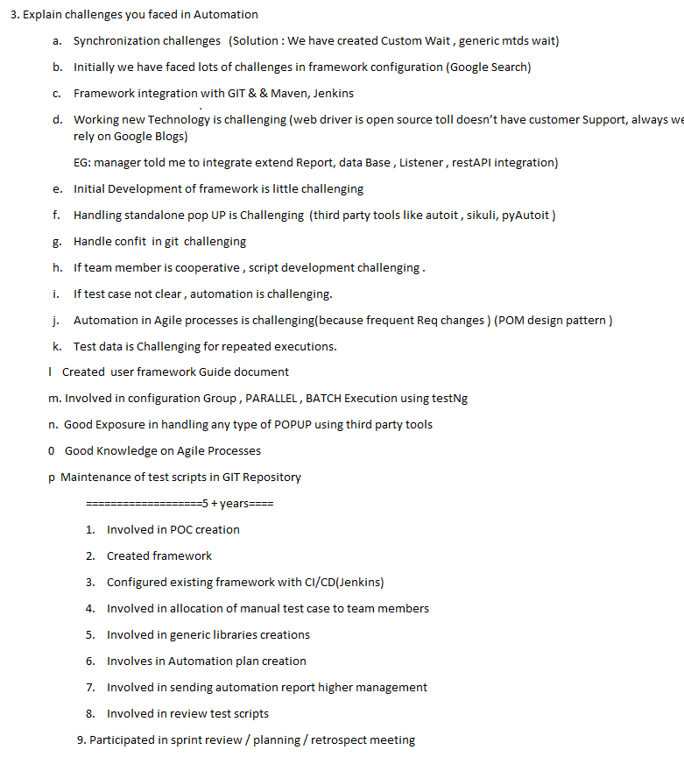

========================================================

1. Explain few complicated scenarios which you automated in your previous Project & explain the Challenged
2. Explain one critical bug which you got via automation
3. What is daily Activity

When Ever I reach Office to Check Email

Email => WRT 🡺 Review

Email => WRT 🡺 test Script Allocation

Email => WRT 🡺 Meeting

Email => WRT 🡺 JIRA (retest the defect)

Email=> WRT 🡺 JENKINS 🡺 verify the report

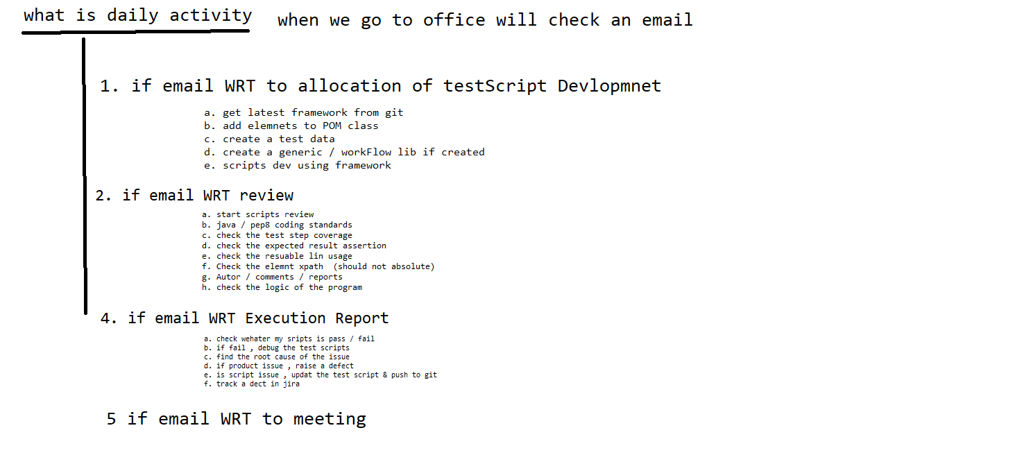

What is duration of the Project?

What is sprint duration in your previous project

**How many build you get in one sprint?**

How many test case you had in your previous project?

Which processes you followed

How many test case used to get for automation in every sprint / release?

How many test case you automated /day/month/year/ in entire project?

What is your team size

I will give 100 test case , what is your estimation ?

How long automation batch execution take place ?

How may defect you found via automation in your previous project ?

Percentage of manual & automation in your previous project ?

How may smoke test u had in your previous Project

120 test case / 3000

**400 /year**

**1 year**

**4 year**

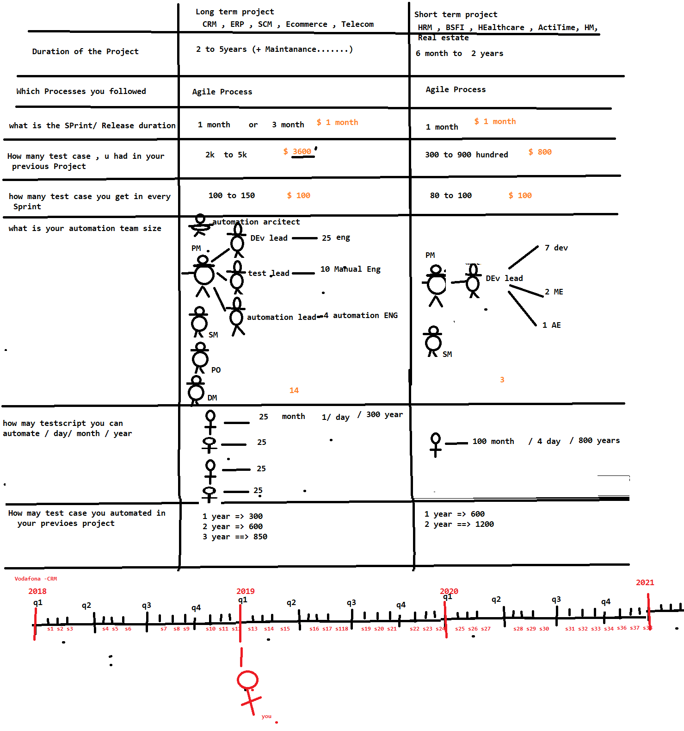

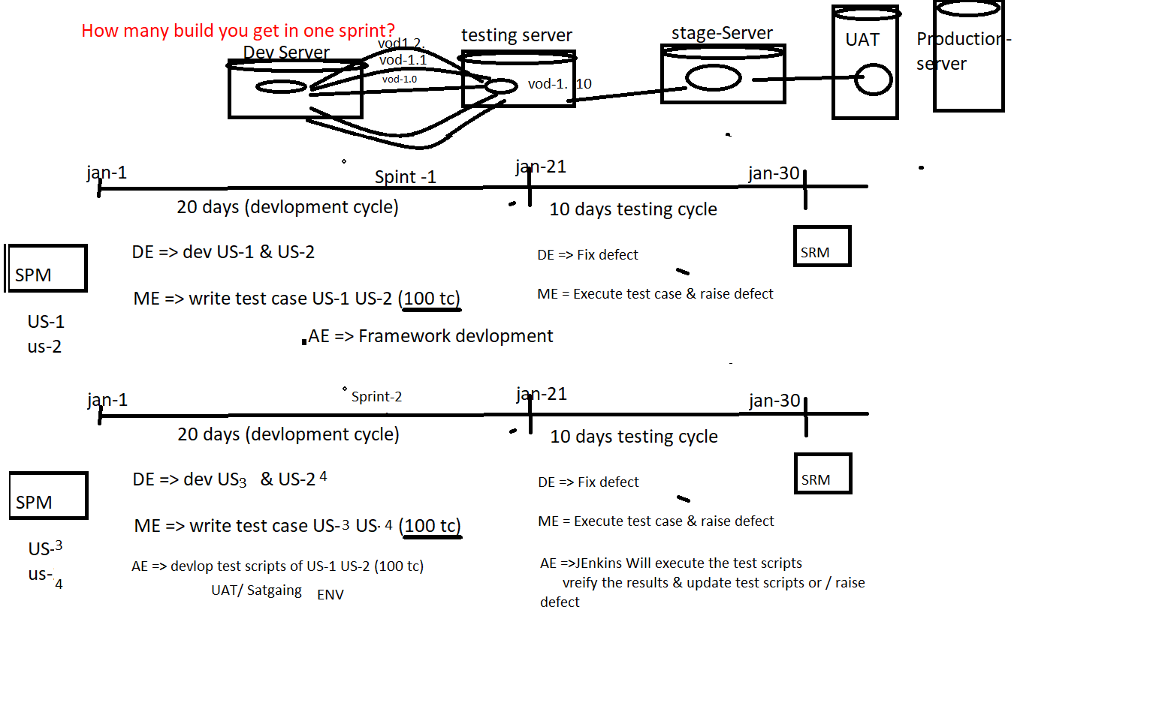

Feb-21

Feb-1

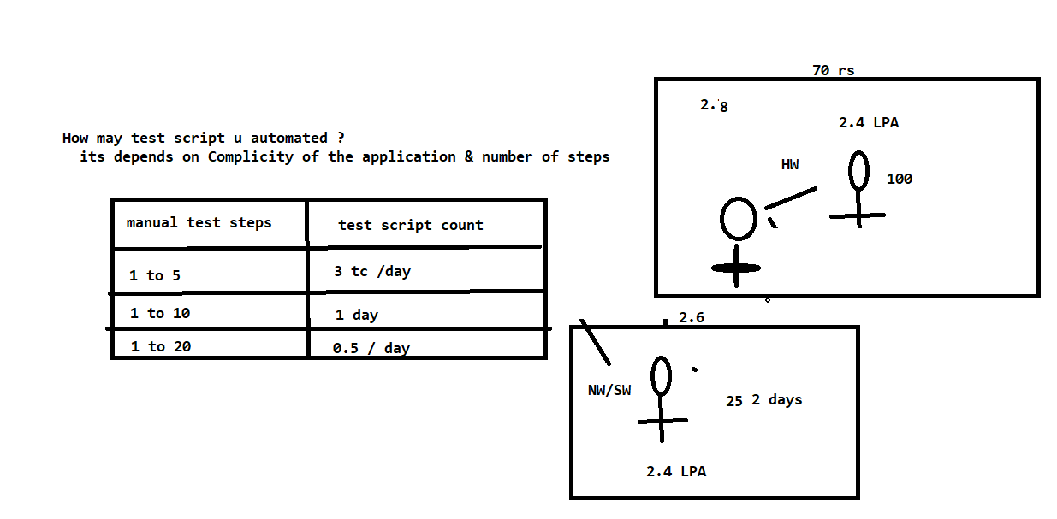

What is your automation Estimation for 100 manual test case ?

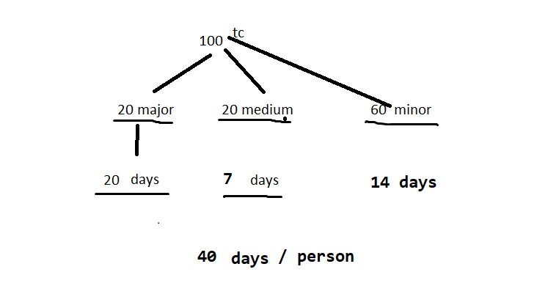

How long automation batch execution take place ?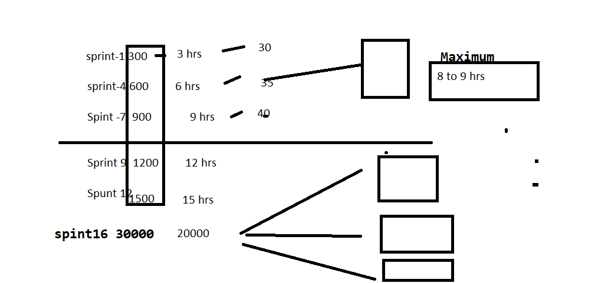

How may defect you found via automation in your previous project ?

